TAHUA

Ta
OR. Write, writing. The name of writing before the term rongorongo in 1871 became current. Fischer.
1. To tattoo ( = tatú), to tattoo pictures on the skin, also: he-tá ite kona, tá-kona. 2. To weave (a net): he-tá i te kupega. 3. To shake something, moving it violently up and down and from one side to the other; he-tá e te tokerau i te maga miro, the wind shakes the branches of the trees; also in the iterative form: e-tá-tá-ana e te tokerau i te tôa, the wind continuously shakes the leaves of the sugarcane. 4. To pull something up suddenly, for instance, an eel just caught, dropping it at once on a stone and killing it: he-tá i te koreha. Tá-tá-vena-vena, ancient witching formula. Vanaga.
1. Of. 2. This, which. 3. Primarily to strike: to sacrifice, to tattoo, to insert, to imprint, to write, to draw, to copy, to design, to color, to paint, to plaster, to note, to inscribe, to record, to describe, number, letter, figure, relation; ta hakatitika, treaty; ta igoa, sign; ta ki, secretary; ta kona, to tattoo; ta vanaga, secretary. Churchill.
... the root ta through its long series of known combinations carries a strongly featured sense of action that is peripheral, centrifugal, and there seems to be at least a suspicion of the further connotation that the action is exerted downward ... The secondary sense of cutting will easily be seen to be a striking with a specialized implement, and we find this sense stated without recognition of the primal striking sense only in Mangareva, Nukuoro, Viti, and Malekula. In Indonesia this secondary sense is predominant, although Malagasy ta may come somewhat close to the striking idea ... Churchill 2.

Hua
1. Testicle. 2. Figuratively: son, hua tahi, only son; fruits of the earth; to grow well (of fruits). 3. To cause a fight, a quarrel. Hua-ai, generation, as lineage of direct descendents; contemporaries. Huahua, coccyx of bird, 'parson's nose': huahua moa, huahua uha. Huataru, a creeper (Chenopodium ambiguum). Vanaga.
1. The same; ki hua, again, to continue, to strain, to struggle, to move, to repeat, over and above. Mq.: hua, the same, to return, to recommence. 2. To bloom, to sprout; flower, fruit (huaa); huaa tae oko, huaa vahio, young fruit; hua atahi, only son; huahaga, fruit; mei te huahaga o tokoe kopu, the fruit of thy body; tikea huahaga, deceptive appearance. P Pau.: ua, to be born; huahaga, lineage. Mgv.: hua, to produce (said of trees, grain, etc.), blooming time of flowers, abundance of fruit. Mq.: hua, to produce, to bear fruit. Ta.: ua, to sprout. Huahua. 1. Tailless fowl. 2. Vein, tendon, line. 3. Mgv.: huahua, pimples covering the face. Ta.: huahua, id. Mq.: hua, tubercules. Sa.: fuafua, abscess on hand or feet. Ma.: huahua, small pimples. Pau.: Hua-gakau, rupture. Ta.: áau, entrails. Sa.: ga'au, id. Ma.: ngakau, id. Churchill.
1. Fruit. 2. Egg. 3. Tā hua = 'genealogical writing' or 'same writing'. Fischer.

1. There are just a few days remaining of October and therefore I decided to once again look at the Tahua text in line b1 (where Halloween presumably might be). It is important to stay in tune with the seasons.


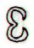 | 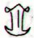 |  | 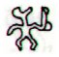
Ab1-1 (671) | Ab1-2 (2 * 336) | Ab1-3 | Ab1-4
Oct 22 (295) | 23 (*216) | 24 | 25 (*218, *584)  FOMALHAUT
13 Aug (408 - 183) | 14 Aug (*146, *512) | (*513 → 19 * 27 = 9 * 57) | 16 Aug (*514)
CLOSE TO THE FULL MOON:
April 22 (112, *32) | 23 | 24 | 25 (115, *35)
12 Febr (408 - 365 = 43) | 13 Febr (*329) | All the 'hearts' | (*514 - *183 = *331)
Te hoea | rutua te pahu - rutua te maeva - atua rerorero - atua ata tuu

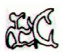 | 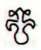 | 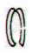
Ab1-5 ( → 25 * 27 = 15 * 45) | Ab1-6 | Ab1-7 (1341)
Oct 26 (412 - 6 - 107) = 299 | Oct 27 (*220) | ρ Lupi (221.0), TOLIMAN = α Centauri (221.2), π Bootis (221.8), ζ Bootis (221.9)
17 Aug (229 = 299 - 70) | 18 Aug (*150) | 19 Aug
16 Febr (412) | 17 Febr (413 → 14 * 29½ | (14 * 29½ + 1) → *41.4 Bharani
atua ata Rei - tuu te Rei hemoa | i ako te vai
Ako. To sing, to recite: he-ako i te kaikai, to recite the [text accompanying a] string figure kaikai; he-ako i te rîu, to sing rîu. Vanaga. Song. Ako hakaha'uru poki = 'song to make children sleep'. Barthel. Ákoáko, to recite hymns in honour of a deity. Vanaga.
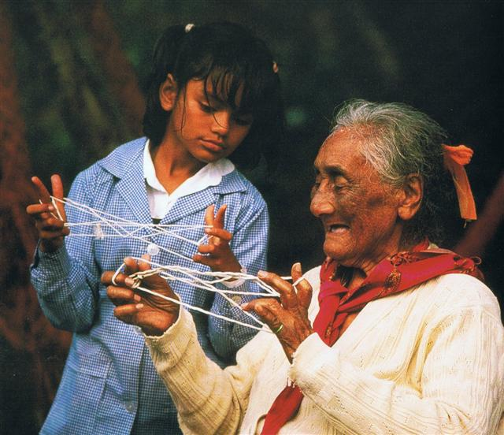

 | 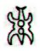 |  | 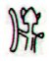 | 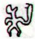 | 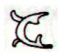
Ab1-8 (1335 + 7) | Ab1-9 | Ab1-10 (90 + 580 + 10 = 1344) | Ab1-11 | Ab1-12 | Ab1-13 (1347)
Oct 29 (*222) | 30 | Halloween | Samhain | 2 (306 = 123 + 183) | Nov 3 (*227)
20 Aug (*152) | 21 Aug | 22 Aug | 23 Aug | 24 Aug (236) | 25 Aug (*157)
CLOSE TO THE FULL MOON:
April 29 | 30 | Beltaine (50 + 71) | 2 (122) | DENEBOLA | MENKAR
19 Febr | 20 Febr (*336) | 21 Febr (29 + 21) | 22 Febr | Terminalia
Ko te maitaki - ko te maharoga | hetuu e roia | - | e ragi huhuki | eaha ia | ko te Rei oho ia mai
Haro. To pull; popohaga o te rua raá, i haro i te aka o te miro, on the morning of the second day, they pulled up the anchor of the boat. He haro i te hagu a roto, to draw in air, to breathe. He-haro te vaka i te au , the boat is towed off course in the current. Vanaga. a. to point, to raise the arm, to stretch out the hand or other member, to spread, to point the yards. b. to hoist, to pull up, to entice. c. to stiffen, to grasp, to squeeze. Haroharo, to point, to limp. PS Sa.: falo, to stretch out. To.: falo, to stretch out, to make tense. Fu.: falo, to stretch out, to lay hands on. Churchill.
Hu. 1. Breaking of wind. T Mgv., uu, to break wind. Mq., Ta.: hu, id. 2. Whistling of the wind, to blow, tempest, high wind. P Pau.: huga, a hurricane. Churchill. Mgv.: hu, to burst, to crackle, to snap. Ha.: hu, a noise. Churchill.
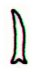
ihe tau

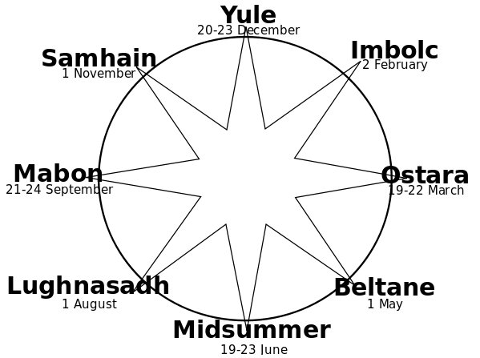

The distance from May 1 to November 1 is 305 - 121 = 184 days. The distance from August 1 (213) to February 2 (33) is 180 → 6 * 30 days. North of the equator summer is longer than winter, south of the equator the winter is longer.

Beltaine | *92 | Lughnasadh | *92 | Samhain
May 1 (*41) | *92 | Aug 1 (*133) | *92 | Nov 1 (*225)
185

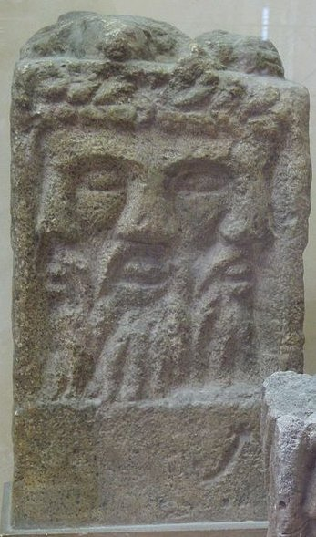
(Lugh)

2. We should remember that on one side of the year was Bharani (→ May 1) and on the other side was Zuben Elgenubi (→ October 31):
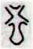 |  | 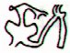 | 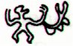
Cb1-15 |  | Cb1-16 (392 + 16 = 408) | Cb1-17
Oct 31 (304) |  | Nov 1 (*225) | 2
Al Zubānā-14a (Claws) / Visakha-16 (Forked) / Root-3 (Badger)  ZUBEN ELGENUBI (Southern Claw) = α Librae (224.2), ξ Bootis, ο Lupi (224.5) |  | KOCHAB (Kakkab, Babylonian for Star) = β Ursae Min. (225.0), ξ Librae (225.7)  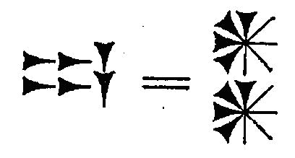 | KE KWAN (Cavalry Officer) = β Lupi (226.3), KE KWAN = κ Centauri (226.4), ZUBEN ELAKRIBI (Claw of the Scorpion) = δ Librae (226.8), π¹ Oct. (226.9)  *185.0 = *226.4 - *41.4 = "Sept 22 (265) = equinox
Bharani-2 (The Bearer) / Stomach-17 (Pheasant)  π Arietis (41.2), MIRAM = η Persei (41.3), BHARANI = 41 Arietis (41.4), τ² Eridani, σ Arietis (41.7) |  | TA LING (Great Mound) = τ Persei (42.4)  *1.0 = *42.4 - *41.4 | ρ Arietis (43.0), GORGONEA SECUNDA = π Persei (43.5), ACAMAR (End of the River) = θ Eridani (43.6), ε Arietis (43.7), λ Ceti (43.9)  DENEBOLA (β Leonis)
e niu tu |  | ki te ariki - e ka hua ra tona rima | koia kua iri i ruga o te rima - e o to vaha mea
Niu. Palm tree, coconut tree; hua niu, coconut. Vanaga. Coconut, palm, spinning top. P Pau., Ta.: niu, coconut. Mgv.: niu, a top; niu mea, coconut. Mq.: niu, coconut, a top. Churchill. The fruit of miro. Buck. T. 1. Coconut palm. 2. Sign for peace. Henry The sense of top lies in the fact that the bud end of a coconut shell is used for spinning, both in the sport of children and as a means of applying to island life the practical side of the doctrine of chances. Thus it may be that in New Zealand, in latitudes higher than are grateful to the coconut, the divination sense has persisted even to different implements whereby the arbitrament of fate may be declared. Churchill 2.

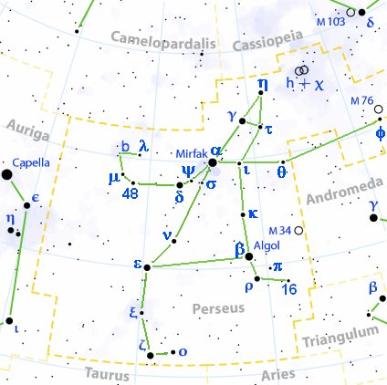
 | 365 days
 | (80 + RA / 24h * 365¼) |  | Day of culmination
Atlas | May 16 (136) | *229 | December 31 (365, *285) | 135
Alkes | September 3 (246) | *229 | April 20 (110) | 135
Denebola | September 15 (258) | *230 | May 3 (123) | 134
Thuban | October 19 (292, *212) | *230 | June 7 (158, *78) | 134
Arcturus | October 22 (295, *215) | *227 | June 8 (159, *79) | *136
Zuben Elgenubi | October 31 (304, *224) |  | June 17 (168, *454. *88) | *136
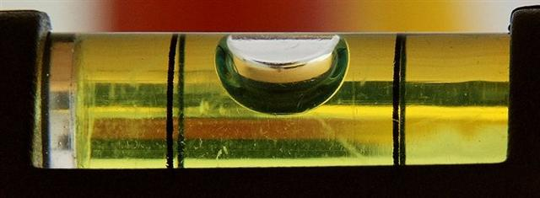
Vega | December 27 (361, *281) | *227 | August 12 (224, *144) | *137
Alphekka Meridiana | January 5 (*290) | *220 | August 13 (225, *145) | '146
Deneb Cygni | February 7 (38, *323) | *221 | September 16 (259, *179) | *144
Fomalhaut | March 3 (62, *348) | *236 | October 25 (*584, *218)
Alrisha | April 19 (109, *212 - *183 = *29) | *232 | December 7 (341, *261) | 132
Menkar | May 4 (124, *44) | *231 | December 21 (355, *275) | 133
*364 - *229 → 135 etc. And *144 (August 12) = *281 (December 27) - *137, etc.

And according to my preliminary results the corresponding place in the text on the Tahua tablet should be:
Ab1-8 (1335 + 7) | Ab1-9 | Ab1-10 (90 + 580 + 10 = 1344) |  | Ab1-11 | Ab1-12 | Ab1-13 (1347)
29 (→ 152 + 150) | Oct 30 | Halloween |  | Samhain (*225) | 2 (306 = 123 + 183) | Nov 3 (*227)
20 Aug (*152) | 21 Aug | 22 Aug |  | 23 Aug | 24 Aug (236) | 25 Aug (*157)
 |  | ZUBEN ELGENUBI
CLOSE TO THE FULL MOON:
April 29 | 30 | Beltaine (50 + 71) |  | 2 | 3 (123) | 4
19 Febr | 20 Febr (*336) | 21 Febr (29 + 21) |  | 22 Febr | Terminalia
 |  | BHARANI |  |  | DENEBOLA | MENKAR
Ko te maitaki - ko te maharoga | hetuu e roia | - |  | e ragi huhuki | eaha ia | ko te Rei oho ia mai
Haro. To pull; popohaga o te rua raá, i haro i te aka o te miro, on the morning of the second day, they pulled up the anchor of the boat. He haro i te hagu a roto, to draw in air, to breathe. He-haro te vaka i te au , the boat is towed off course in the current. Vanaga. a. to point, to raise the arm, to stretch out the hand or other member, to spread, to point the yards. b. to hoist, to pull up, to entice. c. to stiffen, to grasp, to squeeze. Haroharo, to point, to limp. PS Sa.: falo, to stretch out. To.: falo, to stretch out, to make tense. Fu.: falo, to stretch out, to lay hands on. Churchill.
Hu. 1. Breaking of wind. T Mgv., uu, to break wind. Mq., Ta.: hu, id. 2. Whistling of the wind, to blow, tempest, high wind. P Pau.: huga, a hurricane. Churchill. Mgv.: hu, to burst, to crackle, to snap. Ha.: hu, a noise. Churchill.
ihe tau

It seems reasonable to assume that the importance of Bharani / Zuben Elgenubi was due to Kochab at the time when this star was regarded as the star at the norh pole.
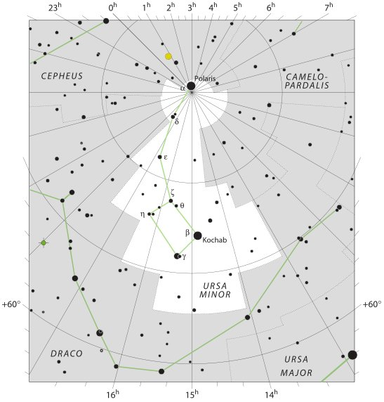
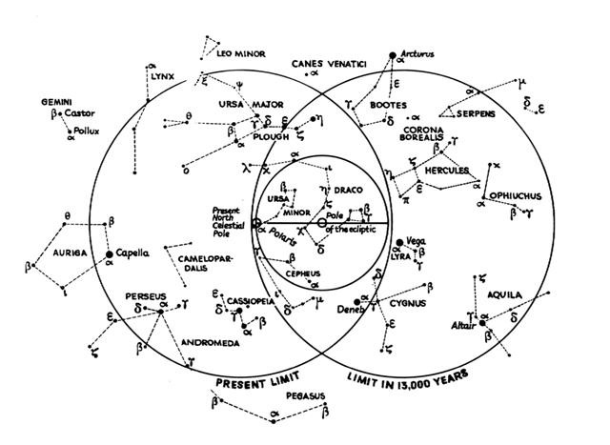
From Kochab (*225 → 225 → August 13 → Creation of Our Present World) to Polaris (the present north pole star) the distance was 16 days (*26 + *16 = *225 - *183), because Polaris was at the other side of the exact position of the current north pole. → 168 + 16 = 184.
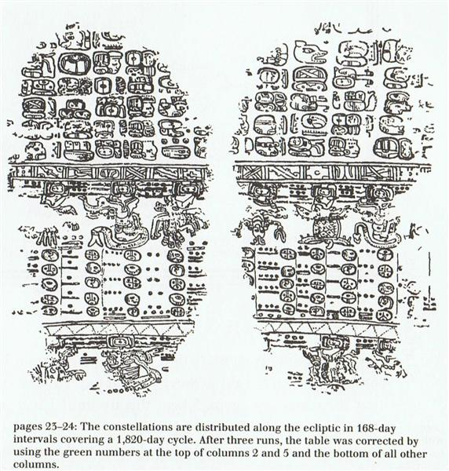

Ab1-11 (*225) - *16 = *183 → 1345 - 16 = 1329 = 664 + 665 (Aa8-80).
... 1329 (Aa8-80) → 1225 + 2 * 52 ...
... When it was evident that the years lay ready to burst into life, everyone took hold of them, so that once more would start forth - once again - another (period of) fifty-two years. Then (the two cycles) might proceed to reach one hundred and four years. It was called One Age when twice they had made the round, when twice the times of binding the years had come together. Behold what was done when the years were bound - when was reached the time when they were to draw the new fire, when now its count was accomplished. First they put out fires everywhere in the country round. And the statues, hewn in either wood or stone, kept in each man's home and regarded as gods, were all cast into the water. Also (were) these (cast away) - the pestles and the (three) hearth stones (upon which the cooking pots rested); and everywhere there was much sweeping - there was sweeping very clear. Rubbish was thrown out; none lay in any of the houses ...
 |  |  |  | 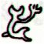
Aa8-80 (1329) | Aa8-81 (666) | Aa8-82 |  | Aa8-83 | Aa8-84 | Aa8-85 (1334)
ki to hatu huri | ma to ua mata - mae tae e ui hia mai |  |  | kua oho te tagata | ki te henua | -
Oct 16 (260 + 29) | 17 (290) | 18 (472 - 181) |  | 19 | 20 | 21 (294)
 |  |  |  | THUBAN
April 16 (314 * 1½) | 17 (16 * 29½) | (365 + 108 = 473) |  | 19 | ALKES | 21 (111)
To. 1. Particle sometimes used with the article in ancient legends; i uto to te hau, the ribbon was in the float. 2. To rise (of the sun) during the morning hours up to the zenith: he-to te raá. Vanaga. 1. Of. T Pau., Ta.: to, of. Mgv.: to, genitive sign. Mq.: to, of, for. 2. This, which. Churchill. Mgv.: To, to make a canoe of planks. Mq.: to, to build a canoe. Sa.: to, to build. Churchill.
Huri. 1. To turn (vt.), to overthrow, to knock down: huri moai, the overthrowing of the statues from their ahus during the period of decadence on the island. 2. To pour a liquid from a container: ka huri mai te vai, pour me some water. 3. To end a lament, a mourning: he huri i te tagi, ina ekó tagi hakaou, with this the mourning (for the deceased) is over, there shall be no more crying. 4. New shoot of banana: huri maîka. Vanaga. 1. Stem. P Mgv.: huri, a banana

shoot. Mq.: hui, shoot, scion. 2. To turn over, to be turned over onto another side, to bend, to lean, to warp; huri ke, to change, to decant; tae huri ke, invariable; huri ke tahaga no mai, to change as the wind; tae huri, immovable; e ko huri ke, infallible; huhuri, rolling; hakahuri, to turn over; hakahuri ke, to divine. P Pau.: huri, to turn. Mgv.: huri, uri, to turn on one side, to roll, to turn upside down, to reverse. Mq.: hui, to turn, to reverse. 3. To throw, to shoot. 4. To water, to wet. 5. To hollow out. Hurihuri: 1. Wrath, anger; kokoma hurihuri, animosity, spite, wrath, fury, hate, enmity, irritable, quick tempered, to feel offended, to resent, to pester; kokoma hurihuri ke, to be in a rage. 2. (huri 4) hurihuri titi, to fill up. 3. To polish. 4. (uriuri). Hurikea, to transfigure, to transform. Churchill. Mq. huri, resemblance. Sa.: foliga, to resemble. Churchill.

... The star [Thuban] could be seen, both by day and night, from the bottom of the central passage of the Great Pyramid of Cheops (Knum Khufu) at Ghizeh, in 30° of north latitude, as also from the similar points in five other like structures; and the same fact is asserted by Sir John Herschel as to the two pyramids at Abousseir ...
... For some reason, too, it had taken their fancy to place the Great Pyramid almost exactly on the 30th parallel at latitude 29º 58' 51". This, a former astronomer royal of Scotland once observed, was 'a sensible defalcation from 30º', but not necessarily in error: For if the original designer had wished that men should see with their body, rather than their mental eyes, the pole of the sky from the foot of the Great Pyramid, at an altitude before them of 30º, he would have had to take account of the refraction of the atmosphere, and that would have necessitated the building standing not at 30º but at 29º 58' 22' ...

