ADDENDA

1. In order to catch further ideas of mine I decided to create an additional apartment for such. I was motivated by re-reading the text quoted below, from a page in my description of the Phaistos Disc (in Level 1):
... We will not go any further in this technical discussion. But another piece of observation: There are 45 different signs on the Phaistos Disc. (I do not count the two special signs, the 'strings with knots' and a sign looking like /.)
Should we divide 360 by 2, 3 or 4 we will reach the whole numbers 180, 120 and 90. And we can also divide by 5 and 6 in order to reach 72 and 60.
7, though, does not work. But with 8 we will get 45. I think the Polynesians had reasons to divide the horizon into 8 parts. With 16 - the next natural division - you get 22.5 which is unacceptable. Only whole numbers are natural and understandable.
45 degrees therefore ought to be important enough to be seen somewhere in the rongorongo texts. Which means we should look for 45 days (glyphs) in the calendar for the year. Days and degrees are equivalent if you disregard periods shorter than what corresponds to a division by 8 ...

For later I had been prompted by a TV program which stated that there were 46 different types of signs on the Phaistos Disc. After a careful examination I decided the number was neither 45 nor 46 but rather 37.
37 happens to be the difference between 257 (= 241 + 16) and 220 (= 236 - 16), where I suggest 241 is the correct number of signs on the Phaistos Disc - not 242 as was stated in the TV program:
PHAISTOS DISC
side a |  | side b
118 | 5 | 83 | 0 | 34
118 + 5 = 123 |  | 84 + 34 = 118
236 + 5 = 241 → 257 - 16
Furthermore, my early statement above that number 22.5 should be unacceptable because it is not a whole nunmber, is probably false. In the ancient world view they managed quite well without any decimal points (or zero signs).
So number 225 (= 360 / 16) could have been used for instance to indicate August 13 = day 225 in the Gregorian calendar.

The dates in a Sun calendar will not be changed over time due to the precession, instead the right ascension positions of the fixed stars will be changed:

... In three magnificent texts at the site of Koba, scribes recorded it as one of the largest finite numbers we humans have ever written. According to these inscriptions, our world was created on the day 4 Ahaw 8 Kumk'u. On this day all the cycles of the Maya calendar above twenty years were set at thirteen - that is to say, the cycles of 400 years, 8,000 years, 160,000 years, 32,000,000 years, and so on, all the way up to a cycle number extending to twenty places (20₂₁ * 1360-day year).
In our calendar, this day fell on August 13, 3114 BC. To understand what this means, we need a little scale. The thirteens in this huge number act like the twelve in our cycles - the next hour after twelve is one. Thirteen changed to one as each of these cycles in the Maya calendar was completed, therefore, we have the following sequence:

13. | 13. | 13. | 0. | 0. | 0. | 1. | 5 Imix | 9 Kumk'u | (Aug. 14, 3114 B.C.)
13. | 13. | 13. | 0. | 0. | 1. | 0. | 11 Ahaw | 3 Pop | (Sept. 2, 3114 B.C.)
13. | 13. | 13. | 0. | 1. | 0. | 0. | 13 Ahaw | 3 Kumk'u | (Aug.7, 3113 B.C.)
13. | 13. | 13. | 1. | 0. | 0. | 0. | 2 Ahaw | 8 Mak | (May 1, 3094 B.C.)
13. | 13. | 1. | 0. | 0. | 0. | 0. | 3 Ahaw | 13 Ch'en | (Nov. 15, 2720 B.C.)
13. | 13. | 13. | 0. | 0. | 0. | 0. | 4 Ahaw | 3 K'ank'in | (Dec. 23, A.D. 2012)
13. | 1. | 0. | 0. | 0. | 0. | 0. | 10 Ahaw | 13 Yaxk'in | (Oct. 15, A.D. 4772)
1. | 0. | 0. | 0. | 0. | 0. | 0. | 7 Ahaw | 3 Zotz' | (Nov. 22, A.D. 154587)

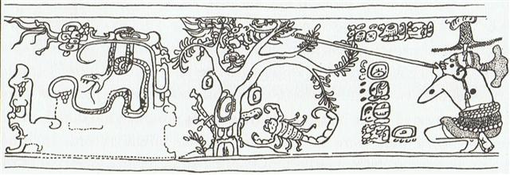

... This pot depicts one of the Hero Twins (One-Ahaw in the Classic texts and One-Hunaphu in the K'iche' Popol Vuh) and a great bird who is trying to land in a huge ceiba tree heavy with fruit. This mythical bird is Itzam-Yeh, Classic prototype of Wuqub-Kaqix, 'Seven-Macaw', of Popol Vuh fame. In that story, in the time before the sky was lifted up to makeroom for the light, the vainglorious Seven-Macaw imagined himself to be the sun. Offended by his pride, the Hero Twins humbled him by breaking his beautiful shining tooth with a pellet from their blowgun. This pot shows One-Ahaw aiming at the bird as he swoops down to land in his tree. As Itzam-Yeh lands on his perch, the text tells us he is 'entering or becoming the sky'.
This particular 'sky-entering' is not the one mentioned in the Palenque text. It is the final event that occurred in the previous creation before the universe was remade. Before the sky could be raised and the real sun revealed in all its splendor, the Hero Twins had to put the false sun, Itzam-Yeh, in his place. If the date on this pot corresponds to that pre-Columbian event, as we believe it does, then Itzam-Yeh was defeated on 12.18.4.5.0.1 Ahaw 3 K'ank'in (May 28, 3149 B.C.). After the new universe was finally brought into existence, First Father also entered the sky by landing in the tree, just as Itzam-Yeh did ...

2. When I early on used much time and effort in order to create a Glyph Catalogue - possible to access from Level 2 - I decided to leave aside what looked like faintly drawn full stops, because this type of sign, although clearly carrying meaning, did not look like a glyph.
When reading the calendar for the week, though, it ought to be commented upon. Because I can without much effort detect such small dots in e.g. these glyphs:
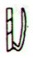 |  | 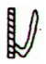 | 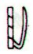 | 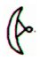 |  | 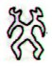 | 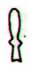 | 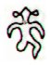
Especially noteworthy is the dot at the throat of the 'One-Leg' figure (Hb9-52), because here the dot has been drawn in the inside instead of outside in front - which is a very strong sign.
The Mayas saw time running from right to left and therefore this lady, when reversed, could be conceptually equivalent to One-Leg in Hb9-52:
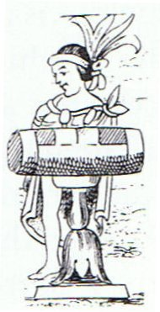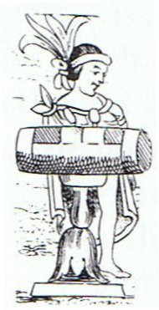
... The tun glyph was identified as a wooden drum by Brinton ... and Marshal H. Saville immediately accepted it ... [the figure below] shows the Aztec drum representation relied on by Brinton to demonstrate his point. It was not then known that an ancestral Mayan word for drum was *tun: Yucatec tunkul 'divine drum' (?); Quiche tun 'hollow log drum'; Chorti tun 'hollow log drum' ...

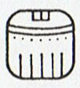 | 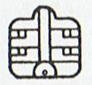 | 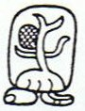 | 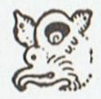
13 Mac (260) | 14 Kankin |  | 15 Moan (300)
BREAK (paxih)
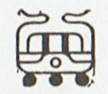 | 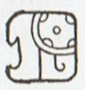 | 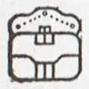 | 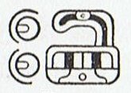
16 Pax (320) | 17 Kayab | 18 Cumhu | 19 Vayeb (365)
... The [tun] glyph is nearly the same as that for the month Pax ... except that the top part of the latter is split or divided by two curving lines. Brinton, without referring to the Pax glyph, identified the tun glyph as the drum called in Yucatec pax che (pax 'musical instrument'; che < *te 'wooden). Yucatec pax means 'broken, disappeared', and Quiche paxih means, among other things, 'split, divide, break, separate'. It would seem that the dividing lines on the Pax glyph may have been used as a semantic/ phonetic determinative indicating that the drum should be read pax, not tun ... Thus, one may expect that this glyph was used elsewhere meaning 'to break' and possibly for 'medicine' (Yuc. pax, Tzel., Tzo. pox) ... It should be added that tun was also the period of 18 months, or 360 days ...

3. The number of previous generations, 22 respecitively 57, are probably not factual but 'sacred' (mythical in sense).
For 22 we have already established an ideal connection with 22 / 7 as the approximation of the circumference of a circle in relation to its diameter. 22 / 7 = 3.142857142 ... ↔ π.
... About Carmenta we know from the historian Dionysus Periergetis that she gave orcales to Hercules and lived to the age of 110 years. 110 was a canonical number, the ideal age which every Egyptian wished to reach and the age at which, for example, the patriarch Joseph died. The 110 years were made up of twenty-two Etruscan lustra of five years each; and 110 years composed the 'cycle' taken over from the Etruscans by the Romans. At the end of each cycle they corrected irregularities in the solar calendar by intercalation and held Secular Games. The secret sense of 22 - sacred numbers were never chosen haphazardly - is that it is the measure of the circumference of the circle when the diameter is 7. This proportion, now known as pi, is no longer a religious secret; and is used today only as a rule-of-thumb formula, the real mathematical value of pi being a decimal figure which nobody has yet been able work out because it goes on without ever ending, as 22 / 7 does, in a neat recurring sequence [3.142857142857 ...]. Seven lustra add up to thirty-five years, and thirty-five at Rome was the age at which a man was held to reach his prime and might be elected Consul ...
22 / 7 ↔ July 27:
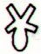 | 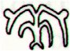
Ga2-29 | Ga3-1
22 / 7 | July 23
Ga2-29 is quite unique in its construction, probably alluding to the idea of Ariki upside down with head down in the earth, i.e. not visible.
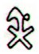

The King personified the World Tree:

... I already knew that the ceiba tree was the model for the sacred World Tree of the Maya, but I had never seen one in flower when I knew what I was looking at. I was really excited because normally you can't see the blossoms even if you're there when the tree is in blossom. The fully mature trees are hundreds of feet high. and the blossoms are very small. 'It's a ceiba', I chirped and began looking for a branch low enough to see one of the blossoms up close. Joyce Livingstone, a retired teacher, did the logical thing. She bent over, picked up a fallen branch, and held it out for me to see. I was too excited and full of myself to listen. She tapped my arm more insistently and still I didn't hear her. Finally, in frustration, she grabbed my wrist and raised her voice. 'Will you look at these?' she said, waving the branch, and finally I did. What I saw stunned me, for in her hand lay a perfect replica of the earflares worn by the Classic Maya kings. Suddenly I understood the full symbolism of so many of the things I had been studying for years. The kings dressed themselves as the Wakah-Chan tree, although at the time I didn't know it was also the Milky Way.
The tzuk [partition] head on the trunk of the tree covered their loins. The branches with their white flowers bent down along their thighs, the double-headed ecliptic snake rested in their arms, and the great bird Itzam-Yeh stood on their head. I already knew as I stood under the young tree in Tikal that the kings were the human embodiment of the ceiba as the central axis of the world. As I stood there gazing at the flowers in Joyce's hand, I also learned that the kings embodied the ceiba at the moment it flowers to yield the sak-nik-nal, the 'white flowers', that are the souls of human beings. As the trees flowers to reproduce itself, so the kings flowered to reproduce the world ...
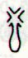
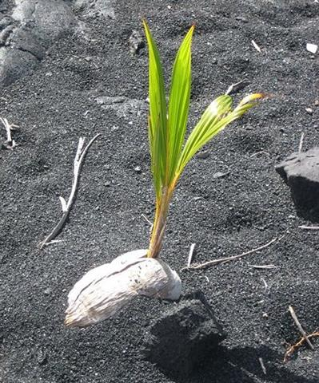

3.1 The number of generations which earlier had arrived from the east, viz. 57, was therefore probably also mythical in sense.
... The story of Rip Van Winkle is set in the years before and after the American Revolutionary War. Rip Van Winkle, a villager of Dutch descent, lives in a nice village at the foot of New York's Catskill Mountains. An amiable man whose home and farm suffer from his lazy neglect, he is loved by all but his wife. One autumn day he escapes his nagging wife by wandering up the mountains. After encountering strangely dressed men, rumored to be the ghosts of Henry Hudson's crew, who are playing nine-pins, and after drinking some of their liquor, he settles down under a shady tree and falls asleep. He wakes up twenty years later and returns to his village. He finds out that his wife is dead and his close friends have died in a war or gone somewhere else. He immediately gets into trouble when he hails himself a loyal subject of King George III, not knowing that in the meantime the American Revolution has taken place. An old local recognizes him, however, and Rip's now grown daughter eventually puts him up ...
... The story is a close adaptation of Peter Klaus the Goatherd by J.C.C. Nachtigal, which is a shorter story set in a German village. The story is also similar to the ancient Jewish story about Honi M'agel who falls asleep after asking a man why he is planting a carob tree which traditionally takes 70 years to mature, making it virtually impossible to ever benefit from the tree's fruit. After this exchange, he falls asleep on the ground and is miraculously covered by a rock and remains out of sight for 70 years. When he awakens, he finds a fully mature tree and that he has a grandson. When nobody believes that he is Honi, he prays to God and God takes him from this world. Note also that the family name of Honi is also a term of geometry ('M'agel' is Hebrew for 'circle maker'), as well as the family name of Rip ('Winkel' is German for 'angle').
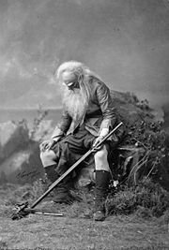

The story is also similar to a 3rd century AD Chinese tale of Ranka, as retold in Lionel Giles in A Gallery of Chinese Immortals. In Orkney there is a similar and ancient folklore tale linked to the Burial mound of Salt Knowe adjacent to the Ring of Brodgar. A drunken fiddler on his way home hears music from the mound. He finds a way in and finds the trowes (Trolls) having a party. He stays and plays for two hours, then makes his way home to Stenness, where he discovers fifty years have passed. The Orkney Rangers believe this may be one source for Washington Irving's tale, because his father was an Orcadian from the island of Shapinsay, and would almost certainly have often told his son the tale.
The original story was by Diogenes Laertius, an Epicurean philosopher circa early half third century, in his book On the Lives, Opinions, and Sayings of Famous Philosophers. The story is in Chapter ten in his section on the Seven Sages, who were the precursors to the first philosophers. The sage was Epimenides. Apparently Epimenides went to sleep in a cave for fifty-seven [57] years. But unfortunately, 'he became old in as many days as he had slept years'. Although according to the different sources that Diogenes relates, Epimenides lived to be one hundred and fifty-seven years, two hundred and ninety-nine years, or one hundred and fifty-four years.
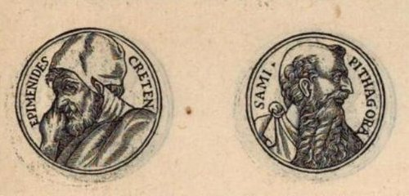

A similar story is told of the Seven Sleepers of Ephesus, Christian saints who fall asleep in a cave while avoiding Roman persecution, and awake more than a century later to find that Christianity has become the religion of the Empire ...

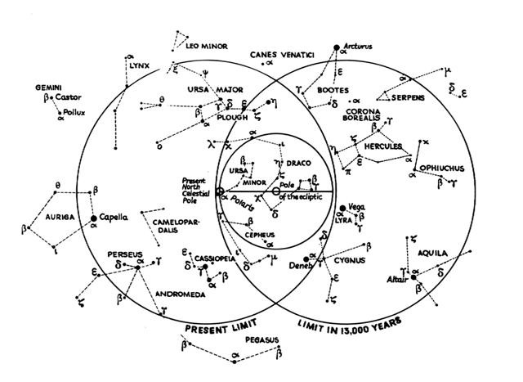
... it should be remembered that during many milleniums the polar point has gradually been approaching our pole-star, which 2000 years ago was far removed from it, - in Hipparchos' time 12º 24' away according to his own statement quoted by Marinus of Tyre and cited by Ptolemy. Miss Clerke writes as to this: The entire millenium before the Christian era may count for an interregnum as regards Pole-stars. Alpha Draconis had ceased to excercise that office; Alruccabah had not yet assumed it ...
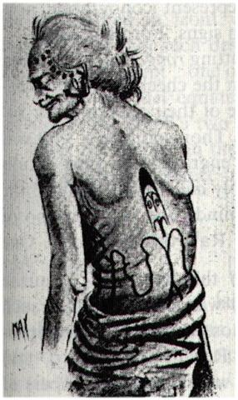
... Originally the highly born family of the Sun, Moon, and stars dwelt in a cave on the summit of Maunga-nui, Great Mountain, in the ancient homeland. They were not at all comfortable in their gloomy home for they could not see distinctly and their eyes watered constantly. After the Sky-father had been elevated to his present eminence Tane decided that the celestial family would be happier in the sky, where they would serve the double purpose of ornamenting the naked body of Rangi and giving light to the Earth-mother. Since Papa had already been turned with her face toward the Underworld it is difficult to see how she would benefit by the illumination ...

3.2 There were two celestial bands crossing each other. One of these was certainly the ecliptic path of the Sun and the other planets. The other ought to be the celestial equator, from where vertical right ascension lines could be drawn to the celestial poles.
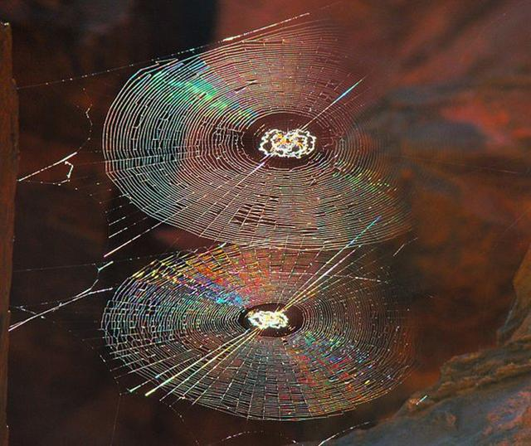.
On Easter Island their World Tree - corresponding to the sacred Ceiba among the Mayas (and evidently also to the Carob tree which was said to need 70 years to mature - might have been the Niu:
... The precessional distance down from the time of rongorongo to that of the First Father can be calculated as around (1842 + 3112) / 26000 * 365.25 = 70 right ascension days, or as 6 days more than 64 = 10 days less than 80. It was evidently Polaris who rose with the Sun when Hun-Nal-Ye became the sky, and it would have been in day 392 (January 26) - 10 = 382 (January 16) when the companion star of Polaris (*26.6), viz. the Belly of the Fish (Baten Kaitos, ζ Ceti, *26.6) would have returned to visibility after the close encounter with the Sun in December 31. Polaris never sank below the horizon and it was therefore outside the cycles of heliacal risings and settings ...

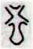
Cb1-15 (407)
e niu tu
BHARANI (*41.4)

Modern science has established as fact that once upon a time there were great palm tress growing also on Easter Island.
According to the text on the Mamari (C) tablet and how Metoro seems to have translated this to Bishop Jaussen on Haiti the Sun rose together with the crucial star Bharani (41 Tauri) in May 1 (80 + 41 = 121). Once upon a time this star would have risen with the Sun at 0h (where the ecliptic crossed the equator of the sky).
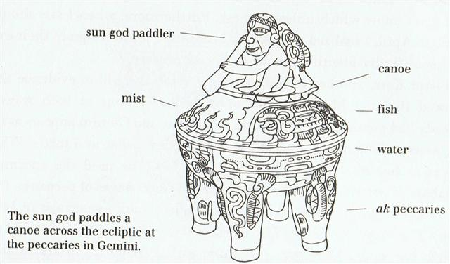

But at the ancient time of Bharani they probably waited for the return to visibility of the stars after the close encounters with the blazing rays from the Sun. Thus 41 + 16 = 57 ↔ 137 - 80 ↔ May 17:

 | *13
Cb1-15 (407) | *13
e niu tu | *13
BHARANI (*41.4) | *13
May 1 (121) | *13
JULY 4 (185) | *13

 | 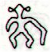 | 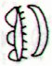 | 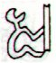
Cb2-4 (420) | Cb2-5 | Cb2-6 | Cb2-7
te ua | koia ra | kua tuku ki to mata - ki tona tukuga | e kiore - henua - pa rei
May 14 (366 + 134 = 500) | THE PLEIADES |  | May 17 (137)
JULY 17 (185 + 13 = 198) | 18 | 19 | 20 (201 = 137 + 64)

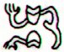 | *227 → π
Bb7-5 | *227 → π | Cb2-6
MIN-EL-AUVA (*195) | *227 → π | ALCYONE (*56)
Space-time | *227 → π | Time-space

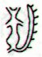 | 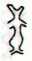 | 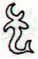
Cb2-8 (424) | Cb2-9 | Cb2-10
Niu |  | moe te goe
May 18 | 19 | 20 (140)
JULY 21 | 22 / 7 | 23 (204)

Te Goe means the Milky Way and half a year after May 19 - in November 18 (322 = 139 + 366 / 2) - was the culmination (at 21h) of The Breast of Cassiopeia (Schedir).

Now we can begin to perceive why Ga2-27 was glyph number 57:

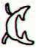 | 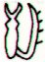
Ga2-27 (57) | Ga2-28 | Ga2-29 | Ga3-1
July 20 (201) | 21 | 22 / 7 | 23 (204)
'June 23 | 24 (350 / 2) | 25 | 26 (354 / 2)
"June 9 (*80) | 10 (161) | 11 | 12 (*83)
MAY 17 (137) | 18 | 19 | 20 (140)

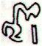 | 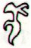 | 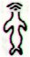 | 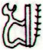
Ga3-2 | Ga3-3 | Ο URSAE MAJORIS (127.4) | Ga3-5 (64)
July 24 | 25 | 26 | 7 / 27 (208)
'June 27 | 28 | 29 (*100) | SIRIUS
"June 13 (*84) | 14 (165) | *127.4 - *41.4 | 16
MAY 21 | 22 | 23 | (12 * 12)
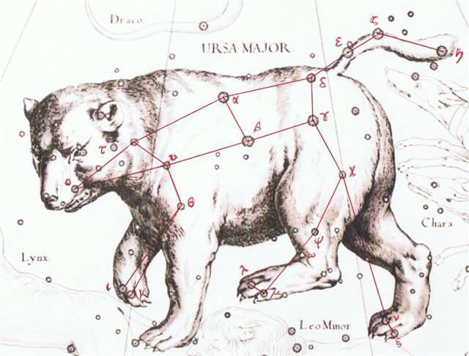

4. To make things more clear: the INDEX document file is beginning at the beginning of Level 1, i.e. with a copy of the page on the internet site from the hyperlink named Rongorongo. Then should ideally follow copies of the pages from the hyperlinks named miroglyph, the experiment, responsible creator, and references. Etc.
However, due to my changes over time in the internet site there is no longer always exact correspondences between the pages for paper in A4-format in INDEX.doc and the current pages in my site. Although INDEX.doc thus is sometimes old it will anyhow mostly serve its purpose quite well - viz. to be used in order to search. It is easy to check with the site if there has been any relevant changes.
So such a search will begin with Level 1, with all the pages to be reached from not only the links which can be immediately seen but also the further links which follow on the pages which are reached from these links.
Then the search will automatically continue in the same manner with the internet pages of Level 2, Level 3, Level 4, Level 5, respectively of Level 6.
INDEX.doc | Level 1 | Level 2 |  | Level 3 | Level 4 | Level 5 | Level 6
INDEX.doc | →
... I found it convenient to add all the pages together, because I don't believe anybody will ever use the facility to look at an awful lot of separate texts via Word ...
The number of doc pages in A4 format for INDEX amounts to ca 1800, i.e. to around 6 normal sized ordinary books.
... 'Most ingenious Thoth', said the god and king Thamus, 'one man has the ability to beget arts, but the ability to judge of their usefulness or harmfulness to their users belongs to another; and now you, who are the father of letters, have been led by your affection to ascribe to them a power the opposite of that which they really possess. For this invention will produce forgetfulness in the minds of those who learn to use it, because they will not practise their memory. Their trust in writing, produced by external characters which are no part of themselves, will discourage the use of their own memory within them. You have invented an elixir not of memory, but of reminding; and you offer your pupils the appearance of wisdom, not true wisdom, for they will read many things without instruction and will therefore seem to know many things, when they are for the most part ignorant and hard to get along with, since they are not wise, but only appear wise.' Now that Plato's apprehensions have become fact, there is nothing left of the ancient knowledge except the relics, fragments and allusions that have survived the steep attrition of the ages ...

5. The label 'translation' is to be understood rather freely. To begin with: my 3 document files named Translations; they are beginning after the end of Index.doc:
INDEX.doc | Level 1 | Level 2 |  | Level 3 | Level 4 | Level 5 | Level 6
INDEX.doc | →
Focus in TRANSLATIONS.doc is to document the process in creating a preliminary dictionary for the different types of glyph.

But I have also used the word 'translations' for hyperlink labels leading to discussions about how to understand the glyph text, e.g. at the beginning of side a on the G tablet. And furthermore, I have used the hyperlink label 'comments' when parallel texts occur.

As time went by it became clear that several of the glyph texts could be put in parallel not only with dates in the Gregorian calendar but also with the positions of revelant stars. This made the idea of translating the rongorongo text recede into the background, for the moment no longer quite as important.

An example can be given from the beginning of side b on the Keiti tablet:

Nov 18 | 19 | 20 | 21 | 22 | 23 | 24 (*248)
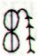 | 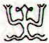 | 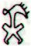 |  | 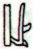 |  | 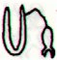
Eb2-1 | Eb2-2 | Eb2-3 | Eb2-4 | Eb2-5 | Eb2-6 (48) | Eb2-7
te maitaki - te maro | Haka  nohoa | e ariki | te tapamea | te henua - tau rakau | no ana ra tau hiva | ko rapai a haga
υ Herculis (242.3), ρ Cor. Borealis (242.4), ι Cor. Borealis (242.5), θ Draconis (242.6), ξ Scorpii (242.7)  SCHEDIR (Breast) α Cassiopeiae  *201.0 = *242.4 - *41.4 | 16h (243.5)  ACRAB (Scorpion) = β Scorpii, JABHAT AL ACRAB (Forehead of the Scorpion) = ω Scorpii (243.3), θ Lupi, RUTILICUS = β Herculis (243.5), MARFIK (Elbow) = κ Herculis (243.7), φ Herculis (243.8) | ψ Scorpii (244.6), LESATH (Sting) = ν Scorpii (244.8) | χ Scorpii (245.1), YED PRIOR (Hand in Front) = δ Ophiuchi, δ Tr. Austr. (245.5) | YED POSTERIOR (Hand Behind) = ε Ophiuchi, RUKBALGETHI SHEMALI (Northern Knee of the Giant) = τ Herculis (246.6). δ Apodis (246.7), ο Scorpii (246.8) | Heart-5 (Fox)  σ Scorpii (247.0), HEJIAN = γ Herculis (247.2), ψ Ophiuchi (247.7) | ρ Ophiuchi (248.1), KAJAM (Club) = ω Herculis (248.3), χ Ophiuchi (248.5), SHE LOW (Market Tower) = υ Ophiuchi, Tr. Austr. (248.7), ζ Tr. Austr. (248.8)
VISIBLE CLOSE TO THE FULL MOON:
λ Tauri (59.3), ν Tauri (59.9) | 4h (60.9)  JĪSHUĬ = λ Persei (60.7)  COR CAROLI (α Canum Ven.) | υ Persei (61.2) | BEID (Egg) = ο¹ Eridani (62.2), μ Persei (62.8)  VINDEMIATRIX ( ε Virginis) | Al Dabarān-2 (The Follower)  HYADUM I = γ Tauri (63.4)  *22.0 = *63.4 - *41.4 | HYADUM II = δ¹ Tauri (64.2) | Net-19 (Crow)  AIN (Eye) = ε Tauri, θ¹ Tauri, θ² Tauri (65.7)
May 19 | 20 (140) | 21 | 22 | 23 | 24 | 25

6. The very special glyph Eb2-1 seems to correspond to the day when on Hawaii the priests watched the sky in order to detect the return to visibility of the Pleiades:
... The correspondence between the winter solstice and the kali'i rite of the Makahiki is arrived at as follows: ideally, the second ceremony of 'breaking the coconut', when the priests assemble at the temple to spot the rising of the Pleiades, coincides with the full moon (Hua tapu) of the twelfth lunar month (Welehu). In the latter eighteenth century, the Pleiades appear at sunset on 18 November. Ten days later (28 November), the Lono effigy sets off on its circuit, which lasts twenty-three days, thus bringing the god back for the climactic battle with the king on 21 December, the solstice (= Hawaiian 16 Makali'i). The correspondence is 'ideal' and only rarely achieved, since it depends on the coincidence of the full moon and the crepuscular rising of the Pleiades ...
Nov 18 | 19 | 20 | 21 | 22 | 23 | 24 (*248)
Eb2-1 | Eb2-2 | Eb2-3 | Eb2-4 | Eb2-5 | Eb2-6 (48) | Eb2-7
te maitaki - te maro | Haka  nohoa | e ariki | te tapamea | te henua - tau rakau | no ana ra tau hiva | ko rapai a haga
υ Herculis (242.3), ρ Cor. Borealis (242.4), ι Cor. Borealis (242.5), θ Draconis (242.6), ξ Scorpii (242.7)  SCHEDIR (Breast) α Cassiopeiae  *201.0 = *242.4 - *41.4 | 16h (243.5)  ACRAB (Scorpion) = β Scorpii, JABHAT AL ACRAB (Forehead of the Scorpion) = ω Scorpii (243.3), θ Lupi, RUTILICUS = β Herculis (243.5), MARFIK (Elbow) = κ Herculis (243.7), φ Herculis (243.8) | ψ Scorpii (244.6), LESATH (Sting) = ν Scorpii (244.8) | χ Scorpii (245.1), YED PRIOR (Hand in Front) = δ Ophiuchi, δ Tr. Austr. (245.5) | YED POSTERIOR (Hand Behind) = ε Ophiuchi, RUKBALGETHI SHEMALI (Northern Knee of the Giant) = τ Herculis (246.6). δ Apodis (246.7), ο Scorpii (246.8) | Heart-5 (Fox)  σ Scorpii (247.0), HEJIAN = γ Herculis (247.2), ψ Ophiuchi (247.7) | ρ Ophiuchi (248.1), KAJAM (Club) = ω Herculis (248.3), χ Ophiuchi (248.5), SHE LOW (Market Tower) = υ Ophiuchi, Tr. Austr. (248.7), ζ Tr. Austr. (248.8)

VISIBLE CLOSE TO THE FULL MOON:
λ Tauri (59.3), ν Tauri (59.9) | 4h (60.9)  JĪSHUĬ = λ Persei (60.7)  COR CAROLI (α Canum Ven.) | υ Persei (61.2) | BEID (Egg) = ο¹ Eridani (62.2), μ Persei (62.8)  VINDEMIATRIX ( ε Virginis) | Al Dabarān-2 (The Follower)  HYADUM I = γ Tauri (63.4)  *22.0 = *63.4 - *41.4 | HYADUM II = δ¹ Tauri (64.2) | Net-19 (Crow)  AIN (Eye) = ε Tauri, θ¹ Tauri, θ² Tauri (65.7)
May 19 | 20 (140) | 21 | 22 | 23 | 24 | 25

And in November 18 the Breast of Cassiopeia culminated (at 21h), which evidently could have been documented in the center on one of the sides of the Phaistos disc:
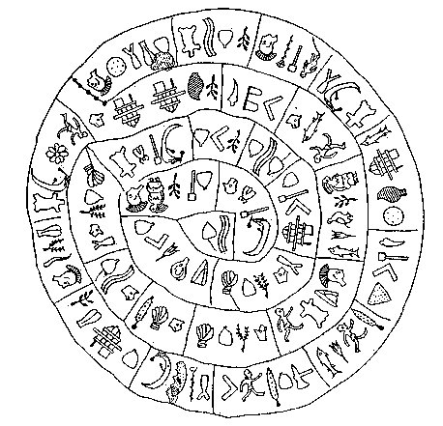

When the priest saw the Pleiades, ideally in November 18 (322, *242), this was not when the Sun had been at ρ in Corona Borealis, for in that evening the rays from the blazing Sun would have made the observation impossible.
... In other words, the ancient Druidic religion based on the oak-cult will be swept away by Christianity and the door - the god Llyr - will languish forgotten in the Castle of Arianrhod, the Corona Borealis. This helps us to understand the relationship at Rome of Janus and the White Goddess Cardea who is ... the Goddess of Hinges who came to Rome from Alba Longa. She was the hinge on which the year swung - the ancient Latin, not the Etruscan year - and her importance as such is recorded in the Latin adjective cardinalis - as we say in English 'of cardinal importance - which was also applied to the four main winds; for winds were considered as under the sole direction of the Great Goddess until Classical times ...

Sumerian SAG | 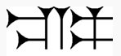 | Phoenician resh | 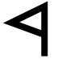 | Greek rho | Ρ (ρ)
... Resh (Arabic: rāۥ) is the twentieth letter of many Semitic alphabets, including Phoenician, Aramaic, Hebrew ... The word resh is usually assumed to have come from a pictogram of a head, ultimately reflecting Proto-Semitic *raۥ(i)š-. The word's East Semitic cognate, rēš-, was one possible phonetic reading of the Sumerian cuneiform sign for 'head' (SAG).
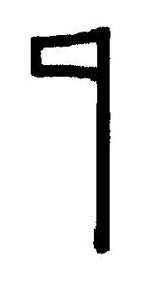
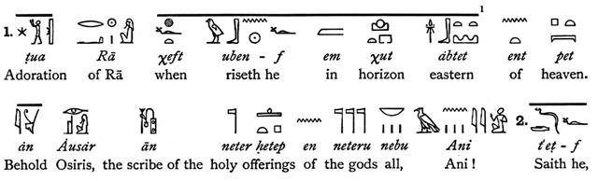
... Then I become aware of ... a presence - a faint, ghostly glimmering, like moonglow, that has appeared on the solstice stone. I don't know how long it lasts, a second or two only I would guess, but while it is there it seems less like a projection - which I know it to be - than something immanent within the stone itself. And it seems to function as a herald for it fades almost as soon as it has appeared and in its place the full effect snaps on - instantaneously. It wasn't there, and then it's there. As Chris had described, the effect does curiously resemble a poleaxe, or a flag on a pole, and consists of a 'shaft',

narrow at the base but widening a little towards the top, running up the left hand side of the solstice stone, surmounted by a right-facing 'head' or 'flag'. An instant later an almond-shaped spot of light, like an eye, appears a few centimeters to the right of the 'flag' and the effect is complete. Weirdly - I do not claim it has any significance - this flag-on-a-pole symbol is the ancient Egyptian hieroglyph neter, meaning 'god', or 'a god' - and not to be understood at all in the Judaeo-Christian usage of that word but rather as a reference to one of the supernatural powers or principles that guide and balance the universe. Manifested here, in this strange Stone Age temple, it glows, as though lit by inner fire ...
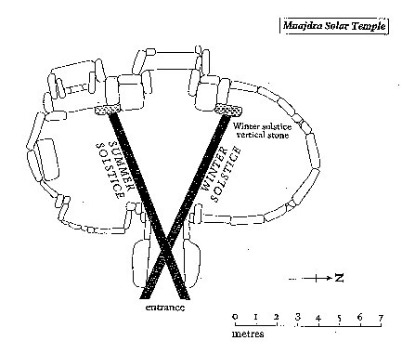
Marija Gimbutas: 'To sleep within the Goddess's womb was to die and to come to life anew'. In a system of reincarnation the old one must die in order to be reborn, of course. At midsummer Sun comes to a standstill, and this must therefore be an occasion when the 'flame of life' had to be transported into a new body.

We should therefore ideally count 16 days (glyphs) backwards from Eb2-1 (43) to 43 - 16 = Eb1-27:

Nov 2 | 3 (*227) | 4
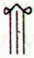 | 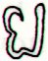 | 
Eb1-27 | Eb1-28 | Eb1-29
te hau tea | ka viri ka taka | ka viri e taka
Viri. 1. To wind, to coil, to roll up; he viri i te hau, to wind, coil a string (to fasten something). 2. To fall from a height, rolling over, to hurl down, to fling down. Viriviri, round, spherical (said of small objects). Viviri te henua, to feel dizzy (also: mimiro te henua). Vanaga. To turn in a circle, to clew up, to groom, to twist, to dive from a height, to roll (kaviri). Hakaviri, crank, to groom, to turn a wheel, to revolve, to screw, to beat down; kahu hakaviri, shroud. Viriga, rolling, danger. Viriviri, ball, round, oval, bridge, roll, summit, shroud, to twist, to wheel round, to wallow. Hakaviriviri, to roll, to round; rima hakaviriviri, stroke of the flat, fisticuff. P Pau.: viriviri, to brail, to clew up; koviriviri, twisting. Mgv.: viri, to roll, to turn, to twist; viviri, to fall to the ground again and again in a fight. Mq.: vii, to slide, to roll, to fall and roll. Ta.: viri, to roll up, to clew up. Viritopa, danger. Mgv.: Viripogi, eyes heavy with sleep. Mq.: viipoki, swooning, vertigo. Churchill. Viti: vili, to pick up fallen fruit or leaves ... In Viti virimbai has the meaning of putting up a fence (mbai fence); viri does not appear independently in this use, but it is undoubtedly homogenetic with Samoan vili, which has a basic meaning of going around; virikoro then signifies the ring-fence-that-goes-about, sc. the moon. In the Maori, aokoro is the cloud-fence ... Churchill 2.
Taka, takataka. Circle; to form circles, to gather, to get together (of people). Vanaga. 1. A dredge. P Mgv.: akataka, to fish all day or all night with the line, to throw the fishing line here and there. This can only apply to some sort of net used in fishing. We find in Samoa ta'ā a small fishing line, Tonga taka the short line attached to fish hooks, Futuna taka-taka a fishing party of women in the reef pools (net), Maori takā the thread by which the fishhook is fastened to the line, Hawaii kaa in the same sense, Marquesas takako a badly spun thread, Mangareva takara a thread for fastening the bait on the hook. 2. Ruddy. 3. Wheel, arch; takataka, ball, spherical, round, circle, oval, to roll in a circle, wheel, circular piece of wood, around; miro takataka, bush; haga takataka, to disjoin; hakatakataka, to round, to concentrate. P Pau.: fakatakataka, to whirl around. Mq.: taka, to gird. Ta.: taa, circular piece which connects the frame of a house. Churchill. Takai, a curl, to tie; takaikai, to lace up; takaitakai, to coil. P Pau.: takai, a ball, to tie. Mgv.: takai, a circle, ring, hoop, to go around a thing. Mq.: takai, to voyage around. Ta.: taai, to make into a ball, to attach. Churchill. Takapu. Mq.: a girdle. Ma.: takapu, the belly. Churchill. Takau. Mgv.: ten pairs. Ta.: toau, id. Mq.: tekau, id. To.: tekau, id. Ma.: tekau, ten. Churchill. Takaure. Fly; horse-fly. Vanaga. A fly; takaure iti, mosquito; takaure marere ke, swarm. Churchill. ... There is a couple residing in one place named Kui and Fakataka. After the couple stay together for a while Fakataka is pregnant. So they go away because they wish to go to another place - they go. The canoe goes and goes, the wind roars, the sea churns, the canoe sinks. Kui expires while Fakataka swims ...
KE KWAN (Cavalry Officer) = β Lupi (226.3), KE KWAN = κ Centauri (226.4), ZUBEN ELAKRIBI (Claw of the Scorpion) = δ Librae (226.8), π¹ Oct. (226.9)  *185.0 = *226.4 - *41.4 = "Sept 22 (265) = equinox | ω Bootis (227.2), NEKKAR (Herdsman) = β Bootis (227.3), σ Librae (227.5), π² Oct. (227.7), NADLAT (Mean Little Ones) = ψ Bootis (227.8), π Lupi (227.9) | 15h (228.3)  ZUBEN HAKRABIM (Claw of the Scorpion) = ν Librae (228.3), λ Lupi (228.9)
ρ Arietis (43.0), GORGONEA SECUNDA = π Persei (43.5), ACAMAR (End of the River) = θ Eridani (43.6), ε Arietis (43.7), λ Ceti (43.9)  DENEBOLA (β Leonis) | MENKAR (The Nose) = α Ceti (44.7) | 3h (45.7)  GORGONEA TERTIA = ρ Persei (45.1), ALGOL (The Demon) = β Persei (45.9)
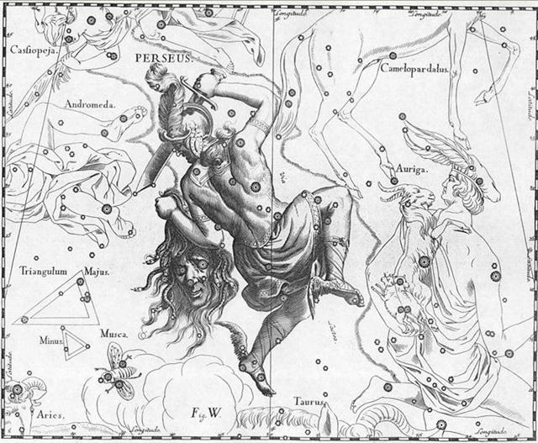

6.1 There is a clear possibility which has to be mentioned here, viz. that the 'feather string' emanating at top right in Eb2-1 represents a kind of feather garland used to demarcate the place for the king:

Nov 18 | 19 | 20 | 21 | 22 | 23 | 24 (*248)
Eb2-1 | Eb2-2 | Eb2-3 | Eb2-4 | Eb2-5 | Eb2-6 (48) | Eb2-7
te maitaki - te maro | Haka  nohoa | e ariki | te tapamea | te henua - tau rakau | no ana ra tau hiva | ko rapai a haga
υ Herculis (242.3), ρ Cor. Borealis (242.4), ι Cor. Borealis (242.5), θ Draconis (242.6), ξ Scorpii (242.7)  SCHEDIR (Breast) α Cassiopeiae  *201.0 = *242.4 - *41.4 | 16h (243.5)  ACRAB (Scorpion) = β Scorpii, JABHAT AL ACRAB (Forehead of the Scorpion) = ω Scorpii (243.3), θ Lupi, RUTILICUS = β Herculis (243.5), MARFIK (Elbow) = κ Herculis (243.7), φ Herculis (243.8) | ψ Scorpii (244.6), LESATH (Sting) = ν Scorpii (244.8) | χ Scorpii (245.1), YED PRIOR (Hand in Front) = δ Ophiuchi, δ Tr. Austr. (245.5) | YED POSTERIOR (Hand Behind) = ε Ophiuchi, RUKBALGETHI SHEMALI (Northern Knee of the Giant) = τ Herculis (246.6). δ Apodis (246.7), ο Scorpii (246.8) | Heart-5 (Fox)  σ Scorpii (247.0), HEJIAN = γ Herculis (247.2), ψ Ophiuchi (247.7) | ρ Ophiuchi (248.1), KAJAM (Club) = ω Herculis (248.3), χ Ophiuchi (248.5), SHE LOW (Market Tower) = υ Ophiuchi, Tr. Austr. (248.7), ζ Tr. Austr. (248.8)
VISIBLE CLOSE TO THE FULL MOON:
λ Tauri (59.3), ν Tauri (59.9) | 4h (60.9)  JĪSHUĬ = λ Persei (60.7)  COR CAROLI (α Canum Ven.) | υ Persei (61.2) | BEID (Egg) = ο¹ Eridani (62.2), μ Persei (62.8)  VINDEMIATRIX ( ε Virginis) | Al Dabarān-2 (The Follower)  HYADUM I = γ Tauri (63.4)  *22.0 = *63.4 - *41.4 | HYADUM II = δ¹ Tauri (64.2) | Net-19 (Crow)  AIN (Eye) = ε Tauri, θ¹ Tauri, θ² Tauri (65.7)
May 19 | 20 (140) | 21 | 22 | 23 | 24 | 25
... The name of the residence (maara noho) of the king, of Hotu, was Oromanga. The name of the place where the roof of the house had been covered [hidden, kona] by Nuku Kehu was Hare Topa (sic!) Tuu.
Nuku Kehu was also in charge of the feather garlands (maro), which served to mark the boundaries of the royal residence. He had pounded (the staffs with the feather garlands) into the ground [he maro tokoa te mee.a Nuku Kehu.i tuki.mai].
The middle (te tini) was located in front of the bay of Hanga Rau [te tini o mua i te hanga.o hanga rau]. The feather garlands went up, continued, and reached Puku Parari [i iri ai te maro.i oho.ai.he tuu ki puku parari]. They went up again and reached Puku O Heha [he iri hokoou he tuu.ki puku o heha].
From Puku O Heha they formed (a line) to the side, to Aro Huri [i hakataha hokoou ai ka aro huri]. From Aro Huri they turned again toward the sea [i hoki hokoou ai.a tai] and reached Maunga Koua [he tuu ki maunga koua], went down, went their way, and reached Hira Moko [he turu he oho.he tuu ki hira moko]. (He) made a second line (? he rua taupa) of feather garlands ... [E:91]
The page numbers in Manuscript E were not chose randomly but instead were used to as pointers. Page 91 surely indicated the number of days in a quarter of a year measuring 364 days.
The breaking of the coco-nut on Hawaii occurred ideally at sunset in November 18 and it was certainly not by chance that the text in Manuscript E at the end of page 90
... Broken is your neck, oh Oto Uta, oh king! Floating (?) like a raft (?) out at sea. To be erected for the drifting huehue (fish) out at sea. Able (?) to put an end to the flight of the flying fish hahave; Able (?) to put an end to the flight of the flying fish ngu; Put an end to this fish, a dorado, with the good face!

7. The natives on Easter Island would certainly have remembered the date when their island was taken over by the Spaniards. They had once upon a time been contacted on Easter Sunday and surely, therefore, the next profound date in the history of the island had also to be significant. At the place of November 20 - according to my reading of the text on the Keiti tablet - there was a King (Ariki) according to Metoro. Possibly he thought of the King of Spain who had changed the name of Easter Island to San Carlos.
E. Ê, yes. E ... é disjunct vocative marker. E vovo é! Girl! E te matu'a é! Father! (Vanaga). 1. By. 2. And. 3. Oh! 4. Yes. 5. Verb sign. 6. Negative verb sign; e maaa, inexperienced; ina e, negative sign; ina e rakerakega, innocent; ina e ko mou, incessant; e ko, not, except. 7. Wave. 8. Weak demonstrative, functioning as article. (Churchill)
Nov 18 | 19 | 20 | 21 (325) | 22 | 23 | 24 (*248)
Eb2-1 | Eb2-2 | Eb2-3 (45) | Eb2-4 | Eb2-5 | Eb2-6 (48) | Eb2-7
te maitaki - te maro | Haka  nohoa | e ariki | te tapamea | te henua - tau rakau | no ana ra tau hiva | ko rapai a haga
υ Herculis (242.3), ρ Cor. Borealis (242.4), ι Cor. Borealis (242.5), θ Draconis (242.6), ξ Scorpii (242.7)  SCHEDIR (Breast) α Cassiopeiae  *201.0 = *242.4 - *41.4 | 16h (243.5)  ACRAB (Scorpion) = β Scorpii, JABHAT AL ACRAB (Forehead of the Scorpion) = ω Scorpii (243.3), θ Lupi, RUTILICUS = β Herculis (243.5), MARFIK (Elbow) = κ Herculis (243.7), φ Herculis (243.8) | ψ Scorpii (244.6), LESATH (Sting) = ν Scorpii (244.8) | χ Scorpii (245.1), YED PRIOR (Hand in Front) = δ Ophiuchi, δ Tr. Austr. (245.5) | YED POSTERIOR (Hand Behind) = ε Ophiuchi, RUKBALGETHI SHEMALI (Northern Knee of the Giant) = τ Herculis (246.6). δ Apodis (246.7), ο Scorpii (246.8) | Heart-5 (Fox)  σ Scorpii (247.0), HEJIAN = γ Herculis (247.2), ψ Ophiuchi (247.7) | ρ Ophiuchi (248.1), KAJAM (Club) = ω Herculis (248.3), χ Ophiuchi (248.5), SHE LOW (Market Tower) = υ Ophiuchi, Tr. Austr. (248.7), ζ Tr. Austr. (248.8)

VISIBLE CLOSE TO THE FULL MOON:
λ Tauri (59.3), ν Tauri (59.9) | 4h (60.9)  JĪSHUĬ = λ Persei (60.7)  COR CAROLI (α Canum Ven.) | υ Persei (61.2) | BEID (Egg) = ο¹ Eridani (62.2), μ Persei (62.8)  VINDEMIATRIX ( ε Virginis) | Al Dabarān-2 (The Follower)  HYADUM I = γ Tauri (63.4)  *22.0 = *63.4 - *41.4 | HYADUM II = δ¹ Tauri (64.2) | Net-19 (Crow)  AIN (Eye) = ε Tauri, θ¹ Tauri, θ² Tauri (65.7)
May 19 | 20 (140) | 21 | 22 | 23 | 24 | 25
I cannot remember that I had thought along these lines when once upon a time I was documenting the birthplace of Metoro. Although I surely ought to have noticed that the 3 crosses on top of 'the parasitic cones Parehe, Teatea, and Vai 'a Heva') were located quite close to where he was born:
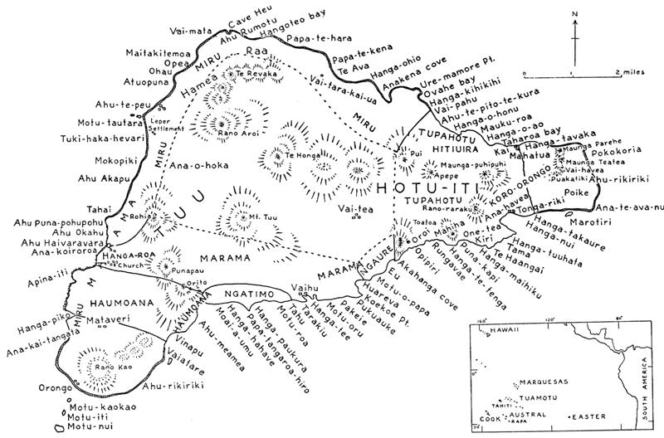
In time-space there were no trivial (irrelevant) dates. Thus they were on common ground the Spaniards and the inhabitants on Easter Island.

And therefore we could now identify the year 1770 as a reflection in the common cosmic implex of self-similarity. It most evidently corresponds to 6 * 29½, i.e. to half a synodic lunar year.
To convince the unbelievers I will point at 241, for according to Fischer Metoro had been one among so many 'to work on the Brander plantation'.
Which we will be able to put in correspondence with the total number of glyphs on the Phaistos Disc.
At top center of the bottom side of the Phaistos Disc we have found the Breast (Schedir which culminated at 21h in November 18) together with its outflow in form of the Milky Way river.
And in the next phase there is ship. Arivers from the outside had to reach Easter Island by boat.
1770 - 1722 = 48.


8. When I recently had to buy hair schampo I encountered difficulties. I searched in vain among all the shelves with every kind of ointments, cures, and medicine pills.
Finally I had to beg for help, and she knew immediately and pointed to a bottle which was of another design and colour than that which I knew and had searched for. The designers had changed everything. I wonder how many previous customers they had lost.
At home I looked closer and the colour of the schampo bottle was a pure white with a pair of labels in a light bluegrey colour. I could read that the ingredients had changed too, and now the viscius fluid inside was based on coco-nut oil.
This made me realize why they in November 18 on Hawaii had connected the return of the Pleiades to visibility with Breaking of the Coconut:
... The correspondence between the winter solstice and the kali'i rite of the Makahiki is arrived at as follows: ideally, the second ceremony of 'breaking the coconut', when the priests assemble at the temple to spot the rising of the Pleiades, coincides with the full moon (Hua tapu) of the twelfth lunar month (Welehu). In the latter eighteenth century, the Pleiades appear at sunset on 18 November. Ten days later (28 November), the Lono effigy sets off on its circuit, which lasts twenty-three days, thus bringing the god back for the climactic battle with the king on 21 December, the solstice (= Hawaiian 16 Makali'i). The correspondence is 'ideal' and only rarely achieved, since it depends on the coincidence of the full moon and the crepuscular rising of the Pleiades ...
Of course! Such a nut will, if it is broken, generate a milky fluid similar to that from a woman's breast! Both were cues for thinking of the Milky Way.
Therefore the culmination (at 21h) of the star named Breast (viz. Schedir in Cassiopeia) had to coincide with November 18.
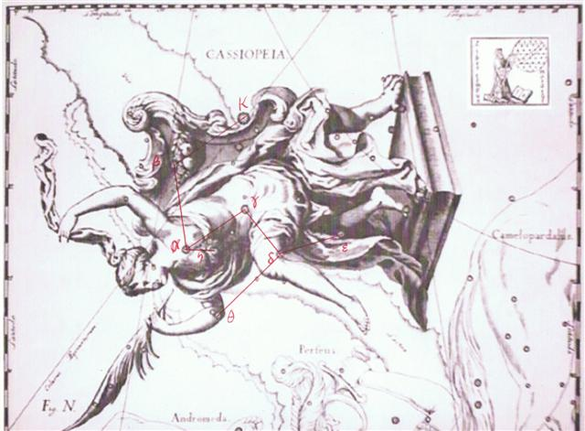

On the islands of Polynesia it would have been quite natural to relate a milky white fluid with coconut milk from their great Niu trees.
The druids had for their part instead the Oak as their world tree. And up at its top end was a very curious growth:
... Hercules first appears in legend as a pastoral sacred king and, perhaps because shepherds welcome the birth of twin lambs, is a twin himself. His characteristics and history can be deduced from a mass of legends, folk-customs and megalithic monuments. He is the rain-maker of his tribe and a sort of human thunder-storm. Legends connect him with Libya and the Atlas Mountains; he may well have originated thereabouts in Palaeolithic times. The priests of Egyptian Thebes, who called him Shu, dated his origin as 17,000 years before the reign of King Amasis.
He carries an oak-club, because the oak provides his beasts and his people with mast and because it attracts lightning more than any other tree. His symbols are the acorn; the rock-dove, which nests in oaks as well as in clefts of rocks; the mistletoe, or Loranthus; and the serpent. All these are sexual emblems. The dove was sacred to the Love-goddess of Greece and Syria; the serpent was the most ancient of phallic totem-beasts; the cupped acorn stood for the glans penis in both Greek and Latin; the mistletoe was an all-heal and its names viscus (Latin) and ixias (Greek) are connected with vis and ischus (strength) - probably because of the spermal viscosity of its berries, sperm being the vehicle of life.
This Hercules is male leader of all orgiastic rites and has twelve archer companions, including his spear-armed twin, who is his tanist or deputy. He performs an annual green-wood marriage with a queen of the woods, a sort of Maid Marian. He is a mighty hunter and makes rain, when it is needed, by rattling an oak-club thunderously in a hollow oak and stirring a pool with an oak branch - alternatively, by rattling pebbles inside a sacred colocinth-gourd or, later, by rolling black meteoric stones inside a wooden chest - and so attracting thunderstorms by sympathetic magic ...
In the Mayan Popol Vuh the idea is described similarly:
... I do want it, said the maiden. Very well. Stretch out your right hand here, so I can see it, said the bone. Yes, said the maiden. She stretched out her right hand, up there in front of the bone. And then the bone spit out its saliva, which landed squarely in the hand of the maiden.
And then she looked in her hand, she inspected it right away, but the bone's saliva wasn't in her hand. It is just a sign I have given you, my saliva, my spittle. This, my head, has nothing on it - just bone, nothing of meat. It's just the same with the head of a great lord: it's just the flesh that makes his face look good. And when he dies, people get frightened by his bones. After that, his son is like his saliva, his spittle, in his being, whether it be the son of a lord or the son of a craftsman, an orator. The father does not disappear, but goes on being fulfilled. Neither dimmed nor destroyed is the face of a lord, a warrior, craftsman, an orator. Rather, he will leave his daughters and sons. So it is that I have done likewise through you. Now go up there on the face of the earth; you will not die. Keep the word. So be it, said the head of One and Seven Hunaphu - they were of one mind when they did it ...

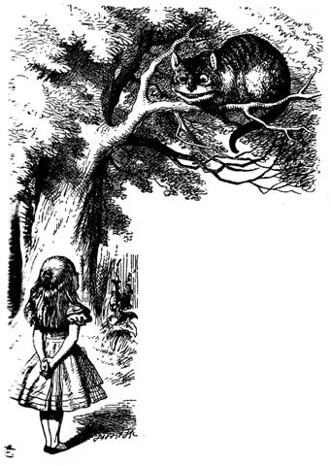

9. I had initially written - which always will be possible to read in the file named INDEX.doc - when I was standing on the platform of Level 5 at the beginning of Aa7-9--71:
... We proceed one step further, now with what I imagine may be another calendar of the year. It will, however, be more complicated than before. There are no parallel texts and there are many strange glyphs, typical for Tahua ...
Now, around 20 years later, in AD 2024 when reviewing what I once upon a time had written, I found it necessary to change this into:
... There are no immediately obvious parallel texts ...
I had to make this change because since AD 2005 it had gradually become quite clear that the text on Small Santiago Tablet (R) was parallel to a part of the long text on the A (Tahua) tablet. Later it also became obvious that the structure of the text on the Aruku Kurenga (B) tablet was quite similar to that of the text on the A tablet.
The identity of time is movement.
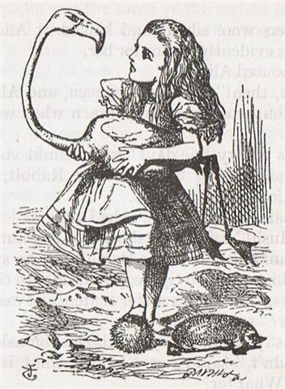

... Alice thought she had never seen such a curious croquet ground in her life: it was all ridges and furrows: the croquet balls were live hedgehogs, and the mallets live flamingoes, and the soldiers had to double themselves up and stand on their hands and feet, to make the arches. The chief difficulty Alice found at first was in managing her flamingo: she succeeded in getting its body tucked away, comfortably enough, under her arm, with its legs hanging down, but generally, just as she had got its neck nicely straightened out, and was going to give the hedgehog a blow with its head, it would twist itself around and look up in her face, with such a puzzled expression that she could not help bursting out laughing; and, when she had got its head down, and was going to begin again, it was very provoking to find that the hedgehog had unrolled itself, and was in the act of crawling away: besides all this, there was generally a ridge or a furrow in the way wherever she wanted to send the hedgehog to, and, as the doubled-up soldiers were always getting up and walking off to other parts of the ground, Alice soon came to the conclusion that it was a very difficult game indeed ...

10. Inspiration suddenly offered me a possible solution to the enigmatic manu mata e toru ('beast' with 3 'eyes'):
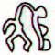 | 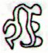
Bb5-14 | Bb6-25
ko te manu mata e toru | etoru mata oona
The new idea was generated from thinking about my presentation table for Level 6 and my suggestion there that there was a Matariki year in H/P/Q connected with my glyph type named maitaki:
maitaki
Matariki refers to the Pleiades and maitaki seems to imply 'very good' (→ the Doublegood Pair = Gemini).
... In Hindu legend there was a mother goddess called Aditi, who had seven offspring. She is called 'Mother of the Gods'. Aditi, whose name means 'free, unbounded, infinity' was assigned in the ancient lists of constellations as the regent of the asterism Punarvasu. Punarvasu is dual in form and means 'The Doublegood Pair'. The singular form of this noun is used to refer to the star Pollux. It is not difficult to surmise that the other member of the Doublegood Pair was Castor ...
In this type of glyph the normal case exhibits 3 (toru) 'eyes' (mata) both to the left and to the right.
And the Hindu stated the Pleiades had 6 stars (not 7). Supposing each one of these half-seen 'eyes' basically were intended to depict a day - and not a month as I previously have contemplated. This would then be a more reasonable explanation for the case of the time when the pharaoh could not be seen:
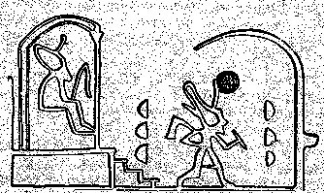

... The king, wearing now a short, stiff archaic mantle, walks in a grave and stately manner to the sanctuary of the wolf-god Upwaut, the 'Opener of the Way', where he anoints the sacred standard and, preceded by this, marches to the palace chapel, into which he disappears. A period of time elapses during which the pharaoh is no longer manifest ...
The number of stars in the Pleiades was normally perceived as 7 - although one of them was unfortunate in having married a mortal:
... To a casual glance, the Pleiades cluster appears as a fuzzy patch like a swarm of flies over the back of the bull ... According to mythology, Alcyone and Celaeno were both seduced by Poseidon. Maia, the eldest and most beautiful of the sisters, was seduced by Zeus and gave birth to Hermes; she later became foster-mother to Arcas, son of Zeus and Callisto. Zeus also seduced two others of the Pleiades: Electra, who gave birth to Dardanus, the founder of Troy; and Taygete, who gave birth to Lacedaemon, founder of Sparta. Asterope was ravished by Ares and became mother of Oenomaus, king of Pisa, near Olympia, who features in the legend of Auriga. Hence six Pleiades became paramours of the gods. Only Merope married a mortal, Sisyphus, a notorious trickster who was subsequently condemned to roll a stone eternally up a hill ...
The odd (unlucky) number 7 could have been avoided by forcefully stating that there were only 6 stars in the Pleiades:
... The Mahabharata insists on six as the number of the Pleiades as well as of the mothers of Skanda and gives a very broad and wild description of the birth and the installation of Kartikeya 'by the assembled gods ... as their generalissimo', which is shattering, somehow, driving home how little one understands as yet. The least which can be said, assuredly: Mars was 'installed' during a more or less close conjunction of all planets; in Mbh. 9.45 (p. 133) it is stressed that the powerful gods assembled 'all poured water upon Skanda, even as the gods had poured water on the head of Varuna, the lord of waters, for investing him with dominion'. And this 'investiture' took place at the beginning of the Krita Yuga, the Golden Age ...
A separation of 7 into a pair of integer halves was not possible. And in the first night of the Moon she could not be seen, because the light from Tane was at her back side in order to rejuvenate her.
...when the new moon appeared women assembled and bewailed those who had died since the last one, uttering the following lament: 'Alas! O moon! Thou has returned to life, but our departed beloved ones have not. Thou has bathed in the waiora a Tane, and had thy life renewed, but there is no fount to restore life to our departed ones. Alas' ...
This idea could have been transferred to the cycle of the Sun. And the Sirius year was begining 6 (not 7) days after Canopus. 175 + 6 = 181. When the face of the new moon was sooty black it could have suggested that also day 181 - 3 = 178 might be in shadow, because 2 * 178 = 356 = the day after day 355 (December 21, the day of solstice). 177 = 6 * 29½.

... it seems fitting to begin a discussion of the Sun by first considering the period during which it is not visible. It is at this time, paradoxically, that the Sun is most obvious, for its absence has the understandable effect of stimulating an increasingly grateful awareness about its existence, together with a growing impatience for its return ...
... The Sun and the Moon were siblings - a brother and a sister - without parents. Siqiniq (the Sun) was staying all alone in an igloo. The camp would hold festivities in the qaggiq. One day, as usual, they started to hold a qaggiq early in evening when it was dark. Someone rushed into Siqiniq's igloo and blew out her qulliq at the same time. She was then pinned down and molested. This happened a number of times and Siqiniq was unable to find out who her attacker was. Her cooking pot always hung over her qulliq. When her attacker came again, she reached out and tried to touch the pot but her lamp was out and it was completely dark. Finally she managed to touch the pot. She then wiped her sooty hands on the face of her aggressor. After she had been molested once again the aggressor left her igloo. She followed him to see where he would go, hoping to finally find out who he was. She saw him going to the qaggiq where the festivities were being held. As she neared it she could hear people laughing. Someone was saying: 'Taqqiq inutuarsiurasumut aasit naatavinaaluk'. - Taqqiq (the Moon) has been marked with soot as he has again been looking for someone who might have been alone. So Siqiniq entered the qaggiq and saw that her brother's face was covered with soot. Embarrased and angry, she took her breast, cut it off and offered it to her brother saying that, as he liked all of her so much, why not eat her breast as well. Her brother refused the breast, but she continued to offer it. Then they both lit torches and ran out of the qaggiq. Siqiniq followed, breast in hand, still offering it to her brother. As she chased her brother around the qaggiq, Taqqiq fell down, extinguishing the flame on his torch, leaving only smouldering embers. Siqiniq's torch continued to burn brightly. Soon they both went up to the sky where the sister became Siqiniq, the Sun, while her brother became Taqqiq, the Moon ...
Therefore manu mata etoru could have been a way to illustrate how the head of this not yet awake 'bird' corresponded to such a dark day.
Although the 3 eyes back to back in the maitaki type of glyph might possibly have been perceived as beginning with 3 black days (when only cold food was served), because they were reversed as in the illustration above with pharaoh in the middle:
... In China, every year about the beginning of April, certain officials called Sz'hüen used of old to go about the country armed with wooden clappers. Their business was to summon the people and command them to put out every fire. This was the beginning of the season called Han-shih-tsieh, or 'eating of cold food'. For three days all household fires remained extinct as a preparation for the solemn renewal of the fire, which took place on the fifth or sixth day after the winter solstice ...
Usually the Sun year should be measured as 360 + 5 = 365 days, but a leap year should be counted as 360 + 6 days.

... Nut, whom the Greeks sometimes identified with Rhea, was goddess of the sky, but it was debatable if in historical times she was the object of a genuine cult. She was Geb's twin sister and, it was said, married him secretly and against the will of Ra. Angered, Ra had the couple brutally separated by Shu and afterwards decreed that Nut could not bear a child in any given month of any year. Thoth, Plutarch tells us, happily had pity on her. Playing draughts with the Moon, he won in the course of several games a seventy-second part of the Moon's light with which he composed five new days. As these five intercalated days did not belong to the official Egyptian calendar of three hundred and sixty days, Nut was thus able to give birth successively to five children: Osiris, Haroeris (Horus), Set, Isis and Nepthys ...:
Furthermore, the Sirius year according to the Julian and Gregorian calendars was a modern type of Sun oriented year and not a year measuring 364 days.
... 'a day and a year' can be equated with the Thirteen Prison Locks that guarded Elphin, if each lock was a 28-day month and he was released on the extra day of the 365. The ancient common-law month in Britain, according to Blackstone's Commantaries (2, IX, 142) is 28 days long, unless otherwise stated, and a lunar month is still popularly so reckoned, although a true lunar month, or lunation, from new moon to new moon, is roughly 29½ days long, and though thirteen is supposed to be an unlucky number ...
... Ancient calendar-makers seem to have interposed the day which had no month, and was therefore not counted as part of the year, between the first and last of their artificial 28-day months: so that the farmer's year lasted, from the calendar-maker's point of view, literally a year and a day ...

Therefore there should no longer be any black day between Canopus and Sirius. Which was much to the good.
maitaki

10a. It could be added that the eye of a crocodile (at the surface of the water) might have inspired the design with an eye divided vertically:
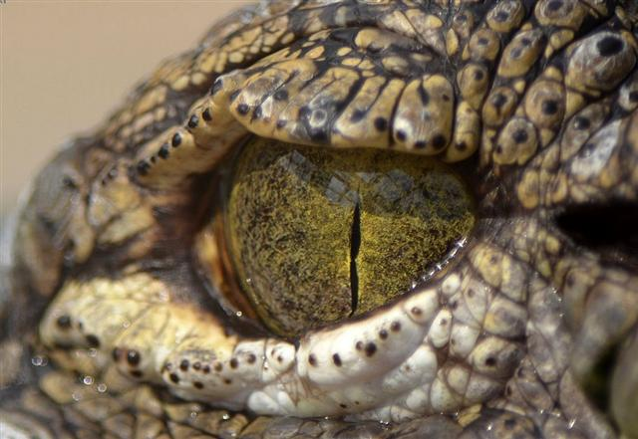
The Chinese list has the star which the Polynesians said was in the middle (Ana-roto, Spica) at its beginning and as a key word they had the suggestion 'Crocodile'.
The pharaoh was evidently in the middle when he was inside the palace chapel, and the idea seems to have been that he should be given permission to carry on:
... When he reappears he is clothed as in the Narmer palette, wearing the kilt with Hathor belt and bull's tail attatched. In his right hand he holds the flail scepter and in his left, instead of the usual crook of the Good Shepherd, an object resembling a small scroll, called the Will, the House Document, or Secret of the Two Partners, which he exhibits in triumph, proclaiming to all in attendance that it was given him by his dead father Osiris, in the presence of the earth-god Geb. 'I have run', he cries, 'holding the Secret of the Two Partners, the Will that my father has given me before Geb. I have passed through the land and touched the four sides of it. I traverse it as I desire.' ...
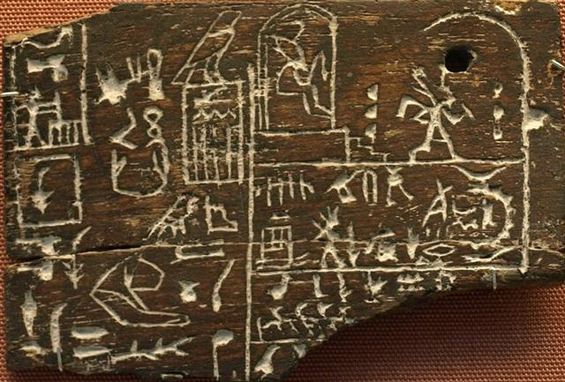
Inside the palace chapel it was dark - this we can deduce from the fact that the wood of the inscribed tablet was ebenholz. Furthermore, the headgear of pharaoh was in touch with a hole through the wood leading to the opposite side. Through holes located at the horizon the winds of change were arriving.

The left (back) side was in the shadows in contrast to the front side:
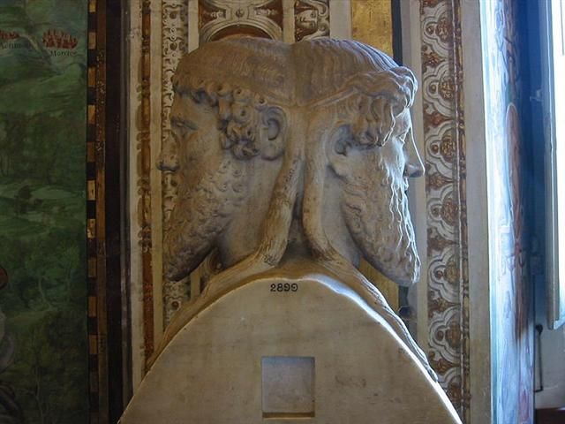
As a kind of windfall from my recent revision of the H tablet we have been given the tables below:
... In other words, the ancient Druidic religion based on the oak-cult will be swept away by Christianity and the door - the god Llyr - will languish forgotten in the Castle of Arianrhod, the Corona Borealis. This helps us to understand the relationship at Rome of Janus and the White Goddess Cardea who is ... the Goddess of Hinges who came to Rome from Alba Longa. She was the hinge on which the year swung - the ancient Latin, not the Etruscan year - and her importance as such is recorded in the Latin adjective cardinalis - as we say in English 'of cardinal importance - which was also applied to the four main winds; for winds were considered as under the sole direction of the Great Goddess until Classical times. As Cardea she ruled over the Celestial Hinge at the back of the North Wind around which, as Varro explains in his De Re Rustica, the mill-stone of the Universe revolves. This conception appears most plainly in the Norse Edda, where the giantesses Fenja and Menja, who turn the monstrous mill-stone Grotte in the cold polar night, stand for the White Goddess in her complementary moods of creation and destruction. Elsewhere in Norse mythology the Goddess is nine-fold: the nine giantesses who were joint-mothers of the hero Rig, alias Heimdall, the inventor of the Norse social system, similarly turned the cosmic mill ...

Cfr the sign of wind (matagi) in front at glyph number 136 (presumably alluding to day 136, May 16, when the Sun rose together with Alcyone in the Pleiades):
2b
APRIL 26 (116) | 27 | 28 (236 / 2) | 29 | 30 | MAY 1 (121)
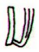 | 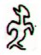 | 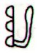 | 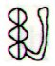 | 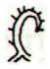 | 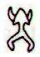
Hb3-36 (136) | Hb3-37 | Hb3-38 | Hb3-39 | Hb3-40 | Hb3-41 (141)
MEBSUTA | *101 | *102 | ALHENA | *104 | ω Gemini (*105.4)
June 29 (180) | 30 | July 1 (118 + 64) | 2 | 3 | NUNKI (*288.4)
Here we can read that in July 1 - the day after Sirius - there were 3 'eyes' (mata etoru) in the past. In front, in contrast, was a sign of general potency (as I can recall from what Barthel has suggested). Clearly it is similar to the sign that was used at Ca6-22 for the night of Ohiro (Mercury):
 | 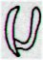
July 1 | Ca6-22
And then the same glyph arrives once again at day 80 + 124 = 204, i.e. 22 days later in July 23 (181 + 23 = 204):
3b
MAY 19 | 20 (→ 413 - 273) | 21 (141) | 22 | 23
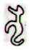 | 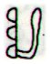 | 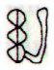 | 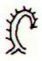 | 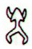
Hb4-12 | Hb4-13 (→ 14 * 29½) | Hb4-14 (141 + 20) | Hb4-15 | (147 + 16 = 163)
*123 | AL TARF | BRIGHT FIRE | *126 | *127 (= 143 + 64 - 80)
July 22 | 23 (80 + 124 = 204) | 24 | 25 | July 26 (207)

July 23 is the day after July 22 which date could be perceived as a sign for the end of a cycle as meassured out by π (because July 22 could be written 22 / 7).
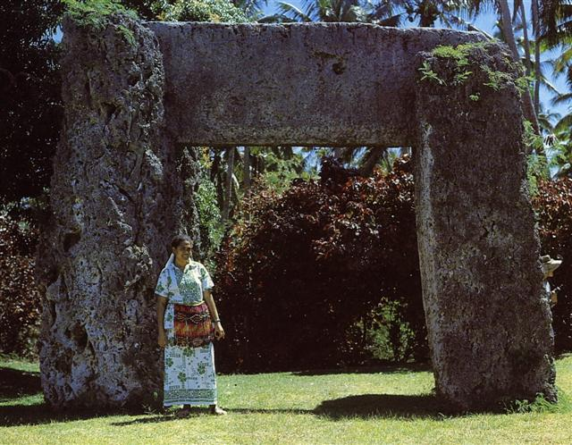
... About Carmenta we know from the historian Dionysus Periergetis that she gave orcales to Hercules and lived to the age of 110 years. 110 was a canonical number, the ideal age which every Egyptian wished to reach and the age at which, for example, the patriarch Joseph died. The 110 years were made up of twenty-two Etruscan lustra of five years each; and 110 years composed the 'cycle' taken over from the Etruscans by the Romans. At the end of each cycle they corrected irregularities in the solar calendar by intercalation and held Secular Games. The secret sense of 22 - sacred numbers were never chosen haphazardly - is that it is the measure of the circumference of the circle when the diameter is 7. This proportion, now known as pi, is no longer a religious secret; and is used today only as a rule-of-thumb formula, the real mathematical value of pi being a decimal figure which nobody has yet been able work out because it goes on without ever ending, as 22 / 7 does, in a neat recurring sequence. Seven lustra add up to thirty-five years, and thirty-five at Rome was the age at which a man was held to reach his prime and might be elected Consul ...

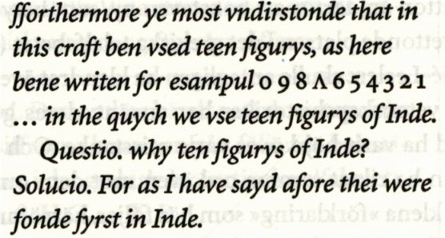

The star names The End (Al Tarf) and Bright Fire could allude to 413 (= 14 * 29½) respectively to 414 ('one more').

We should notice that the triplet of 'walking sky' glyphs are arriving 3 days later in both instances - which suggests the subject matter is the night sky (ragi). 360 / 2 = 6 * 29½ + 3.
1b | *25 | 2b | *22 | 3b
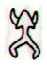 | *25 |  | *22
Hb3-16 (116) | *25 | Hb3-41 (141) | *22 | Hb4-16 (163)
ELNATH (*80) | *25 | ω Gemini (*105.4) | *22 | ο Ursae Majoris (*127.4)
APRIL 6 (96 = 80 + 16) | *25 | MAY 1 (*41) | *22 | MAY 23 (*63)
"April 29 (119, *39) | *25 | "May 24 (144) | *22 | "June 15 (166)
June 9 (160, *80) | *25 | July 4 (185 = 121 + 64) | *22 | July 26 (207)
48

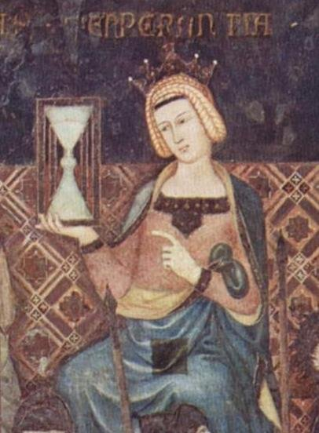

10b. The ancient Egyptians had 4 gods supporting their night sky:
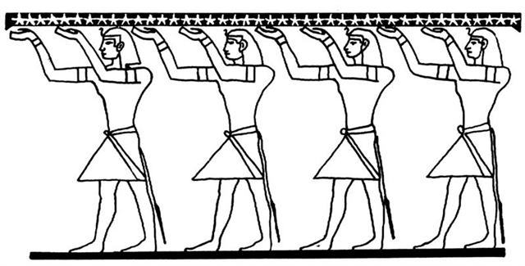
Perhaps these gods were born by Nut (the Night), viz. in those 4 nights which corresponded to the difference between 364 and 360.
... Another name for Mercury was Hermes and Hermes Trismegisthos (thrice-mighty) could have referred to the fact that there were 3.141 * 115.88 = 364.0 days for the cycle of the Earth around the Sun. Although the calendar has 365 days for a year this is due to the fact that the Earth has to turn around an extra day in order to compensate for how the direction to the Sun changes during a year ...
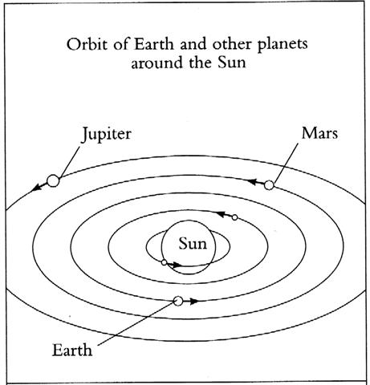

In the illustration at top above the star roof carries 42 stars. → 360 + 4 + 42 = 406 = 366 + 40.
Also the Mayas had 4 sky supporters, viz. their Bacabob:
... Among the multitude of gods worshipped by these people [the Maya] were four whom they called by the name Bacab. These were, they say, four brothers placed by God when he created the world at its four corners to sustain the heavens lest they fall . . In the ms. Ritual of the Bacabs, the cantul kuob [the suffix '-ob' indicates plural], cantul bacabob, the four gods, the four bacabs, occur constantly in the incantations, with the four colors, four directions, and their various names and offices ...
4 * 91 = 364.
Day number 406 (360 + 4 + 42) - 366 was February 9 (31 + 9 = 40, *325 = *365 - *40), which date was halfway to 0h and which could be spelled as 2-9 (→ 29 → the dark night of Ohiro in the Moon cycle). We can compare with the expression 'forty days and forty nights'.
... On February 9 the Chorti Ah K'in, 'diviners', begin the agricultural year. Both the 260-day cycle and the solar year are used in setting dates for religious and agricultural ceremonies, especially when those rituals fall at the same time in both calendars. The ceremony begins when the diviners go to a sacred spring where they choose five stones with the proper shape and color. These stones will mark the five positions of the sacred cosmogram created by the ritual. When the stones are brought back to the ceremonial house, two diviners start the ritual by placing the stones on a table in a careful pattern that reproduces the schematic of the universe. At the same time, helpers under the table replace last year's diagram with the new one.
They believe that by placing the cosmic diagram under the base of God at the center of the world they demonstrate that God dominates the universe. The priests place the stones in a very particular order. First the stone that corresponds to the sun in the eastern, sunrise position of summer solstice is set down; then the stone corresponding to the western, sunset position of the same solstice. This is followed by stones representing the western, sunset position of the winter solstice, then its eastern, sunrise position. Together these four stones form a square. They sit at the four corners of the square just as we saw in the Creation story from the Classic period and in the Popol Vuh. Finally, the center stone is placed to form the ancient five-point sign modern researchers called the quincunx ...

And in April 25 (115 → Hermes Trismegisthos, Mercury, Ohiro) - which came 75 (→ 350 / 4) days later - the diviners for the Chorti indians continued:their sacred duties. At midnight in April 25 (115) these diviners were beginning to raise their square sky, presumably represented in the form of a square piece of cloth:

... Later on in this series of rituals, the Chorti go through a ceremony they call raising the sky. This ritual takes place at midnight on the twenty-fifth of April and continues each night until the rains arrive. In this ceremony two diviners and their wives sit on benches so that they occupy the corner positions of the cosmic square. They take their seats in the same order as the stones were placed, with the men on the eastern side and the women on the west. The ritual actions of sitting down and lifting upward are done with great precision and care, because they are directly related to the actions done by the gods at Creation. The people represent the gods of the four corners and the clouds that cover the earth. As they rise from their seats, they metaphorically lift the sky. If their lifting motion is uneven, the rains will be irregular and harmful ...

According to the ancient Mesopotamians there was only one planet which could be associated with spring equinox, viz. Nabū:
... Ganz ähnlich is der Name 'Gott von Duazag' des Gottes Nabū ... zu erklären. Er bezeichnet ihn als den Gott des Wachtstums, welches als aus dem Osten stammend betrachtet wird, weil die Sonne, die das Wachstum bringt, im Osten aufgeht. Dass aber Nabū als Ost-Gott aufgefasst wurde, hängt damit zusammen, dass sein Stern, der Mercur, nur im Osten oder Westen sichtbar ist ...

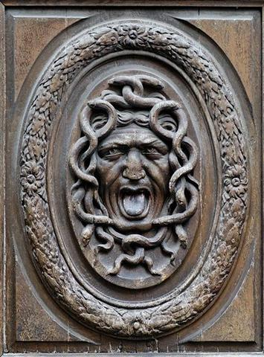
3.141 (π) * 115.88 (synodic cycle of Mercury) = 364.0 and with 22 implying 22 / 7 = 3.14 → π
... The secret sense of 22 - sacred numbers were never chosen haphazardly - is that it is the measure of the circumference of the circle when the diameter is 7. This proportion, now known as pi, is no longer a religious secret; and is used today only as a rule-of-thumb formula, the real mathematical value of pi being a decimal figure which nobody has yet been able work out because it goes on without ever ending, as 22 / 7 does, in a neat recurring sequence. Seven lustra add up to thirty-five years, and thirty-five at Rome was the age at which a man was held to reach his prime and might be elected Consul ...
we can figure out that the strangely curved figure looking back (into his past) should be Mercury. His sprirg season is ending and another season will begin:

3b
MAY 19 | 20 (→ 413 - 273) | 21 (141) | 22 | 23
Hb4-12 | Hb4-13 (→ 14 * 29½) | Hb4-14 (141 + 20) | Hb4-15 | (147 + 16 = 163)
*123 | AL TARF | BRIGHT FIRE | *126 | *127 (= 143 + 64 - 80)
July 22 | 23 (80 + 124 = 204) | 24 | 25 | July 26 (207)

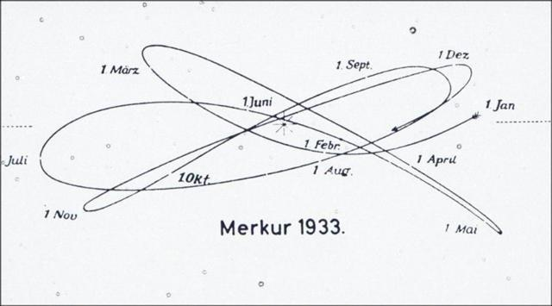

10c. As to the bird looking back in June 30 (when Sirius was bound to rise together with the Sun);
2b
APRIL 26 (116) | 27 | 28 (236 / 2) | 29 | 30 | MAY 1 (121)
Hb3-36 (136) | Hb3-37 (36 + 101) | Hb3-38 | Hb3-39 | Hb3-40 | Hb3-41 (141)
MEBSUTA | SIRIUS | *102 | ALHENA | *104 | ω Gemini (*105.4)
June 29 (180) | 30 | July 1 (118 + 64) | 2 | 3 | NUNKI (*288.4)
we surely ought to go back in time to Hb1-36, i.e. to the place in time-space 101 right ascension days earlier.
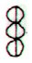 | 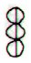 | 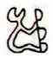 | 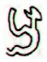 | 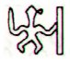 | 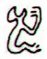 |  | 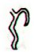
Hb1-33 | Hb1-34 | Hb1-35 | Hb1-36 | Hb1-37 | Hb1-38 | Hb1-39 | Hb1-40
*363 | *364 | SIRRAH | *1 | *2 | *3 | *4 | *5
March 19 (78) | 20 (444) | 0h | 22 | 23 | 24 | 25 (84) | 26 (450)
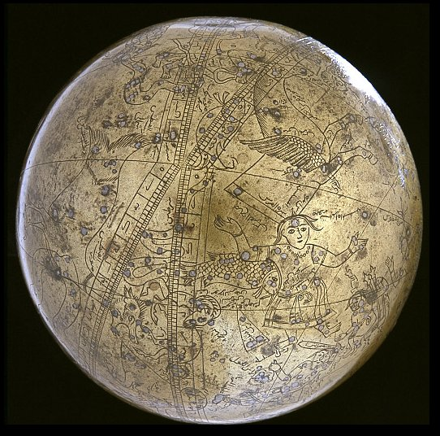

4 * 101 = 404 = 354 + 50. And from Sirrah to Spica there were twice 101 days:
SIRRAH | ALGENIB PEGASI | *99 | MEBSUTA |  | SIRIUS | 181 + 1 | *99 | 181 + 101 = 282 `= 2 * 141
Hb1-35 | Hb1-36 | *99 | Hb3-36 (136) |  | Hb3-37 (137) | Hb3-38 | *99 | Hb5-40 (238)
March 21 (0h) | 22 | *99 | June 29 |  | 30 | July 1 | *99 | SPICA
The glyph at July 1 (182) could evidently be expressing the reversal of the glyph at March 21 (80). In between was the season when the sky roof steadily was beeing raised higher and higher. Thus this triplet of half-seen 'eyes' (mata e toru) in Hb1-35 seems to illustrate the very special quarter of the year when the Sun would be shining high and bright, a season which all regarded as very good (maitaki).
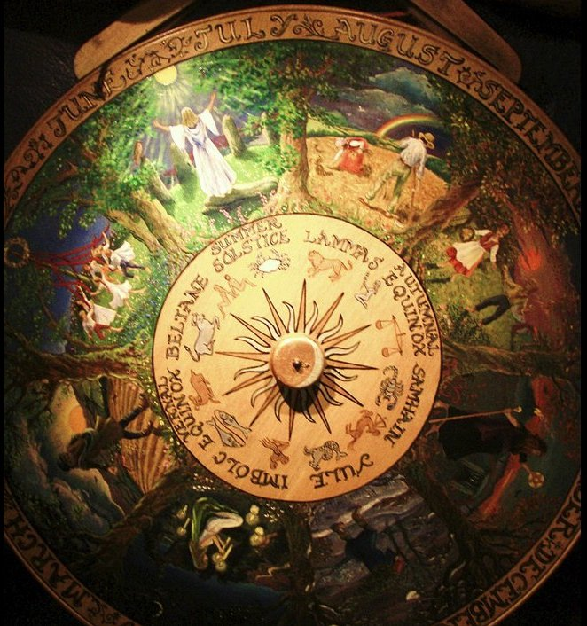

Maitaki. Clean, neat, pure, pretty, nice, beautiful, handsome; tagata rima maitaki, clean-handed man, correct man. Vanaga. 1. Good. Henua maitaki = the good earth. 2. Shine. Marama maitaki = the shining moon. Barthel. Ce qui est bon. Jaussen according to Barthel. Meitaki, good, agreeable, efficacious, excellent, elegant, pious, valid, brilliant, security, to please, to approve (maitaki); ariga meitaki, handsome, of pleasant mien; mea meitaki ka rava, to deserve; meitaki ke, marvelous, better. Hakameitaki, to make good, to amend, to do good, to bless, to establish. Meitakihaga, goodness. PS Pau.: maitaki, good. Mgv.: meitetaki, beautiful, good. Mq.: meitai, good, agreeable, fit, wise, virtuous. Ta.: maitaiki, good, well. Niuē: mitaki, good. Maitakia, clean. Churchill.

Then came the rain clouds caused by the Sun reaching Sirius.
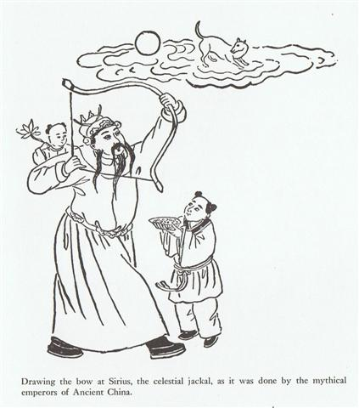

And from there was the decline which ended at Spica in the constellation of the Virgin - below the ecliptic plane down into Mother Earth as if a planted acorn..

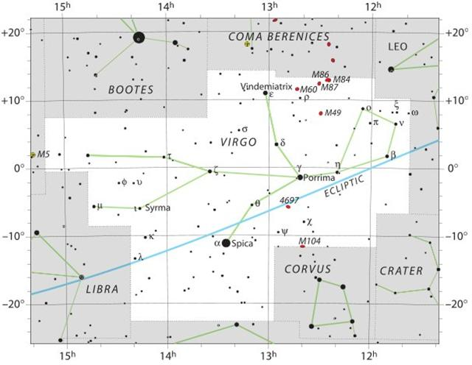

10d. Thus we can interpret the pair in the H text as representing the pair of border lines for the maitaki season, the first marking the beginning of this season when the Sun should be moving upwards (which explains the orientation of the sign) and the 2nd when the Sun was at his apex (straight above):
maitaki

 | *101
March 21 (80) | *101 | July 1 (182)

From this perspecitve we could then guess a maitaki season might also begin and end at Bb5-14 respectively at Bb6-25 - where the 'bird' is very old according to the length and curvature of his beak (in contrast to his short juvenile beak at the beginning):
 | *51
Bb5-14 (177) | *51 | Bb6-25 (228)
ko te manu mata e toru | *51 | etoru mata oona
It is easy to guess that 5-14 might refer (or allude) to May 14 (134), in which case 6-25 ought to correspond to day 134 + 51 = 185 (July 4). The basic meaning of the moe type of glyph seems to be 'on the verge of coming awake'.
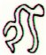
moe

At left in Bb5-14 we can see a standing man with no arm in front, which I guess might refer to Mars:
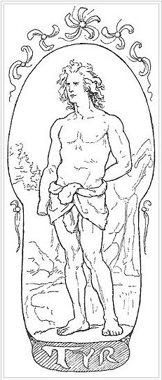
Tuesday means the day of Tyr, who had lost his arm in the mouth of the wolf Fenrir:
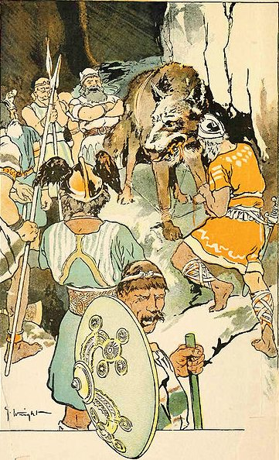

... The king, wearing now a short, stiff archaic mantle, walks in a grave and stately manner to the sanctuary of the wolf-god Upwaut, the 'Opener of the Way', where he anoints the sacred standard and, preceded by this, marches to the palace chapel, into which he disappears. A period of time elapses during which the pharaoh is no longer manifest ...
In the Chinese star list their 15th station (out of a total of 28) was named Legs, and above we can see that Fenrir has allowed his legs to be bound together (in order to stop him from moving) because Tyr had put his right hand into is mouth as a security for him.
The position of the Chinese Legs station was April 1 (91), which allows me to suggest the following dates:
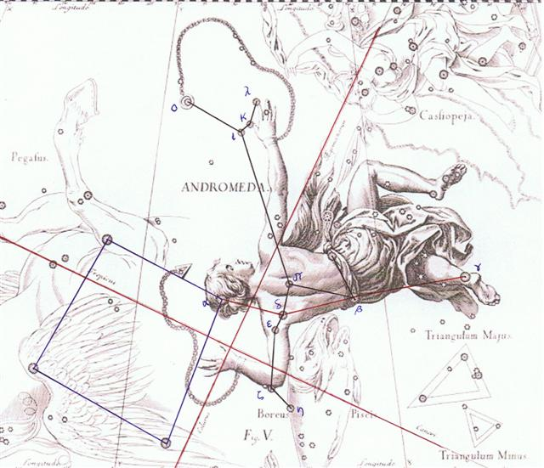
 | *51
Bb5-14 (177) | *51 | Bb6-25 (228)
ko te manu mata e toru | *51 | etoru mata oona
April 1 (*11) | *51 | May 22 (*62)
η Andromedae (*11.4) | *51 | BEID

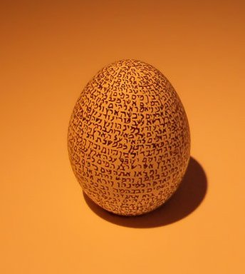

10e. In order to secure this interpretation as correct, we must then try to connect it with earlier documentations.
 | *51
Bb5-14 (177) | *51 | Bb6-25 (228)
ko te manu mata e toru | *51 | etoru mata oona
April 1 (*11) | *51 | May 22 (*62)
η Andromedae (*11.4) | *51 | BEID
I guess etoru mata oona might mean the negative (reverse) of etoru mata, for although I have no definitive documentation in my Polynesian word list regarding oona there seems to be an aura of negation and being careful:
Ata 1. Dawn, first light before sunrise; ku-hamu-á te ata, dawn has broken; ku-tehe-á te ata, it's already dawn (lit.: the lights have flown). 2. Particle inserted between the imperative prefix ka and the verb to signify 'well, carefully, intelligently': ka-ata-hakarivariva, prepare it well. Between the prefix e and kahara it expresses 'to make sure that, to take good care that...' : e-ata-kahara koe o oona, be careful not to get dirty; e-ata-kahara koe o kori te moa o te tahi pa, be sure not to steal chickens of another property.
Hara, Harahara 1. Misaligned (of roofing, basketware, etc.); e harahara nó te kete, the basket is misaligned (its strips are not parallel. 2. A sort of taro. 3. Latrine, defecating ground. Vanaga. 1. Pandanus. P Mgv.: ara, puhara, pandanus (tree); hara, a bunch of pandanus fruit, old pandanus. Mq.: faá haá, pandanus. Ta.: fara, id. 2. Error, mistake, oversight, wrong; to err, to confound, to mistake; manau hara, illusion; toua hara, discussion without knowing the object. P Mgv.: ara, arara, defective, abortive, to miss, to fail, a fault, a quarrel; hara, a fault, a mistake, an error, a dispute, a quarrel, undisciplined. Mq.: hara, a rake, libertine. Ta.: hara, sin, fault, crime. Churchill.
Ke. 1. Other; different; different being; hare ké, a different house; e-ké-ro-á... e-ké-ro-á... there are some who... and others who...; me'e ké, something distinct, different: te puaka ina oona kuhane; me'e ké te tagata, he hakari oona, he kuhane, an animal has no soul; man is different, he has a body, and a soul ...
Number 22 followed by 8 (in day 228) suggests 'one more' (than 227 → π) and 'one more' than Tyr (as in Tuesday) should correspond to Wednesday and Odin. He gained his wisdom from sacrificing one of his eyes. And the planet corresponding to Odin should be Mercury.

22 belongs to Mercury and so does 1 and 8:

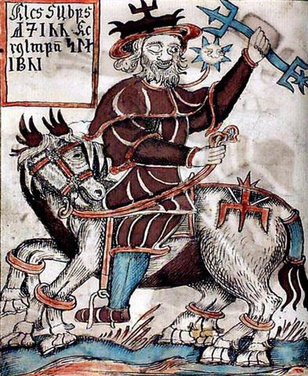

10f. In April 25 (115) the Chorti diviners began to raise their sky roof - and they had to be careful in order to secure regular rains ahead:
... Later on in this series of rituals, the Chorti go through a ceremony they call raising the sky. This ritual takes place at midnight on the twenty-fifth of April and continues each night until the rains arrive. In this ceremony two diviners and their wives sit on benches so that they occupy the corner positions of the cosmic square. They take their seats in the same order as the stones were placed, with the men on the eastern side and the women on the west. The ritual actions of sitting down and lifting upward are done with great precision and care, because they are directly related to the actions done by the gods at Creation. The people represent the gods of the four corners and the clouds that cover the earth. As they rise from their seats, they metaphorically lift the sky. If their lifting motion is uneven, the rains will be irregular and harmful ...
... although I have no definitive documentation in my Polynesian word list regarding oona there seems to be an aura of negation and being careful ...

We should shift our attention to the era of Bharani in order to obtain a better understanding:
 | *51
Bb5-14 (177) | *51 | Bb6-25 (228)
ko te manu mata e toru | *51 | etoru mata oona
April 1 (91, *11) | *51 | May 22 (142, *62)
η Andromedae (*11.4) | *51 | BEID (*62)
"Febr 19 (*335, 415) | *51 | "April 11 (*11, 101)
415 (Bb5-14) + 51 = 466 (= 365 + 101).
Perhaps this pair of glyphs were drawn alike in order to visualize the distinction between the current date of April 1 and an ancient position which was to be counted not from March 21 (80) but from March 31 (90).

Furthermore, the Pope Gregory XIII had stolen 10 days, otherwise Beid would have been at *52.
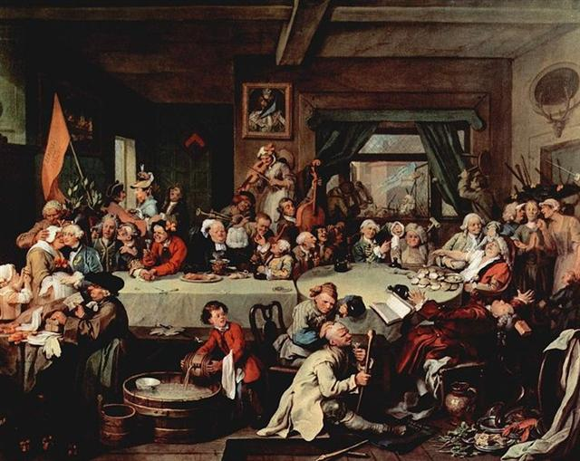
... Gregory dropped 10 days to bring the calendar back into synchronisation with the seasons. Accordingly, when the new calendar was put in use, the error accumulated in the 13 centuries since the Council of Nicaea was corrected by a deletion of ten days. The Julian calendar day Thursday, 4 October 1582 was followed by the first day of the Gregorian calendar, Friday, 15 October 1582 (the cycle of weekdays was not affected) ...
... However, the Gregorian calendar was not accepted at once everywhere: ... The reform was adopted initially by the Catholic countries of Europe. Protestants and Eastern Orthodox countries continued to use the traditional Julian calendar and adopted the Gregorian reform after a time, for the sake of convenience in international trade. The last European country to adopt the reform was Greece, as late as 1923 ... Britain and the British Empire (including the eastern part of what is now the United States) adopted the Gregorian calendar in 1752, by which time it was necessary to correct by 11 days. Wednesday, 2 September 1752, was followed by Thursday, 14 September 1752 ...

If the Gregorian calendar was adopted on Easter Island around my assumed era for rongorongo it ought to have been necessary to correct the old view with 12 days. And after such an earth shaking event much effort must have been used in order to translate the old and well known Julian space-time structure into that which was brought to the island by the Europeans.
This could account for why side b on the G tablet carries 242 glyphs, because 2 * 115 (synodic cycle of Mercury) = 230 = 242 - 12.
MARCH 7 | 8 | 9 | 10 (*354) | 11 (70) | 12 (436) | 13
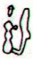 | 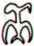 | 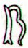 | 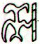 |  | 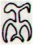 | 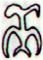
(229 + 229) | Gb8-18 (230) | Gb8-19 (460) | Gb8-20 | Gb8-21 | Gb8-22 | Gb8-23
ALGENIB PERSEI  (*50.0) |  |  | ACRUX |  | PLEIADES

3-14 (73) | MARCH 15 | 16 (360 + 80) |  | MARCH 17 | 18 (*361) | 19 (78) | 20 (*364)
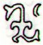 | 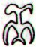 | 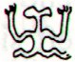 |  | 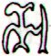 | 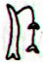 | 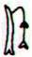
Gb8-24 (465) | Gb8-25 | Gb8-26 |  | Gb8-27 | Gb8-28 | Gb8-29 | Gb8-30 (242)
PORRIMA |  | "April 8 |  | May 20 (140) | 21 (77 + 64) | BEID | HYADUM I (*63.4)
The prominent back side (occiput) heads of 6 of these manu rere can be perceived and contrasted with that of the 7th - here presumably described as mortal due to the position at the left side of ihe tau.
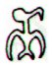 |  | 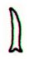
manu rere | Gb8-27 (239) | ihe tau

.... Alcyone and Celaeno were both seduced by Poseidon. Maia, the eldest and most beautiful of the sisters, was seduced by Zeus and gave birth to Hermes; she later became foster-mother to Arcas, son of Zeus and Callisto. Zeus also seduced two others of the Pleiades: Electra, who gave birth to Dardanus, the founder of Troy; and Taygete, who gave birth to Lacedaemon, founder of Sparta. Asterope was ravished by Ares and became mother of Oenomaus, king of Pisa, near Olympia, who features in the legend of Auriga. Hence six Pleiades became paramours of the gods. Only Merope married a mortal, Sisyphus, a notorious trickster who was subsequently condemned to roll a stone eternally up a hill ...

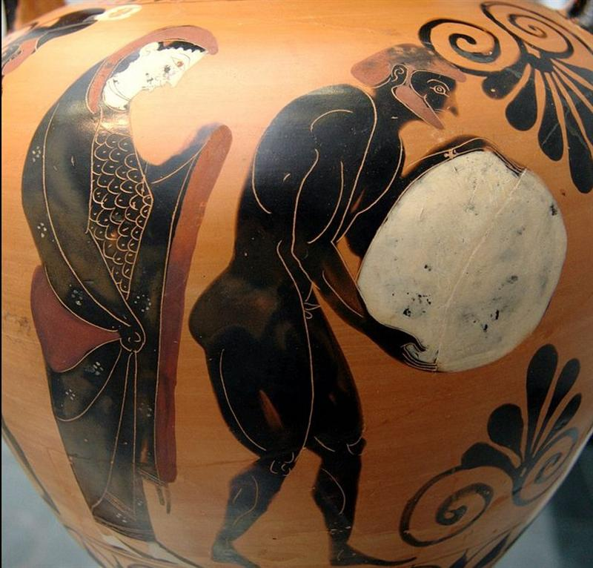

10.1 After these few and somewhat scetchy preliminaries we should now go back and investigate what I earlier have writen regarding the glyph lines Bb5 and Bb6, see docindexII.htm.
 | *51
Bb5-14 (177) | *51 | Bb6-25 (228)
ko te manu mata e toru | *51 | etoru mata oona
April 1 (91, *11) | *51 | May 22 (142, *62)
η Andromedae (*11.4) | *51 | BEID (*62)
"Febr 19 (*335, 415) | *51 | "April 11 (*11, 101)
The proper way to do this is to primarily use my three document files for Aruku Kurenga (the B tablet).
We should activate the search function in the word program and look for Bb5-14, beginning with Aruku Kurenga III (which was createrd after I and II).
I can find 2 places with Bb5-14, and the last of them is documenting the html file I have named Bb5.9.
Below is the relevant table (including hyperlinks) copied from Bb5.9:
JAN 20 | 21 | 22 | 23 (388) | 24 | 25 | 26
X-mas Eve | 'Dec 25 | 26 (177 + 183) | 27 | 28 | 29 (3 * 121) | 30 (348 + 16)
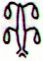 | 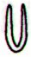 |  |  |  | 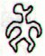 | 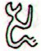
Bb5-12 (175) | Bb5-13 | Bb5-14 (177) | Bb5-15 | Bb5-16 (600) | Bb5-17 | Bb5-18 (181)
mai tupu ona poporo | i haga o tere | ko te manu mata e toru | kua ui ki te maitaki | kua vero hia ia | ko te tagata ra | -
Tupu. 1. Shoot, sprout, bud; to sprout, to bud. 2. Pregnant: vî'e tupu (o te poki); to be conceived (of fetus in its mother's womb): he-tupu te poki i roto i te kopú o toona matu'a. Vanaga. To grow, to sprout, to germinate, to come forth, to conceive, pregnant, germ; mea tupu, plant; tupu ke avai, of rapid growth; tupu horahorau, precocious; hakatupu, to produce, to stimulate growth, to excite. P Pau.: fakatupu, to raise up, to create. Mgv.: tupu, to grow, to conceive, to be pregnant. Mq.: tupu, to grow, to sprout, to conceive. Ta.: tupu, to grow, to sprout. Churchill. Mgv.: Tupu, the best or worst, used of men or of bad qualities. Sa.: tupu, king. Ma.: tupu, social position, dignity. Churchill.
Ona. 1. Ta.: ona, he, she. Sa.: ona, his, hers. Ma.: ona, id. 2. Ta.: ona, rich. Mq.: ona, id. Churchill.
Tere. 1. To run, to flee, to escape from a prison. 2. To sail a boat (also: hakatere); tere vaka, owner of a fishing boat. 3. (Deap-sea) fisherman; tere kahi, tuna fisherman; tere ho'ou, novice fisherman, one who goes deap-sea fishing for the first time. Penei te huru tûai; he-oho te tere ho'ou ki ruga ki te hakanonoga; ana ta'e rava'a, he-avai e te tahi tagata tere vaka i te îka ki a îa mo hakakoa, mo iri-hakaou ki te hakanonoga i te tahi raá. The ancient custom was like this: the novice fisherman would go to a hakanonoga; if he didn't catch anything, another fisherman would give him fishes to make him happy so he'd go again one day to the hakanonoga (more distant fishing zones where larger fishes are found). Vanaga. To depart, to run, to take leave, to desert, to escape, to go away, to flee, fugitive, to sail, to row, to take refuge, to withdraw, to retreat, to save oneself; terea, rest, defeat; tetere, to beat a retreat, to go away, refugee; teretere, to go away, hurrah; hakatere, to set free, to despatch, to expel, to let go, to liberate, to conquer, helmsman; terega, departure, sailing; teretai, a sailor. Churchill.
HELIACAL STARS:
SHANG WEI (Higher Guard) = κ Cephei (305.2), θ Sagittae (305.4), TSEEN FOO (Heavenly Raft) = θ Aquilae (Ant.) (305.6), ξ Capricorni (305.8)  *264.0 = *305.4 - *41.4 | TSO KE (Left Flag) = ρ Aquilae (306.3) | GREDI (Goat) = α Capricorni (307.2), σ Capricorni (307.5), ALSHAT (The Sheep) = ν Capricorni (307.9) | Al Sa’d al Dhabih-20 (Lucky One of the Slaughterers) / Ox / Heard Boy (Buffalo)  DABIH = β Capricorni (308.0), κ Sagittarii (308.1), SADIR (Hen's Breast) = γ Cygni (308.4), PEACOCK = α Pavonis (308.7)  *267.0 = *308.4 - *41.4 | OKUL = π Capricorni (309.6), BOS = ρ Capricorni (309.9)  ARNEB (α Leporis)  MINTAKA (δ Orionis) | ο Capricorni (310.2), θ Cephei (310.5)  HEKA (λ Orionis)  ALNILAM (ε Orionis) | ROTTEN MELON = ε Delphini, φ Pavonis (311.2), η Delphini (311.4), ζ Delphini, ρ Pavonis (311.7)  PHAKT (α Columbae)  ALNILAK (ζ Orionis)  *270.0 = *311.4 - *41.4
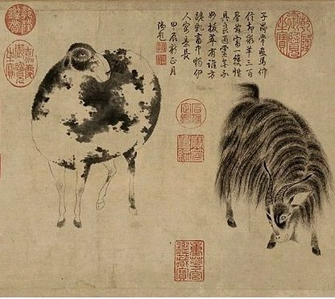
RIGHT ASCENSION DAYS AT THE FULL MOON:
ρ Puppis (122.0), HEAP OF FUEL = μ Cancri (122.1), ζ Monocerotis (122.3), ψ Cancri (122.6), REGOR (Roger backwards) = γ Velorum (122.7) | TEGMINE (The Cover) = ζ Cancri (123.3) | AL TARF (The End) = β Cancri (124.3)  RAS ALGETHI (α Herculis) | χ Cancri (125.2), BRIGHT FIRE = λ Cancri (125.4)  *84.0 = *125.4 - *41.4 | AVIOR = ε Carinae (126.4), φ Cancri (126.8)  *85.0 = *126.4 - *41.4 | ο Ursae Majoris (127.4)  *86.0 = *127.4 - *41.4 | Pushya-8 (Nourisher)  υ Cancri (128.1), θ Cancri (128.2)
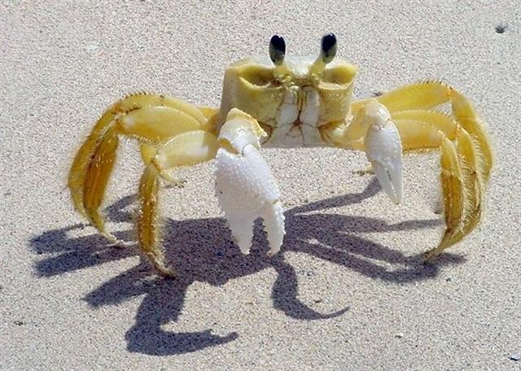

We can copy dates according to the Gregorian calendar and also the corresponding full moon nights:
 | *51
Bb5-14 (177) | *51 | Bb6-25 (228)
ko te manu mata e toru | *51 | etoru mata oona
GREDI + ALSHAT (*307) | *51
Jan 22 (387, *307) | *51
"Dec 12 (346, *266) | *51
RAS ALGETHI (*124 = *307 - *183) | *51
July 23 (204, *124) | *51
"June 12 (163, *83) | *51
Here the B text seems to connect the glyph with the culmination (at 21h) of the star at the Head of Hercules (Ras Algethi), which could explain why in the glyph image the head of this Mars (no right arm) person seems to be counted as the top mata.
In the era of Bharani - it can be extrapolated back in time from 41 days of precession - the culmination of the Head of Hercules would have occurred 41 days earlier, viz. in "June 12. Half a year away the Sun had been at the Goat and the Sheep (Gredi respectively Alshat).
When the Head of Hercules culminated (cfr the copied table above) this was at the star named The End (Al Tarf, significatnly β Cancri). → The Alpha Male (α) had changed into a Female with Breasts (β) for nourishing newborns. Thus "June 12 was a time of birth (*) in contrast to the time of death (†) half a year away.
... Up to the present time, fertility spells for fowls have played an important role. Especially effective were the so-called 'chicken skulls' (puoko moa) - that is, the skulls of dead chiefs, often marked by incisions, that were considered a source of mana. Their task is explained as follows: 'The skulls of the chiefs are for the chicken, so that thousands may be born' (te puoko ariki mo te moa, mo topa o te piere) ... As long as the source of mana is kept in the house, the hens are impregnated (he rei te moa i te uha), they lay eggs (he ne'ine'i te uha i te mamari), and the chicks are hatched (he topa te maanga). After a period of time, the beneficial skull has to be removed, because otherwise the hens become exhausted from laying eggs ...

In order for a new generation to be born and thrive the old one had to go (be recycled). This was due in the month of Jupiter (Father of Light, the old one). This month began in June 10 and in the era of Bharani it would have begun in "June 10.
... Midsummer is the flowering season of the oak, which is the tree of endurance and triumph, and like the ash is said to 'court the lightning flash'. Its roots are believed to extend as deep underground as its branches rise in the air - Virgil mentions this - which makes it emblematic of a god whose law runs both in Heaven and in the Underworld ... The month, which takes its name from Juppiter the oak-god, begins on June 10th and ends of July 7th. Midway comes St. John's Day, June 24th, the day on which the oak-king was sacrificially burned alive. The Celtic year was divided into two halves with the second half beginning in July, apparently after a seven-day wake, or funeral feast, in the oak-king's honour ...

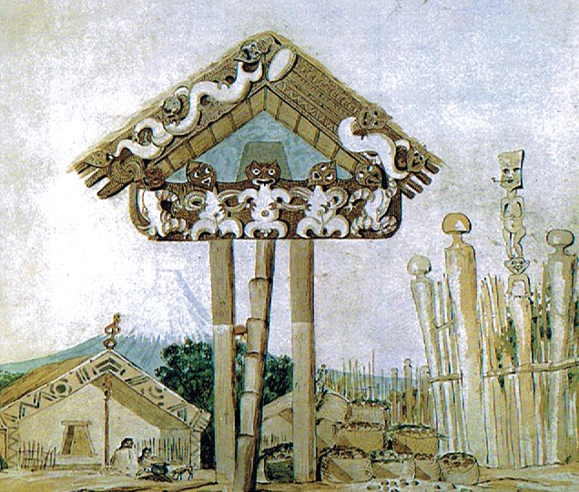

10-1a. Once again. The B text is obviously here referring to midsummer (in the era of Bharani) and not to the time of spring which I had guessed:
 | *51
Bb5-14 (177) | *51 | Bb6-25 (228)
ko te manu mata e toru | *51 | etoru mata oona
April 1 (91, *11) | *51 | May 22 (142, *62)
η Andromedae (*11.4) | *51 | BEID (*62)
"Febr 19 (*335, 415) | *51 | "April 11 (*11, 101)

 | *51
Bb5-14 (177) | *51 | Bb6-25 (228)
ko te manu mata e toru | *51 | etoru mata oona
GREDI + ALSHAT (*307) | *51
Jan 22 (387, *307) | *51
"Dec 12 (346, *266) | *51
RAS ALGETHI (*124 = *307 - *183) | *51
July 23 (204, *124) | *51
"June 12 (163, *83) | *51
And on Easter Island midsummer was in December (and not in June).
Therefore, when in the night of January 22 the right ascension line at the Full Moon should (ideally) have been seen close to the star named Tegmine = the Cover, ζ Cancri, *123 (= 5 days after *118.4 at φ Gemini) - cfr Ga2-29 (→ number of glyphs on side a of the G tablet) - where it would be known that the Sun had moved on, beyond his apex and then disappeared behind the cover of the rain clouds (generated from evaporation due to his hot rays earlier).

... The life-force of the earth is water. God moulded the earth with water. Blood too he made out of water. Even in a stone there is this force, for there is moisture in everything. But if Nummo is water, it also produces copper. When the sky is overcast, the sun's rays may be seen materializing on the misty horizon. These rays, excreted by the spirits, are of copper and are light. They are water too, because they uphold the earth's moisture as it rises.
The Pair excrete light, because they are also light ... 'The sun's rays,' he went on, 'are fire and the Nummo's excrement. It is the rays which give the sun its strength. It is the Nummo who gives life to this star, for the sun is in some sort a star.' It was difficult to get him to explain what he meant by this obscure statement. The Nazarene made more than one fruitless effort to understand this part of the cosmogony; he could not discover any chink or crack through which to apprehend its meaning. He was moreover confronted with identifications which no European, that is, no average rational European, could admit. He felt himself humiliated, though not disagreeably so, at finding that his informant regarded fire and water as complementary, and not as opposites. The rays of light and heat draw the water up, and also cause it to descend again in the form of rain. That is all to the good. The movement created by this coming and going is a good thing. By means of the rays the Nummo draws out, and gives back the life-force. This movement indeed makes life ...
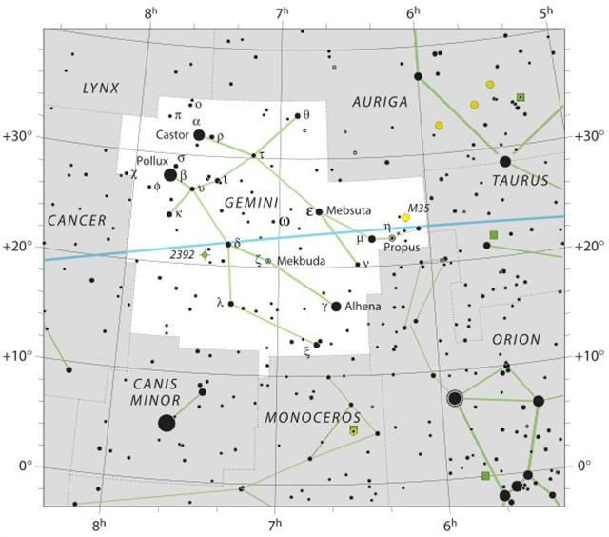

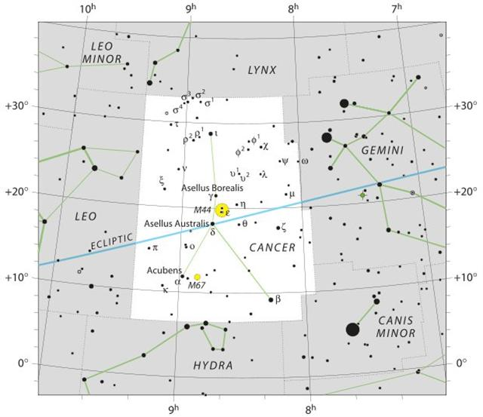

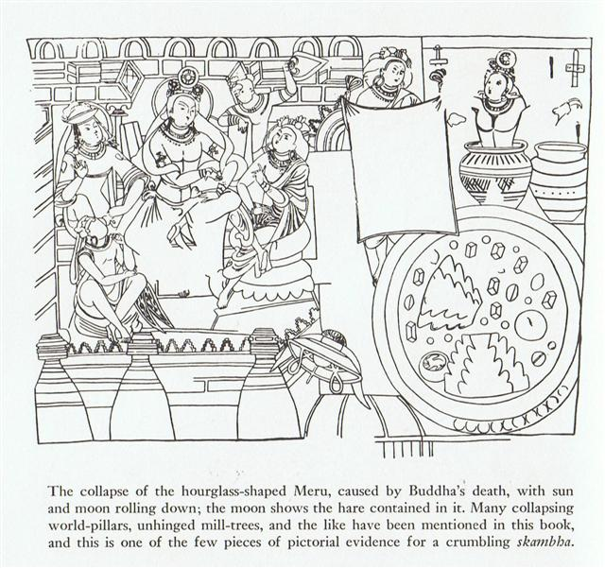

And reasonable the Chorti diviners could have expected to continue with their sacred work of carefully raising the sky until July 22 (115 + 88 = 203), when the Sun would rise at Tegmine.
... Later on in this series of rituals, the Chorti go through a ceremony they call raising the sky. This ritual takes place at midnight on the twenty-fifth of April and continues each night until the rains arrive. In this ceremony two diviners and their wives sit on benches so that they occupy the corner positions of the cosmic square. They take their seats in the same order as the stones were placed, with the men on the eastern side and the women on the west. The ritual actions of sitting down and lifting upward are done with great precision and care, because they are directly related to the actions done by the gods at Creation. The people represent the gods of the four corners and the clouds that cover the earth. As they rise from their seats, they metaphorically lift the sky. If their lifting motion is uneven, the rains will be irregular and harmful ...
118 (Φ Gemini) + 5 ↔ Ga2-27 (57) + 123 = 180 (Ga7-11) → .7 * 11 = 77 = 177 - 100. It was like a great moving caleidoscope.

10-1b. Why should there be precisely *52 right ascension days to the exceedingly old 'moe bird' depicted at Bb6-25?
 | *51
Bb5-14 (177) | *51 | Bb6-25 (228)
ko te manu mata e toru | *51 | etoru mata oona
GREDI + ALSHAT (*307) | *51
Jan 22 (387, *307) | *51
"Dec 12 (346, *266) | *51
RAS ALGETHI (*124 = *307 - *183) | *51
July 23 (204, *124) | *51
"June 12 (163, *83) | *51
To my mind comes the underlying structure for the Bacabob:
91 | 91 | 91 | 91

52 | 260 = 5 * 52 | 52
364 = 4 * 91 = 7 * 52
... This connects up the present section with the beginning of the 'sacred tonalamatl', at the Spring equinox with the Mayas as with the Mexicans, and in the center of the 364-day year (52 days of which preceded and 52 followed the tonalamatl or tzolkin), ruled by its 91-day quarters by the Four Bacabs, whose quarternary repetition (in the 1820-day period) we have thus verified ...
7 * 52 = 364 means we cannot expect a season with 260 days necessarily should begin after Bb6-25.
Instead we could try to count in the other direction: 203 (July 22) - 52 = 151 (May 30) → 151 - 41 = 110 ("April 20).

... About Carmenta we know from the historian Dionysus Periergetis that she gave orcales to Hercules and lived to the age of 110 years. 110 was a canonical number, the ideal age which every Egyptian wished to reach and the age at which, for example, the patriarch Joseph died. The 110 years were made up of twenty-two Etruscan lustra of five years each; and 110 years composed the 'cycle' taken over from the Etruscans by the Romans. At the end of each cycle they corrected irregularities in the solar calendar by intercalation and held Secular Games ...

But we should follow the Sun in the current Gregorian calendar and right ascension day 388 (January 22) at the Goat and the Sheep minus 52 = 336 (December 2) at the Club (Cujam) of Hercules:
... Hercules is male leader of all orgiastic rites and has twelve archer companions, including his spear-armed twin, who is his tanist or deputy. He performs an annual green-wood marriage with a queen of the woods, a sort of Maid Marian. He is a mighty hunter and makes rain, when it is needed, by rattling an oak-club thunderously in a hollow oak and stirring a pool with an oak branch - alternatively, by rattling pebbles inside a sacred colocinth-gourd or, later, by rolling black meteoric stones inside a wooden chest - and so attracting thunderstorms by sympathetic magic ...
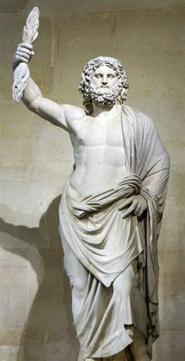

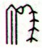 | *51
Bb4-4 (125) → 125 + 366 = 491 (Bb12-30) | *51 | Bb5-14 (177)
i te maitaki o to maro | *51 | ko te manu mata e toru
CUJAM, the Club, ε Herculi (*256→ 4 * 64) | *51 | GREDI + ALSHAT (*307)
Dec 2 (336 = 80 + 256) | *51 | Jan 22 (388 = 366 + 22, *307)
"Sept 22 (295 = 336 - 41, equinox) | *51 | "Dec 12 (346, *266)
HASSALEH, ι Aurigae (*73) | *51 | RAS ALGETHI (*124 = *307 - *183)
June 2 (336 - 183 = 153 = 80 + 73) | *51 | July 23 (204, *124)
"April 22 (112 = 153 - 41) | *51 | "June 12 (163, *83)
In December 2 the Full Moon should ideally be at Hassaleh:
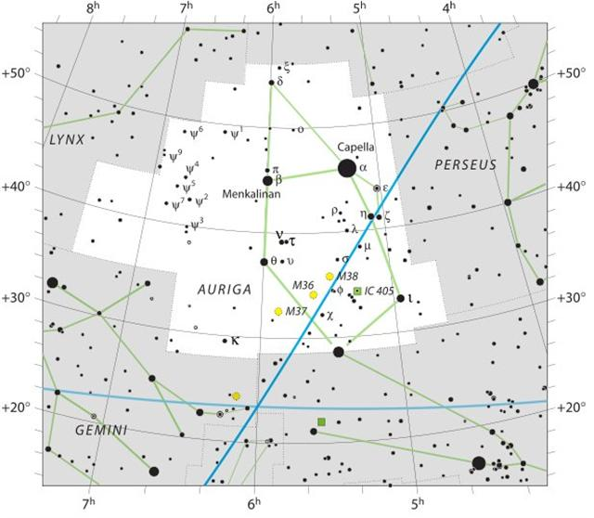

And pershaps it means we should be able to count 260 days from January 22, to October 9 (282, *202 → Spica).
Notably the synodic cycle of Jupiter (398.88) was precisely 283 days longer than that of Mercury (115.88). April 25 (125) + 283 = 408 → Sirrah at Gb6-26.
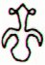
Gb6-26 (408)
0h
Which all possibly could explain the curious statement of twice 52 years (given that such a 'year' measured 52 right ascension days):
... When it was evident that the years lay ready to burst into life, everyone took hold of them, so that once more would start forth - once again - another (period of) fifty-two years. Then (the two cycles) might proceed to reach one hundred and four [104] years. It was called One Age when twice they had made the round, when twice the times of binding the years had come together. Behold what was done when the years were bound - when was reached the time when they were to draw the new fire, when now its count was accomplished. First they put out fires everywhere in the country round. And the statues, hewn in either wood or stone, kept in each man's home and regarded as gods, were all cast into the water. Also (were) these (cast away) - the pestles and the (three) hearth stones (upon which the cooking pots rested); and everywhere there was much sweeping - there was sweeping very clear. Rubbish was thrown out; none lay in any of the houses ...

... There are numerous Egyptian words for 'the year', and the same goes for other ancient languages. Thus we propose to understand eniautos as the particular cycle belonging to the respective character under discussion: the mere word eniautos ('in itself', en heauto; Plato's Cratylus 410D) does not say more that just this. It seems unjustifiable to render the word as 'the year' as is done regularly nowadays, for the simple reason that there is no such thing as the year; to begin with, there is the tropical year and sidereal year, neither of them being of the same length as the Sothic year. Actually, the methods of Maya, Chinese, and Indian time reckoning should teach us to take much greater care of the words we use. The Indians, for instance, reckoned with five different sorts of 'year', among which one of 378 days, for which A. Weber did not have any explanation. That number of days, however, represents the synodical revolution of Saturn. Nothing is gained by the violence with which the Ancient Egyptian astronomical system is forced into the presupposed

primitive frame. The eniautos of the Phoenix would be the said 500 (or 540) years; we do not know yet the stag's own timetable: his 'year' should be either 378 days or 30 years, but there are many more possible periods to be considered than we dream of - Timaios told us as much. For the time being the only important point is to become fully aware of the plurality of 'years', and to keep an eye open for more information about the particular 'year of the stag' (or the Oryx), as well as for other eniautio, especially those occurring in Greek myths which are, supposedly, so familiar to us, to mention only the assumed eight years of Apollo's indenture after having slain Python (Plutarch, De defectu oraculorum, ch. 21, 421C), or that 'one eternal year (aidion eniauton)', said to be '8 years (okto ete)', that Cadmus served Ares ...
... A young Egyptian called Setna (or Seton Chamwese) wanted to steal the magic book of Thot from the corpse of Nefer-ka Ptah, one of the great Egyptian gods, who was often portrayed as a mummy. Ptah, however, was awake and asked him: 'Are you able to take this book away with the help of a knowing scribe, or do you want to overcome me at checkerboards? Will you play 'Fifty-Two'?' Setna agreed, and the board with its 'dogs' (pieces) being brought up, Nefer-ka Ptah won a game, spoke a formula, laid the checkerboard upon Setna's head and made him sink into the ground up to his hips. On the third time, he made him sink up to his ears, then Setna cried aloud for his brother, who saved him ...

October 9 (282) + 22 = October 31:

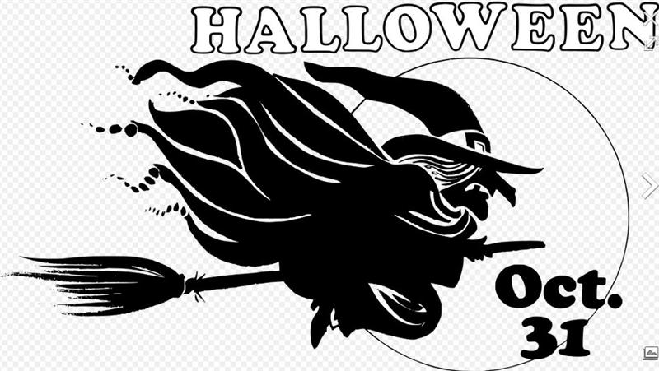

10-1c. Let's now look at my earlier documentation of the B text as regards glyph Bb6-25, using the same procedure of searching in the word document named Aruku Kurenga III.
From the html file named Bb6.9 we can then copy:
 |  | 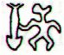 | 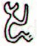
Bb6-25 | Bb6-26 | Bb6-27 | Bb6-28
etoru mata oona | e te maitaki | ihe vero hia | koia ku akapava
March 14 → π | 15 | 16 (440 = 75 + 365) | 17
λ Piscium (358.0), MANUS CATENATA = ι Andromedae (358.1), θ Phoenicis, ALRAI = γ Cephei (358.4), κ Andromedae (358.7)  *358.4 - *41.4 = *317.0 | ω Aquarii (359.2), 78 Pegasi (359.5) | ψ Andromedae (360.1), σ Phoenicis (360.4)  *360.4 - *41.4 = *319.0 | γ¹ Oct. (361.4), φ Pegasi (361.7)  *361.4 - *41.4 = *320.0
Sept 12 (255) | 13 | 14 (440 - 183) | 15
θ Crateris (175.0), υ Leonis (175.2), ω Virginis (175.3), ι Crateris (175.5) | ο Hydrae (176.1) | ζ Crateris, ξ Virginis (177.0), λ Muscae (177.1), ν Virginis (177.2), μ Muscae (177.8) | Al Sarfah-10 (Turn) / Uttara Phalguni-12 (Second Reddish One) / Zibbat A.-16 (Tail of the Lion) / Shēpu-arkū sha-A-17 (Hind Leg of the Lion)  93 Leonis (178.0), DENEBOLA = β Leonis (178.3), ALARAPH (Unarmed) = β Virginis (178.6)

And from there we can update the information in my table:
 | *51
Bb4-4 (125) → 125 + 366 = 491 (Bb12-30) | *51
i te maitaki o to maro | *51
CUJAM, the Club, ε Herculi (*256→ 4 * 64) | *51
Dec 2 (336 = 80 + 256) | *51
"Sept 22 (295 = 336 - 41, equinox) | *51
HASSALEH, ι Aurigae (*73) | *51
June 2 (336 - 183 = 153 = 80 + 73) | *51
"April 22 (112 = 153 - 41) | *51

 | *51
Bb5-14 (177 → 307 - 260 / 2) | *51 | Bb6-25 (228 → 358 - 260 / 2)
ko te manu mata e toru | *51 | etoru mata oona
GREDI + ALSHAT (*307) | *51 | MANUS CATENATA (*358)
Jan 22 (387, *307) | *51 | March 14 (73, *358)
"Dec 12 (346, *266) | *51 | "Febr 1 (32, *317)
RAS ALGETHI (*124 = *307 - *183) | *51 | θ Crateris (*175.0)
July 23 (204, *124) | *51 | Sept 12 (255)
"June 12 (163, *83) | *51 | "Aug 2 (214, '134 = *317 - *183)
The place of the Sun is here at the famous right chained hand (Manus Catenata) of Andromeda, at the time when the Full Moon ought to be seen at the empty vessel of Crater, where the old one had run out of steam so to say and could no longer produce the necessary sweet waters.

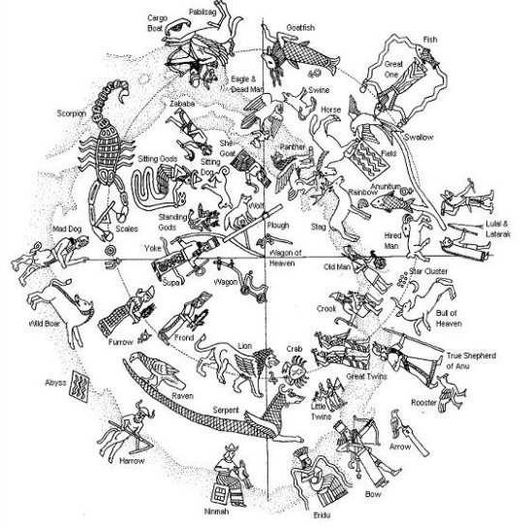
But close to the Chained Hand was the irrigated Field with plenty of fresh water.

11. Let's look again at the pair of glyphs preceding 0h with the sitting figure calling out (ragi) at the beginning of the season of growth:
1. Sky, heaven, firmament; ragi moana, blue sky. 2. Cloud; ragipuga, cumulus; ragitea, white, light clouds; ragi poporo, nimbus; ragi hoe ka'i cirrus (literally: like sharp knives); ragi viri, overcast sky; ragi kerekere, nimbus stratus; ragi kirikiri miro, clouds of various colours. 3. To call, to shout, to exclaim. Vanaga.
Hb1-33 | Hb1-34 | Hb1-35 | Hb1-36 | Hb1-37 | Hb1-38 | Hb1-39 | Hb1-40
*363 | *364 | SIRRAH | *1 | *2 | *3 | *4 | *5
March 19 (78) | 20 (444) | 0h | 22 | 23 | 24 | 25 (84) | 26 (450)
Quite possibly it was anciently the custom to call out for all to hear when there was a major change of seasons, e.g.:
... In China, every year about the beginning of April, certain officials called Sz'hüen used of old to go about the country armed with wooden clappers. Their business was to summon the people and command them to put out every fire. This was the beginning of the season called Han-shih-tsieh, or 'eating of cold food'. For three days all household fires remained extinct as a preparation for the solemn renewal of the fire, which took place on the fifth or sixth day after the winter solstice ...
... In the morning of the world, there was nothing but water. The Loon was calling, and the old man who at that time bore the Raven's name, Nangkilstlas, asked her why. 'The gods are homeless', the Loon replied. 'I'll see to it', said the old man, without moving from the fire in his house on the floor of the sea. Then as the old man continued to lie by his fire, the Raven flew over the sea. The clouds broke. He flew upward, drove his beak into the sky and scrambled over the rim to the upper world. There he discovered a town, and in one of the houses a woman had just given birth ...
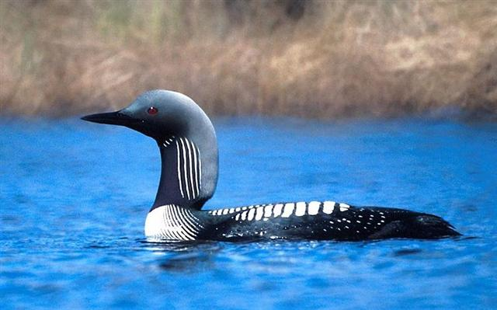

... And here is the dawning and showing of the sun, moon, and stars. And Jaguar Quitze, Jaguar Night, Not Right Now, and Dark Jaguar were overjoyed when they saw the sun carrier. It came up first. It looked brilliant when it came up, since it was ahead of the sun.
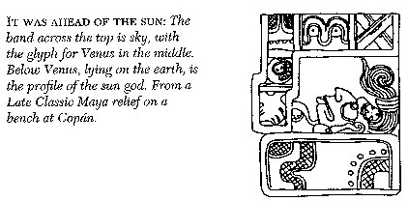
After that they unwrapped their copal incense, which came from the east, and there was triumph in their hearts when they unwrapped it. They gave their heartfelt thanks with three kinds at once:
Mixtam Copal is the name of the copal brought by Jaguar Quitze.
Cauiztan Copal, next, is the name of the copal brought by Jaguar Night.
Godly Copal, as the next one is called, was brought by Not Right Now.
The three of them had their copal, and this is what they burned as they incensed the direction of the rising sun. They were crying sweetly as they shook their burning copal, the precious copal. After that they cried because they had yet to see and yet to witness the birth of the sun. And then, when the sun came up, the animals, small and great, were happy. They all came up from the rivers and canyons; they waited on all the mountain peaks. Together they looked toward the place where the sun came out. So then the puma and jaguar cried out, but the first to cry out was a bird, the parrot by name.

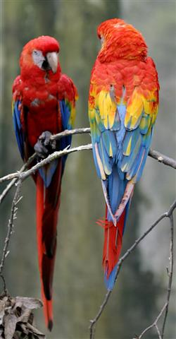
All the animals were truly happy. The eagle, the white vulture, small birds, great birds spread their wings, and the penitents and sacrificers knelt down. They were overjoyed, together with the penitents and sacrificers of the Tams, the Ilocs. And the Rabinals, Cakchiquels, those of Bird House. And the Sweatbath House, Talk House, Quiba House, those of Yokes House. And the Mexican Sovereigns - however many tribes there may be today. There were countless peoples, but there was just one dawn for all tribes. And then the face of the earth was dried out by the sun. The sun was like a person when he revealed himself. His face was hot, so he dried out the face of the earth. Before the sun came up it was soggy, and the face of the earth was muddy before the sun came up. And when the sun had risen just a short distance he was like a person, and his heat was unbearable. Since he revealed himself only when he was born, it is only his reflection that now remains. As they put it in the ancient text, 'The visible sun is not the real one ...'

... I must here take the opportunity to document, before it vanishes from my memory, how scientists (according to a TV program I happened to stumble on yesterday) had found out that the 91 vertical stone segments clearly had been arranged in order to produce a remarkable acoustical phenomenon - viz. how someone (like a priest) when clapping his hands standing on the ground in front of the pyramid would receive an echo of approval from the stones, sounding exactly like the chirp of the Flying Serpent (Kukulkan, the Quetzal Coatl) ...
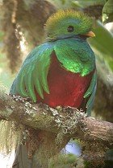
Clearly the essence of calling out was to establish contact, to evoke a response, to create a common ground.
... Long ago in the very beginning of time there dwelt within a shell an infant god whose name was Ta'aroa. He was Ta'aroa the unique one, the ancestor of all gods, the creator of the universe whose natures were myriad, whose backbone was the ridgepole of the world, whose ribs were its supporters. The shell was called Rumia, Upset.
Becoming aware at last of his own existence and oppressed by a yearning loneliness Ta'aroa broke open his shell and, looking out, beheld the black limitless expanse of empty space. Hopefully, he shouted, but no voice answered him. He was alone in the vast cosmos. Within the broken Rumia he grew a new shell to shut out the primeval void ...

11-1. Once again. The Pegasus Square was beginning with the straight line between Scheat (β) and Markab (α), and this was 16 right ascension days before Sirrah. And Hb1-35 - 16 = Hb1-19.

However, after Hb1-6 the glyphs cannot be seen - it is as if they had been totally submerged. Not until Hb1-28 are they fully in sight again.
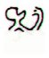 |  | ...
Hb1-5 | Hb1-6 | ...

 | 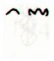 | 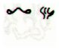 | 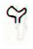 | 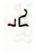
Hb1-23 | Hb1-24 | Hb1-25 | Hb1-26 | Hb1-27
KERB | *354 | *355 | *356 | *357
March 9 | 10 | 11 (70) | 12 | 13
... τ, 4.5, with υ, was Al Sufi's Sa'd al Na'amah, which Knobel thinks should be Al Na'āim, the Cross-bars over a well; but they also were known as Al Karab, the Bucket-rope. The usual titles for τ - Markab and Sagma or Salma - are from Bayer, but the last two should be Salm, a Leathern Bucket ...
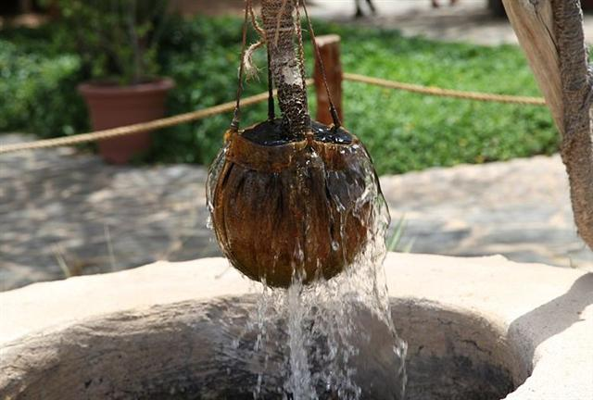

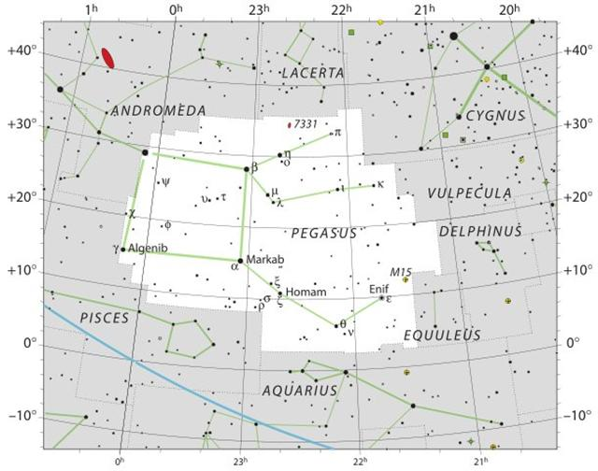
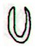 |  |  | 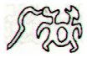 | 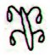
Hb1-28 | Hb1-29 | Hb1-30 | Hb1-31 | Hb1-32
MANUS CATENATA | *359 | *360 | *361 | *362
March 14 | 15 | 16 (75) | 17 | 18

Hb1-33 | Hb1-34 | Hb1-35 | Hb1-36 | Hb1-37 | Hb1-38 | Hb1-39 | Hb1-40
*363 | *364 | SIRRAH | ALGENIB | *2 | *3 | *4 | *5
March 19 (78) | 20 (444) | 0h | 22 | 23 | 24 | 25 (84) | 26 (450)

The above supports my idea of how to read Hb1-35 and Hb1-36. Evidently the creator of the text had cleverly balanced the burnt area late on side a of his tablet with a water submerged area early on side b.
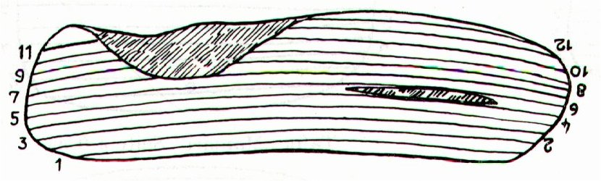
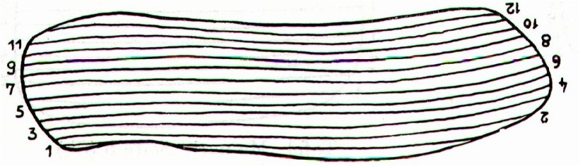
a1 | 50 | 50 | burnt area could have contained the number of glyphs below | 50 | b1 | *52 | 52
a2 | 58 | 108 | burnt area could have contained the number of glyphs below | 108 | b2 | 48 | 100
a3 | 52 | 160 | burnt area could have contained the number of glyphs below | 160 | b3 | 47 | 147
a4 | 56 | 216 | burnt area could have contained the number of glyphs below | 216 | b4 | 51 | 198
a5 | 59 | 275 | burnt area could have contained the number of glyphs below | 275 | b5 | 57 | 255
a6 | 64 | 339 | *5 | 344 | b6 | 54 | 309
a7 | 48 | 387 | *3 | 395 | b7 | 50 | 359
a8 | 46 | 433 | *8 | 449 | b8 | *54 (?) | 413
a9 | 40 | 473 | *13 | 502 | b9 | 65 | 478
a10 | 49 | 522 | *18 | 569 | b10 | 67 | 545
a11 | 36 | 558 | *22 | 627 | b11 | 53 | 598
a12 | *21 (?) | *579 | (*18) | 648 (?) | b12 | *50 (?) | 648
sum | *648 (?) |  |  |  | sum | *648 (?)

Furthermore, we can guess Hb1-35 could have alluded to 135 (May 15) when the 6 sisters (Tau-ono) in the Pleiades ought to rise at the horizon in the east simultaneously with the Sun. This perception in a way could explain why there had to be a pair, because there were 3 more stars in the Pleiades rising with the Sun in the following day, in May 16 (viz. Alcyone, Pleione, and Atlas).

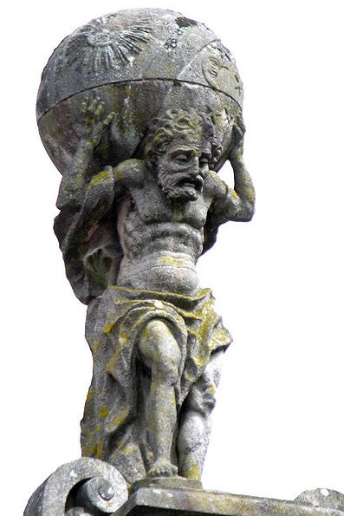

But the structure of the Square of Pegasus could also explain why there had to be a pair, because Sirrah (at the occiput of Andromeda)
was followed by Algenib (the Wing, γ).

It was as if the Corner at the Wing (Γ) symbolized how the Sun here was lifting off up into the air from a mound of earth at Sirrah:
... Tu'i Tofua was the son of Vakafuhu. His mother was Langitaetaea, but she was only one of the many young women whom Vakafuhu had living behind the fences of his dwelling. When Tu'i Tofua grew he was given the first-born sons of all the wives for his companions, and they all used to play sika outside the enclosure of Vakafuhu. They made their sika of clean-peeled sticks and threw them in turn along the ground, they glanced them off a mound and each one tried to make the longest throw. One day while Vakafuhu was sleeping off a kava-drinking those boys were playing their game outside, and Tu'i Tofua threw his sika. Then indeed the enormous strength of Tu'i Tofua made that sika fly over the fences into his father's place. It landed where the women were and they all began to giggle, those girls, and shriek and laugh. They did this because they wanted that handsome youth to come among them, they desired him. More than his father they desired him. They fell with joy upon the sika of their master's son, and snapped it. When he came inside to get it back they called out things that made him embarrased. 'Haven't you got another long thing there, Tu'i?' those women said. 'This one's broken.' And they put their hands across their faces and they laughed ...
Sika corresponds to Tika in other dialects of the Polynesian language and because Maui was born from the topknot of his mother he was named Maui Tikitiki a Taranga. The pair of words tiki-tiki and tika are similar, yet quite different in meaning.

... 'From the time I was in your womb,' Maui went on, 'I have known the names of these children of yours. Listen,' he said as he pointed to his brothers in turn. 'You are Maui mua, you are Maui roto, you are Maui taha, and you are Maui pae. And as for me, I am Maui potiki, Maui-the-last-born. And here I am.' When he had finished, Taranga had to wipe her eyes because there were tears in them, and she said: 'You are indeed my lastborn son. You are the child of my old age. When I had you, no one knew, and what you have been saying is the truth. Well, as you were formed out of my topknot you can be Maui tikitiki a Taranga.' So that became his name, meaning Maui-formed-in-the-topknot-of-Taranga. And this is very strange, because women in those days did not have topknots. The topknot was the most sacred part of a person, and only men had them ...

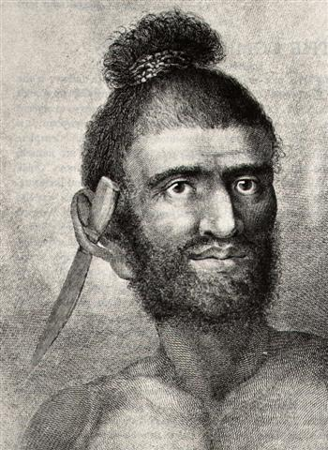

11-2. So why should there be a pair of maitaki glyphs preceding Sirrah at 0h?
Hakarava hakaturu, quadrangular ... Hakarava omua to come before, precede.
... There is a couple residing in one place named Kui [Tui] and Fakataka [Hakataka]. After the couple stay together for a while Fakataka is pregnant. So they go away because they wish to go to another place - they go. The canoe goes and goes, the wind roars, the sea churns, the canoe sinks. Kui expires while Fakataka swims. Fakataka swims and swims, reaching another land. She goes there and stays on the upraised reef in the freshwater pools on the reef, and there delivers her child, a boy child. She gives him the name Taetagaloa [Not Tagaroa].When the baby is born a golden plover flies over and alights upon the reef. (Kua fanau lā te pepe kae lele mai te tuli oi tū mai i te papa). And so the woman thus names various parts of the child beginning with the name 'the plover' (tuli): neck (tuliulu), elbow (tulilima), knee (tulivae) ...
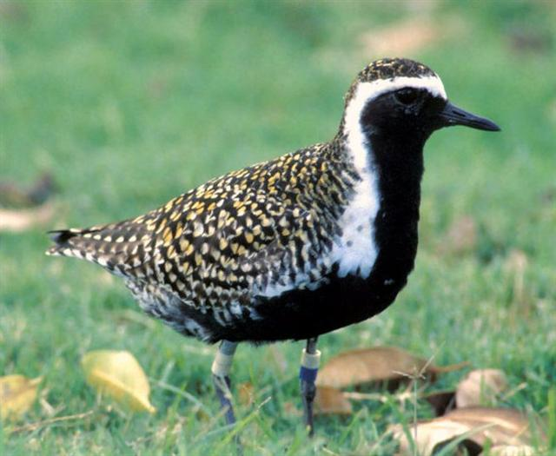

Was it some kind of allusion to the Doublegood Pair, Punarvasu?
... In Hindu legend there was a mother goddess called Aditi, who had seven offspring. She is called 'Mother of the Gods'. Aditi, whose name means 'free, unbounded, infinity' was assigned in the ancient lists of constellations as the regent of the asterism Punarvasu. Punarvasu is dual in form and means 'The Doublegood Pair'. The singular form of this noun is used to refer to the star Pollux. It is not difficult to surmise that the other member of the Doublegood Pair was Castor. Then the constellation Punarvasu is quite equivalent to our Gemini, the Twins ...
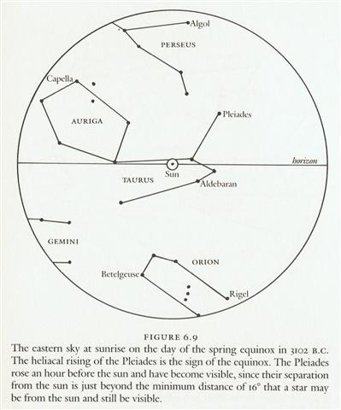

Hb1-28 | Hb1-29 | Hb1-30 | Hb1-31 | Hb1-32
MANUS CATENATA | *359 | *360 | *361 | *362
March 14 | 15 | 16 (75, 440) | 17 | 18

Hb1-33 | Hb1-34 | Hb1-35 | Hb1-36 | Hb1-37 | Hb1-38 | Hb1-39 | Hb1-40
*363 | *364 | SIRRAH | ALGENIB | *2 | *3 | *4 | *5
March 19 (78) | 20 (444) | 0h (*0) | 22 | 23 | 24 | Julian equinox | 26 (450)
We should notice that when Metoro saw a pair of maitaki glyphs close together he said maitaki (good) only at the first one of them. At the 2nd glyph he tended to say maharoga.

We can learn from studying this triplet of double pair of maitaki variants:
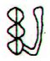 | 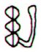 | *59 | 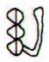 | 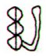 | *28 | 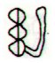 | 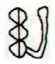
Hb4-41 (188) | Hb4-42 | *59 | Hb5-50 (248) | Hb5-51 | *28 | Hb6-23 (278) | Hb6-24

We have been here before:

4b
JUNE 15 | 16 | 17 (168) | 18 | 19 | 20 | MIDSUMMER
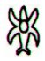 | 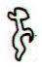 |  |  | 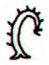 | 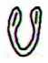 | 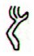
Hb4-39 | Hb4-40 | Hb4-41 (188) | Hb4-42 | Hb4-43 | Hb4-44 | Hb4-45 (192)
*150 | *151 | REGULUS | *153 | *154 | *155 | *156
Aug 18 (230) | 19 | 20 | 21 | 22 | 23 | 24 (236)
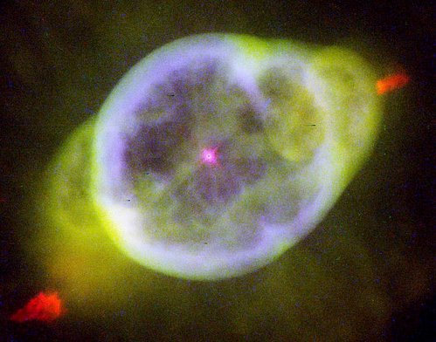

5b
AUG 14 | (227 → 350 - 23) | 16 | 17 (293 - 64 = 229) | 18 (5 * 46) | 19
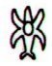 | 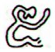 |  |  | 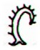 | 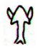
Hb5-48 (2 * 123) | Hb5-49 | Hb5-50 | Hb5-51 | Hb5-52 (250) | Hb5-53
"Sept 6 | 7 (*170) | 8 | 9 | 10 (253) | (*174.0 → 6 * 29)
*210 | *211 (= 170 + 41) | THUBAN | Oct 20 | *214, 294 | ARCTURUS

6b
16 (320) | 17 | Nov 18 | 19 | 20 (324)
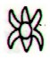 | 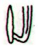 |  |  | 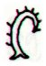
Hb6-21 | Hb6-22 | Hb6-23 | Hb6-24 | Hb6-25 (280)
*240 | VRISCHIKA | SCHEDIR | *243 | *244

There were 60 right ascension days from Regulus to Thuban and another 30 days to the culmination (at 21h) of Schedir (the Breast of Cassiopeia) in November 18.

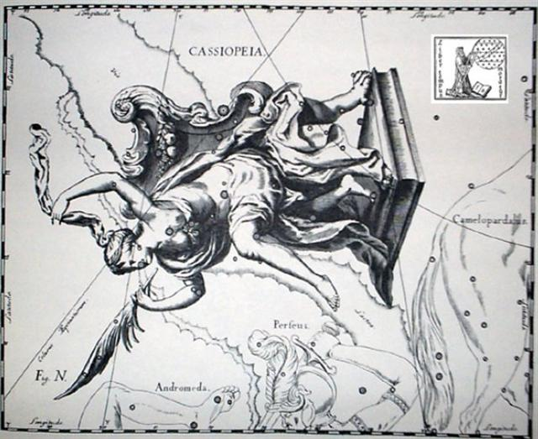

There was a quarter of 364 days from Regulus to November 18.
 |  | *59 |  |  | *28
Hb4-41 (188) | Hb4-42 | *59 | Hb5-50 (248) | Hb5-51 | *28 | Hb6-23 (278) | Hb6-24
REGULUS | *153 | *59 | THUBAN | *213 | *28 | SCHEDIR | *243
Aug 20 | 21 (233) | *59 | Oct 19 | 20 (294) | *28 | Nov 18 | 19 (323)
91 days |  |  |  |  |  | SEPT 16 (*178) | 323 - 64 = 259

Indeed the first item in the maitaki pairs seems to have been the significant one, with no need to pay much attention to the 2nd one of them. It was Castor (the mortal one of the twins) who rose first, who evidently ought to have signified Punarvasu.

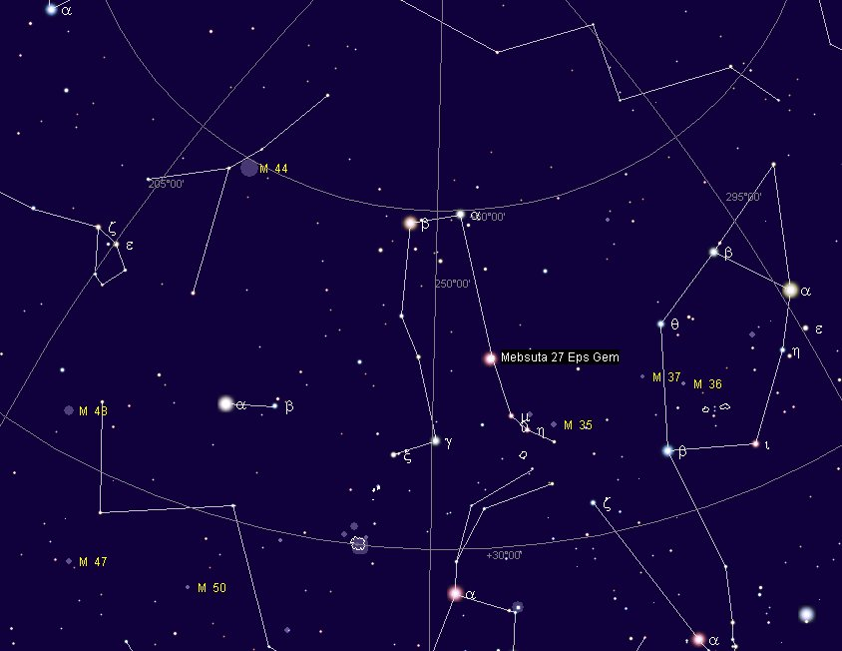

We should look for Castor (*113) and Pollux (*116). With Regulus (*152) at glyph number 188 we should find Pollux 36 positions earlier (→ Hb1-36), viz. at glyph number 188 - (152 - 116) = 152.
And August 20 (232, Regulus) - 36 = 196 (July 15). Here we can imagine a standing up and fully grown (tagata) Pollux person at left being the same person as the 'bird' to his night, presumably Castor - like a Beaver (Castor Fiber) hiding down in the dark watera.
3a
MAY 9 (129) | 10 (127 + 3) | 11 | 12 (196 - 64 = 132) | 13 (*53)
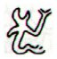 | 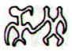 | 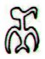 | 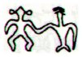 | 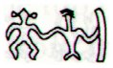
Hb4-2 (146 + 3) | Hb4-3 (150) | Hb4-4 | Hb4-5 (152) | Hb4-6 (53 + 100)
CASTOR | *111 + *3 | *115 (→ 460 / 4) | POLLUX | *117
12 | 13 (150 + 44) | July 14 | 15 (196) | 16 (53 + 144)

The change from the great night (Po) to light (Latin: Lux) was occurring halfway through July, and there was also a Roman river named Po.


Thus, which star was Significant at *363 (Hb1-33)?
I can find a pair by using the tool of fractions = .0 (for the Sun) and .4 (for the Moon):
Hb1-33
η Tucanae (363.0), ψ Pegasi (363.1), 32 Piscium (363.2), π Phoenicis (363.4), ε Tucanae (363.6), τ Phoenicis (363.9)
March 19 (78)
Sept 18 (78 + 183 = 261 = 9 * 29)

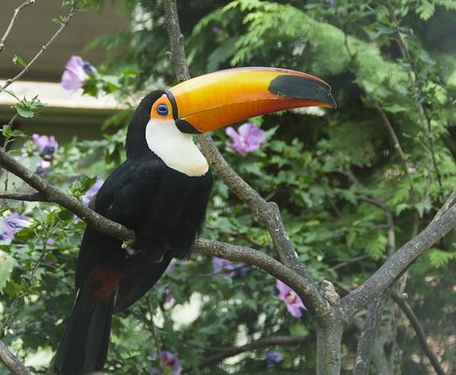

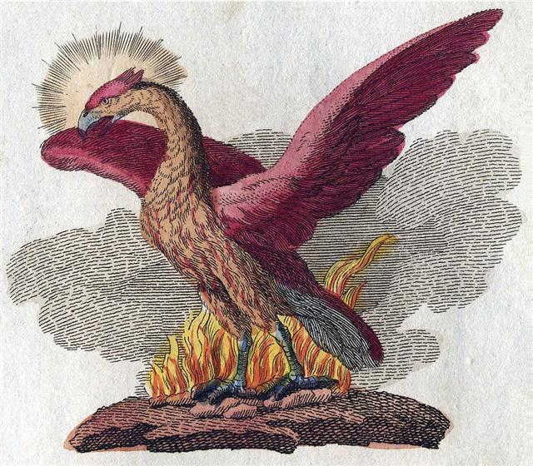

11-3. The Chinese delineated not a Square but a pair of straight parallel lines at the place for our Pegasus:
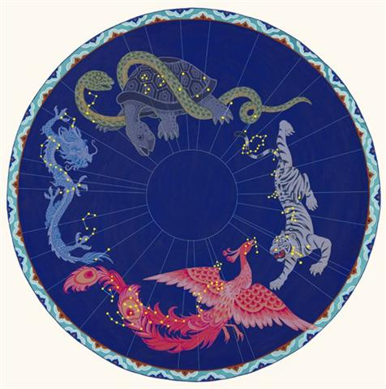

The first of these straight lines was associated with a House (→ home) and the 2nd with a Wall (→ rim).

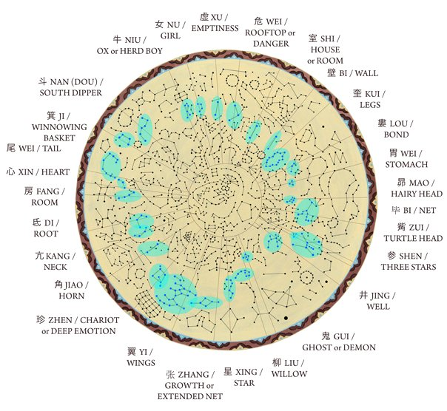

In between was the March Equinox:

1 | Horn | α Virginis (Spica) | Crocodile | (202.7) | Oct 9 (282)
2 | Neck | κ Virginis | Dragon | (214.8) | Oct 21 (294)
3 | Root | α Librae (Zuben Elgenubi) | Badger | (224.2) | Oct 31 (304)
4 | Room | π Scorpii (Vrischika) | Hare | (241.3) | Nov 17 (321)
5 | Heart | σ Scorpii | Fox | (247.0) | Nov 23 (327)
6 | Tail | μ Scorpii (Denebakrab) | Tiger | (254.7) | Nov 30 (334)
7 | Winnowing Basket | γ Sagittarii (Nash) | Leopard | (273.7) | Dec 19 (353)
December solstice
8 | South Dipper | φ Sagittarii (?) | Unicorn | (284.0) | Dec 30 (364)
9 | Ox / Herd Boy | β Capricornii (Dabih) | Buffalo | (308.0) | Jan 23 (388)
10 | Girl | ε Aquarii (Albali) | Bat | (314.8) | Jan 29 (394)
11 | Emptiness | β Aquarii (Sadalsud) | Rat | (325.9) | Feb 9 (405)
12 | Rooftop | α Aquarii (Sadalmelik) | Swallow | (334.6) | Feb 18 (414)
13 | House | α Pegasi (Markab) | Pig | (349.5) | Mar 5 (429)
March equinox
14 | Wall | γ Pegasi (Algenib) | Porcupine | (1.8) | Mar 22 (81)
15 | Legs | η Andromedae (?) | Wolf | (11.4) | Apr 1 (91)
16 | Bond | β Arietis (Sheratan) | Dog | (27.4) | Apr 17 (107)
17 | Stomach | 4¹ Arietis (Bharani) | Pheasant | (41.4) | May 1 (121)
18 | Hairy Head | η Tauri (Alcyone) (?) | Cockerel | (56.1) | May 16 (136)
19 | Net | ε Tauri (Ain) | Crow | (65.7) | May 25 (145)
20 | Turtle Head | λ Orionis (Heka) | Monkey | (83.2) | Jun 12 (163)
21 | Three Stars | ζ Orionis (Alnitak) | Gibbon | (84.7) | Jun 13 (164)
June solstice
22 | Well | μ Gemini (Tejat Posterior) | Tapir | (95.4) | Jun 24 (175)
23 | Ghost | ρ Gemini ? | Goat | (112.1) | Jul 11 (192)
24 | Willow | δ Hydrae | Stag | (129.6) | Jul 28 (209)
25 | Star | α Hydrae (Alphard) | Horse | (142.3) | Aug 10 (222)
26 | Extended Net | ε Hydrae / μ Hydrae | Ox | (131.9 / 157.1) | Jul 30 (211) / Aug 25 (237)
27 | Wings | α Crateris (Alkes) | Snake | (165.6) | Sep 2 (245)
28 | Chariot | γ Corvi (Gienah) | Worm | (185.1) | Sep 22 (265)
September equinox

Could these fundamental facts have inspired the creator of the H text to put a pair of parallel maitaki figures in front before Sirrah?
Hb1-33 | Hb1-34 | Hb1-35 | Hb1-36 | Hb1-37 | Hb1-38 | Hb1-39 | Hb1-40
*363 | *364 | SIRRAH | ALGENIB | *2 | *3 | *4 | *5
March 19 (78) | 20 (444) | 0h (*0) | 22 | 23 | 24 | Julian equinox | 26 (450)

