1 There ought to have been agreement by everyone that number 364 expressed the fact that the Sun year was not 365 days long but in reality 1 day less.
... Although the calendar has 365 days for a year this is due to the fact that the Earth has to turn around an extra day in order to compensate for how the direction to the Sun changes during a year ...
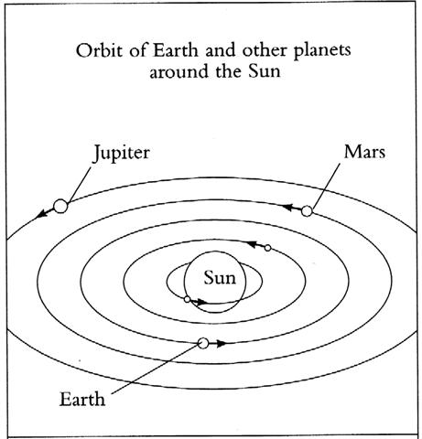
This surely would have been deduced at the very beginning when observant Man was looking up at the night sky.


2 That is, it was necessary to add 1 more day to 364 in order to reach what for some people might have appeared to be the length of a year.
... Ancient calendar-makers seem to have interposed the day which had no month, and was therefore not counted as part of the year, between the first and last of their artificial 28-day months: so that the farmer's year lasted, from the calendar-maker's point of view, literally a year and a day ...
... Curiously (and synchronously) I notice a paper slip in the book which I recently borrowed from the University Library at Lund (Barthel) demanding me to return the book within 364 days. I have never before seen that limit in practice ...
... The expression 'within a year and a day' may have meant that the last day in such a year was December 30 with Sirius at the Full Moon, and with the following day 31 belonging as day zero in the following year - similar to how in the night of the New Moon she was invisible...
... one of the Natives [by the name 'Maroowahai'] swam off to her and insisted on coming on board the ship where he remained two nights and a Day. The first thing he did after coming on board, was to measure the length of the Ship by fathoming her from the Tafferl to the Stern and as he counted the fathoms we observed that he called the Numbers by the same names as they do at Otaheite, Nevertheless his Languish was in a manner wholy unintelligible to all of us ...
... The author of the Book of Enoch in his treatise on astronomy and the calendar also reckoned a year to be 364 days, though he pronounced a curse on all who did not reckon a month to be 30 days long ...

As we can see the simple fact of 365 = 364 + 1 was an idea which generated (→) a swarm of offspring so to say.
... Night came, midnight came, and Tuu Maheke said to his brother, the last-born: 'You go and sleep. It is up to me to watch over the father.' (He said) the same to the second, the third, and the last. When all had left, when all the brothers were asleep, Tuu Maheke came and cut off the head of Hotu A Matua. Then he covered everything with soil. He hid (the head), took it, and went up. When he was inland, he put (the head) down at Te Avaava Maea. Another day dawned, and the men saw a dense swarm of flies pour forth and spread out like a whirlwind (ure tiatia moana) until it disappeared into the sky ...

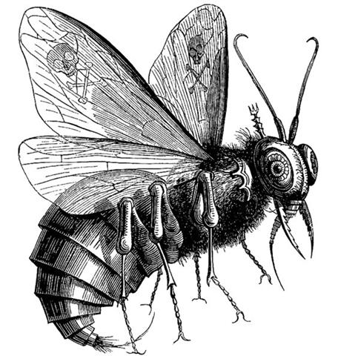

3 The Foundation 'Stone', 'Foot' (Temennu, Bunda) for 364
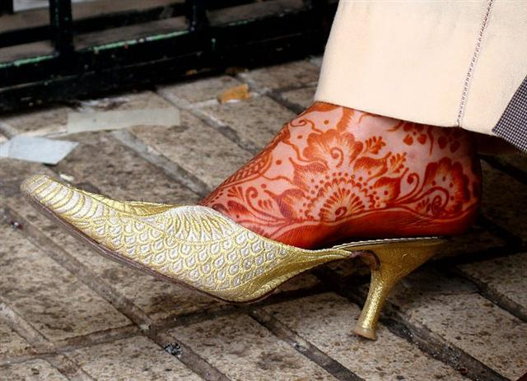
... The Arabians called it Al Dhāt al Kursiyy [cfr Cursa], the Lady in the Chair - Chilmead's Dhath Alcursi, - the Greek proper name having no significance to them; but the early Arabs had a very different figure here, in no way connected with the Lady as generally is supposed, - their Kaff al Hadib, the large Hand [cfr Caph] Stained with Henna, the bright stars marking the fingertips; although in this they included the nebulous group in the left hand of Perseus ...
could for instance generate the idea of 300 + 64 in order to separate the days of summer from the season when the Sun was 'dormant':
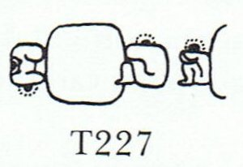

... The author of the Book of Enoch in his treatise on astronomy and the calendar also reckoned a year to be 364 days, though he pronounced a curse on all who did not reckon a month to be 30 days long ...
10 times 3(0) would correspond to the hands of 3 men, perhaps to be regarded as king makers:
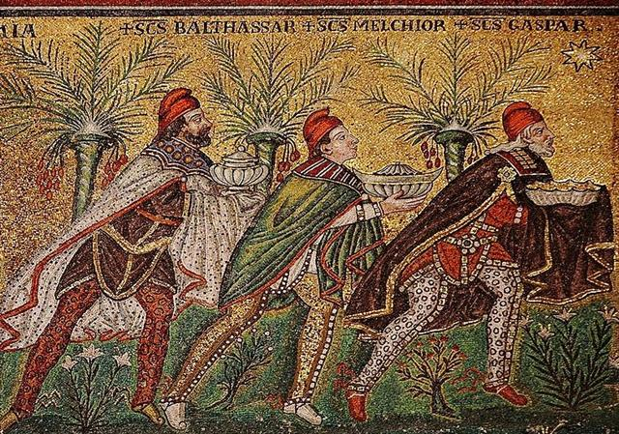
227 → 22 / 7 = π, cfr the glyph determined to be T227 above.
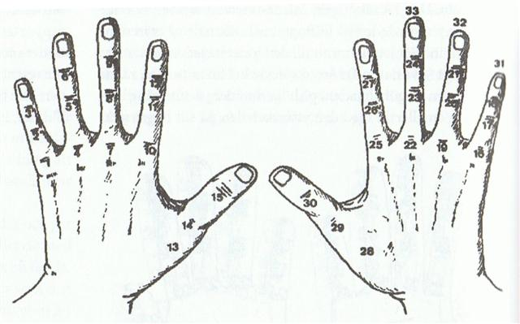

Which in turn ought to be reflected (as if written) in the night sky, because what was below should also be above.
... Ogotemmêli had his own ideas about calculation. The Dogon in fact did use the decimal system, because from the beginning they had counted on their fingers, but the basis of their reckoning had been the number eight and this number recurred in what they called in French la centaine, which for them meant eighty. Eighty was the limit of reckoning, after which a new series began. Nowadays there could be ten such series, so that the European 1,000 corresponded to the Dogon 800. But Ogotemmêli believed that in the beginning men counted by eights - the number of cowries on each hand, that they had used their ten fingers to arrive at eighty, but that the number eight appeared again in order to produce 640 (8 x 10 x 8). 'Six hundred and forty', he said, 'is the end of the reckoning.'

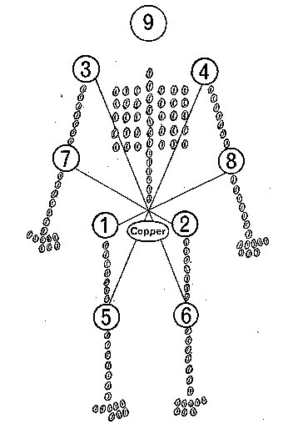

4 But obviously there were not 5 to be counted for each hand, because the thumbs were of another sort.
Thus there should be 10 - 2 = 8 true fingers for each Man. And since cowries visualized pairs 'face to face' they could symbolize merchants. Anciently cowries were used as a kind of coin.
... So the cowries that the father of the first twins found in the ground when harvesting millet after the second sowing, were a foreshadowing of commerce ...
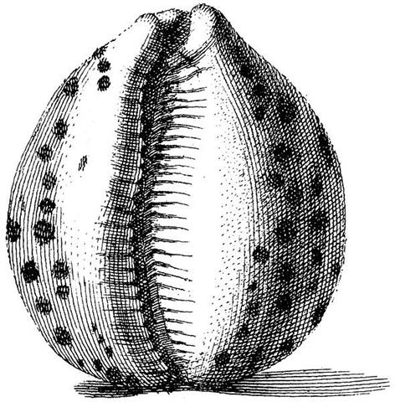

And therefore the counting for each true finger ought to be a pair, resulting in 4 * 2 = 8 for each hand.
(2 * 8 =) 16 times 3(0) could then be associated with (→) the hands of 3 hakaariki men.
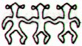

227 → 22 / 7 = π, cfr the glyph determined to be T227 above.
And looking again we will now perceive the Foot resting (moe) in the center of T227. (→ 2 * 27 = 54 = 354 - 300).
Moe. To sleep, to lie at full length, to dream, to brood, to place, to cohabit; moe atu, to leave off, to desist; moe atu ra, to adjourn, to postpone; moe hakahepo, to talk in the deep; moe aherepo, somnambulist, sleepwalker; moe hakataha, to sleep on the side; moe no, to oversleep, concubinage; moe tahae, to be a light sleeper; moe tahaga, a sleeper; moe vaeahatu, moe hakaroa, to sleep sprawling; rava moe, to sleep sound; ariga moe ki raro, to lie flat on the ground; tae moe, bachelor; hakamoe, to brood, to fold the wings; to reserve, to lay up; to struggle. P Pau.: moe, sleep. Mgv.: moe, sleep, to lie down, coitus, to shut the eyes. Mq.: moe, to sleep, to lie down; haámoe, to set down on the ground. Ta.: moe, to sleep, to lie down. Moea raruga, lying flat. Moeaivi, thin. Mq.: ivi, haáivi, id. Ta.: ivi, id. Moega, mat. Pau.: moehega, bed. Mgv.: moega, a sleeping mat. Mq.: moena, moeka, mat, floor cloth, bed. Ta.: moea, bed. Moemata, to sleep with the eyes open; mea moemata, phantom. Moemoea, a dream, vision; tikeahaga moemoea, apparition by night. T Mgv., Mq., Ta.: moemoea, dream. Churchill. Mgv. Moemoe, to steal, to purloin at a food distribution. Mq.: moemoe, to seize, to grasp. Churchill. Ta.: 1. Moemoe, ambush. Ha.: moemoe, id. 2. Moemoe, Phyllanthus simplex. To.: mohemohe, a tree. Churchill. Mq.: Moehu, exiled, banished, prisoner of war. Ma.: morehu, a survivor. Churchill.

16 * 3(0) = 48(0).
... The complementary C tablet - 242 (side b on the G tablet) + 348 (side b on the C tablet) = 59(0) → 20 * 29½ (synodic cycle of the Moon) - on the other hand, should be turned around after 740 - 260 = 480 nights as counted from Rigel.
*260 |  | *131 | 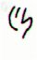 |  |  | *346
*260 | Ca10-6 (9 * 29) | *131 | Ca14-29 (392 → 56 weeks) |  | Cb1-1 (393) | *346
*260 | Dec 7 (*261) | *131 | April 16 (472) |  | April 17 (107 → 473 - 366) | *346
*260 | 'Nov 10 (314) | *131 | 'March 20 (445) |  | 'March 21 (80 = 107 - 27) | *346
*260 | ALRISHA | *131 | POLARIS (*26) |  | SHERATAN (*27.4) | *346
*260 | THUBAN | *131 | *209 |  | *210 → *27 + *183 | *346
*260 | June 7 (158) | *131 | Oct 16 (289) |  | Oct 17 (290 = 80 + 210) | *346
*260 | 'May 11 (131) | *131 | 'Sept 19 (2 * 131) |  | 'Sept 20 (263 = 290 - 27) | *346

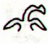
Cb14-18 | Cb14-19 (392 + 348 = 740)
March 28 (87 → 348 / 4) | 3-29 (107 + 347 - 366)
ANDROMEDA GALAXY (M31) | SCHEDIR (THE BREAST)
*190  ALDERAMIN | PORRIMA (*191)  M104 (SOMBRERO)
Sept 27 (9 * 30 = 270) | Sept 28 (271)
'Aug 31 (243 = 270 - 27) | JULY 26 (207 = 271 - 64)

In short:
 | *479
Ca10-6 (261) | *479 | Cb14-19 (740)
ALRISHA | *479 | SCHEDIR (*8)
THUBAN | *479 | PORRIMA (*191)
From the 'Foot' Rigel (resting on Cursa, the 'chair') ideally visible at the right ascension line of the Full Moon in the night of June 7 - at the place where Thuban was bound to culminate at 21h - to the place where the Sun would rise in the east together with the Breast (Schedir) of Cassiopeia there should be 48(0) days. (→ twice 24h).

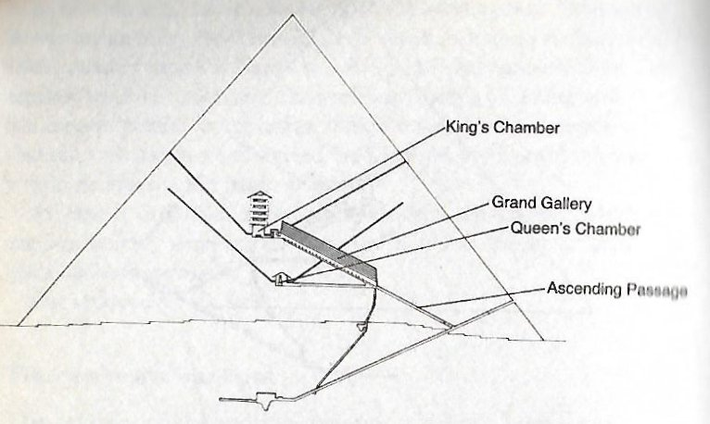

261 (9 * 29, Rigel) + 365 + 115 (Mercury) = 480.
December 7 (341 = 11 * 31) + 115 = 456 (April 25).
... On the twenty-fifth day [raa] of the first month ('Vaitu Nui'), Ira and Makoi set sail; on the first day [te raa po rae] of the month of June ('Maro'), the bow [te ihu] of Ira's canoe touched land again ... [E:17]
456 = 6 * 76 and *76 was at Cursa (the resting chair - mat, moega - for the Foot):
... That there is a whirlpool in the sky is well known, it is most probably the essential one, and it is precisely located. It is a group of stars so named (zalos) at the foot of Orion, close to Rigel (beta Orionis, Rigel being the Arabic word for 'foot'), the degree of which was called 'death', according to Hermes Trismegistos, whereas the Maori claim outright that Rigel marked the way to Hades (Castor indicating the primordial homeland) ...
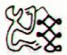 | 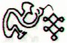 |  | 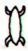
Ca10-4 | Ca10-5 (260) | Ca10-6 (9 * 29) | Ca10-7 (262)
Dec 5 | Dec 6 | Dec 7 (341, *261) | Dec 8
...We should now of course take a look at June 6 according to Ca10-5 (260) and also at December 6 (340) where the planet Mars was bound to cross over his own path.
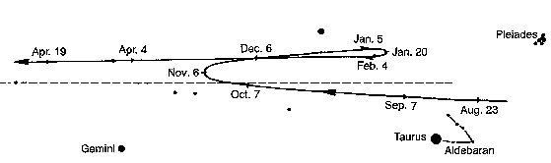
Mula-19 (The Root)  *259 | RAS ALGETHI | Sarin (*261.0), ο Ophiuchi (*261.4)  ALRISHA | θ Ophiuchi, ν Serpentis, ζ, ι Apodis (*262.4)
5h (*76.1)  CURSA (*76.4)  ψ (65) ERIDANI | *77 | CAPELLA (*78.4)  THUBAN | *262 + *183 = *445  ARCTURUS
June 5 | 6-6 (314 / 2) | June 7 (158, *78) | June 8
"April 25 (115) | 26 (4 * 29) | 27 (158 - 41 = 117, *37) | "April 28 (→ 4 * 29½)
APRIL 2 (*12) | 3 (93 → 3 * 31) | 4 (158 - 64 = 94, *14) | APRIL 5 (95, *79 - *64)
te kiore - te inoino | kua oho te rima kua kai - ihe nuku hoi | Tupu te toromiro | kua noho te vai
Kiore. Rat. Vanaga. Rat, mouse; kiore hiva, rabbit. P Pau., Mgv.: kiore, rat, mouse. Mq.: kioē, íoé, id. Ta.: iore, id. Churchill.
... In China, with Capricornus, Pisces, and a part of Sagittarius, it [Aquarius] constituted the early Serpent, or Turtle, Tien Yuen; and later was known as Hiuen Ying, the Dark Warrior and Hero, or Darkly Flourishing One, the Hiuen Wu, or Hiuen Heaou, of the Han dynasty, which Dupuis gave as Hiven Mao. It was a symbol of the emperor Tchoun Hin, in whose reign was a great deluge; but after the Jesuits came in it became Paou Ping, the Precious Vase. It contained three of the sieu, and headed the list of zodiac signs as the Rat, which in the far East was the ideograph for 'water', and still so remains in the almanacs of Central Asia, Cochin China, and Japan ...
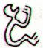
... The decoded meaning of the names 'the dark rat' (i.e., the island king as the recipient of gifts) and 'the gathering place of the island population' (for the purpose of presenting the island king with gifts) links them with the month 'Maro', which is June ...
Toromiro. Sophora toromiro, a tree endemic to Easter Island and preferably used for wood carving. Hard, finely grained, reddish wood. Heyerdahl 3. Tree (Sophora tetraptera) anciently used for sculpting the statuettes called moai toromiro. Vanaga. The heaviest and hardest wood, it is used for tapa beaters T. Churchill. Sophera toromiro. The hard wood of the toromiro tree was the most important material for all kinds of wood, work, from the construction of houses and of canoes to the manufacture of sculptures and other items. Barthel 2.

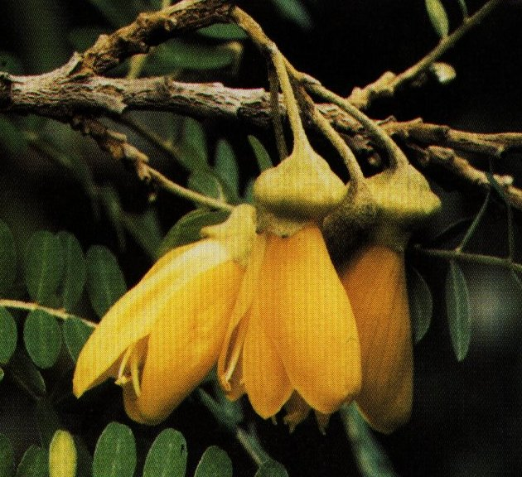

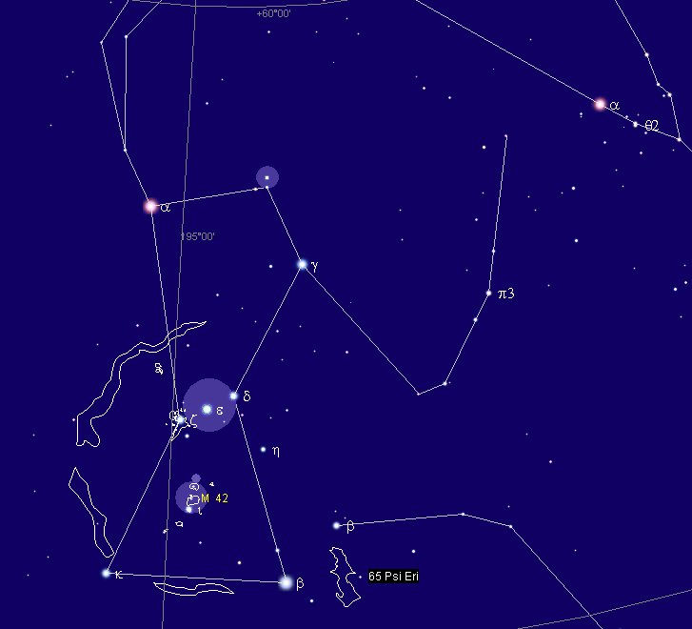

5 So number 10 should not correspond to the number of fingers on a Man. Instead we ought to consider the 10 leading stars in the night:
... Aries only rose to its prominent position as the leading sign of the zodiac in the Neo-Babylonian (7th century BCE) revision of the Babylonian zodiac, as Hamal (α Ari) came to be located close to the point of vernal equinox ...
... Strassmeier and Epping, in their Astronomishes aus Babylon, say that there its stars formed the third of the twenty-eight ecliptic constellations, - Arku-sha-rishu-ku, literally the Back of the Head of Ku, - which had been established along that great circle milleniums before our era; and Lenormant quotes, as an individual title from cuneiform inscriptions, Dil-kar, the Proclaimer of Dawn, that Jensen reads As-kar, and others Dil-gan, the Messenger of Light.
George Smith inferred from the tablets that it might be the Star of the Flocks; while other Euphratean names have been Lu-lim, or Lu-nit, the Ram's Eye; and Si-mal or Si-mul, the Horn star, which came down even to late astrology as the Ram's Horn. It also was Anuv, and had its constellation's titles I-ku and I-ku-u, - by abbreviation Ku, - the Prince, or the Leading One, the Ram that led the heavenly flock, some of íts titles at a different date being applied to Capella of Auriga. Brown associates it with Aloros, the first of the ten mythical kings of Akkad anterior to the Deluge, the duration of whose reigns proportionately coincided with the distances apart of the ten chief ecliptic stars beginning with Hamal, and he deduces from this kingly title the Assyrian Ailuv, and hence the Hebrew Ayil; the other stars corresponding to the other mythical kings being Alcyone, Aldebaran, Pollux, Regulus, Spica, Antares, Algenib, Deneb Algedi, and Scheat ...
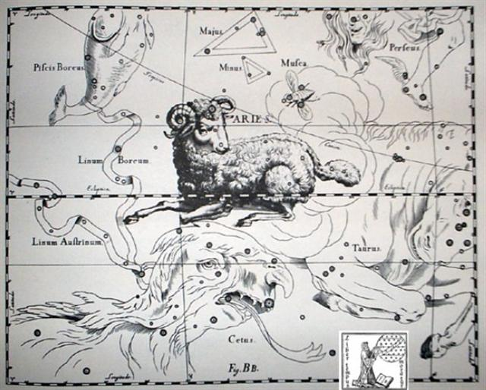

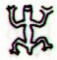
Ca10-8 | Ca10-9 (264) |  | Ca10-10 (→ 365 - 100)
Dec 9 | 10 (161 + 183, *364) |  | 11 (345 → 3 * 115)
*263 | LESATH (Sting) |  | Al Shaula-17  SHAULA (Sting)  HAMAL (α ARIETIS)
BELLATRIX (γ), Saif al Jabbar (*80.7), ELNATH (*80.9) | NIHAL (*81.7) |  | KHUFU  MINTAKA (*82.4), ε Columbae (*82.6)
June 9 (2 * 80) | 10 (161) |  | 11
"April 29 | 30 (161 - 41 = 120) |  | "May 1 (11 * 11)
APRIL 6 (192 / 2) | 7 (161 - 64 = 97) |  | 8 (2 * 49)
te moko | te marama |  | te kava
... A une certaine saison, on amassait des vivres, on faissait fête. On emmaillottait un corail, pierre de defunt lézard, on l'enterrait, tanu. Cette cérémonie était un point de départ pour beaucoup d'affaires, notamment de vacances pour le chant des tablettes ou de la prière, tanu i te tau moko o tana pure, enterrer la pierre sépulcrale du lézard de sa prière ...
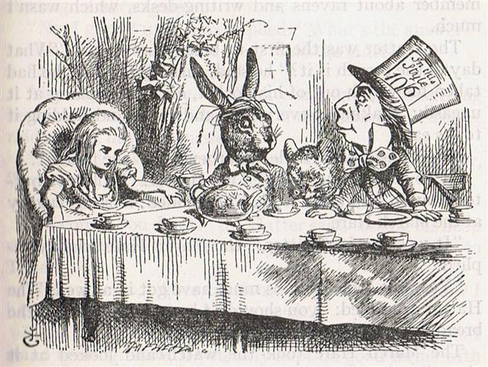
... Midsummer is the flowering season of the oak, which is the tree of endurance and triumph, and like the ash is said to 'court the lightning flash'. Its roots are believed to extend as deep underground as its branches rise in the air - Virgil mentions this - which makes it emblematic of a god whose law runs both in Heaven and in the Underworld ... The month, which takes its name from Juppiter the oak-god, begins on June 10th and ends of July 7th. Midway comes St. John's Day, June 24th, the day on which the oak-king was sacrificially burned alive. The Celtic year was divided into two halves with the second half beginning in July, apparently after a seven-day wake, or funeral feast, in the oak-king's honour ...

From APRIL 7 (Ca10-9) to July 7 (when the month of the oak-god was ending) we can count 188 - 97 = 91 → 364 / 4.
As we have seen, the star Hamal (Lu-lim) should be at the beinning of a list of 10 (or 8) antediluvian kings and correspond to Adam in the Bible:
The Bible (King James' verison)
1 Adam | 130
2 Seth | 105
3 Enoch | 90
4 Kenan | 70
5 Mahalel | 65
6 Jared | 162
7 Enoch | 65
8 Methuselah | 187
9 Lamech | 182
10 Noah: until Flood | 600
Sum | 1,656

ko oto uta | ariki motongi | 1
ko tangaroa.a oto uta | ariki motongi | 2
ko tiki hati.a tangaroa | ariki motongi | 3
ko roroi.a tiki hati | ariki motongi | 4
ko tuu kumā.a roroi | ariki motongi | 5
ko ataranga.a tuu kumā | ariki motongi | 6
ko harai.a ataranga | ariki motongi | 7
ko taana.a harai | ariki motongi | 8
ko matua.a taana | ariki motongi | 9
ko hotu.a matua | ariki motongi | 10

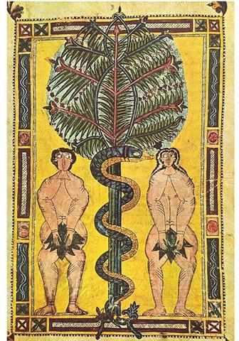

6 The 'age' of Noah before he went onboard his Ark was said to have been 600:
The Bible (King James' verison)
1 Adam | 130 | 130
2 Seth | 105 | 235
3 Enoch | 90 | 325
4 Kenan | 70 | 395
5 Mahalel | 65 | 460
6 Jared | 162 | 622
7 Enoch | 65 | 687
8 Methuselah | 187 | 874
9 Lamech | 182 | 1056
10 Noah: until Flood | 600 | ↓
Sum | 1,656 | 4 * 264
And in the table above I have suggested the sum of 'years' up to Noah should be perceived as 4 times 264 (= 1056), because I was inluenced by glyph number 264 at Ca10-9:
Ca10-8 | Ca10-9 (264) |  | Ca10-10 (→ 365 - 100)
Dec 9 | 10 (161 + 183, *364) |  | 11 (345 → 3 * 115)
*263 | LESATH (Sting) |  | Al Shaula-17  SHAULA (Sting)  HAMAL (α ARIETIS)
BELLATRIX (γ), Saif al Jabbar (*80.7), ELNATH (*80.9) | NIHAL (*81.7) |  | KHUFU  MINTAKA (*82.4), ε Columbae (*82.6)
June 9 (2 * 80) | 10 (161) |  | 11
"April 29 | 30 (161 - 41 = 120) |  | "May 1 (11 * 11)
APRIL 6 (192 / 2) | 7 (161 - 64 = 97) |  | 8 (2 * 49)
te moko | te marama |  | te kava
... A une certaine saison, on amassait des vivres, on faissait fête. On emmaillottait un corail, pierre de defunt lézard, on l'enterrait, tanu. Cette cérémonie était un point de départ pour beaucoup d'affaires, notamment de vacances pour le chant des tablettes ou de la prière, tanu i te tau moko o tana pure, enterrer la pierre sépulcrale du lézard de sa prière ...
... Midsummer is the flowering season of the oak, which is the tree of endurance and triumph, and like the ash is said to 'court the lightning flash'. Its roots are believed to extend as deep underground as its branches rise in the air - Virgil mentions this - which makes it emblematic of a god whose law runs both in Heaven and in the Underworld ... The month, which takes its name from Juppiter the oak-god, begins on June 10th and ends of July 7th. Midway comes St. John's Day, June 24th, the day on which the oak-king was sacrificially burned alive. The Celtic year was divided into two halves with the second half beginning in July, apparently after a seven-day wake, or funeral feast, in the oak-king's honour ...
From APRIL 7 (Ca10-9) to July 7 (when the month of the oak-god was ending) we can count 188 - 97 = 91 → 364 / 4.

Presumably these ridiculously high 'age' numbers for the antediluvian kings were used to document exact astronomical measures (before the introduction of the decimal point). In which case 600 at Noah could be perceived as 60.0.
And with every month measured as 30 days there would therefore be 2 months before Noah encountered the Flood.
... The author of the Book of Enoch in his treatise on astronomy and the calendar also reckoned a year to be 364 days, though he pronounced a curse on all who did not reckon a month to be 30 days long ...
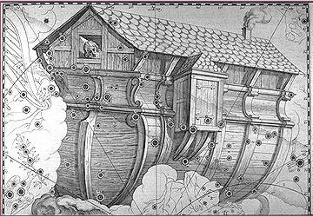

From this we can then guess that 10 should be understood as 1. Which would give us a reasonable explanation for 10 mythical kings before the deluge. They would not be different but in essence the same. For we should remember that in ancient Mesopotamia 60 was the number corresponding to our base (foundation) number 10.
... It also was Anuv, and had its constellation's titles I-ku and I-ku-u, - by abbreviation Ku, - the Prince, or the Leading One, the Ram that led the heavenly flock ...

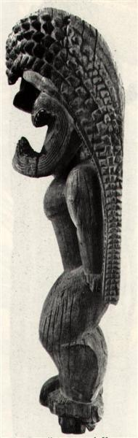
... In many Polynesian cultures the bodies of gods were conceived of as covered with feathers and they were frequently associated with birds: in Tahiti and the Society Islands, bird calls on the marae signaled the presence of the gods. Hawaiian feathered god figures generally depict only the head and neck of the god ...
... According to an etiological Hawaiian myth, the breadfruit originated from the sacrifice of the war god Kū. After deciding to live secretly among mortals as a farmer, Ku married and had children. He and his family lived happily until a famine seized their island. When he could no longer bear to watch his children suffer, Ku told his wife that he could deliver them from starvation, but to do so he would have to leave them. Reluctantly, she agreed, and at her word, Ku descended into the ground right where he had stood until only the top of his head was visible. His family waited around the spot he had last been day and night, watering it with their tears until suddenly a small green shoot appeared where Ku had stood. Quickly, the shoot grew into a tall and leafy tree that was laden with heavy breadfruits that Ku's family and neighbors gratefully ate, joyfully saved from starvation ...

This explanation does not rule out other ideas. For instance was Enoch number 7 (→ 364 / 52) in the list and the preceding king Jared reached the age of 162 → 52 + 110.
.. About Carmenta we know from the historian Dionysus Periergetis that she gave orcales to Hercules and lived to the age of 110 years. 110 was a canonical number, the ideal age which every Egyptian wished to reach and the age at which, for example, the patriarch Joseph died. The 110 years were made up of twenty-two Etruscan lustra of five years each; and 110 years composed the 'cycle' taken over from the Etruscans by the Romans. At the end of each cycle they corrected irregularities in the solar calendar by intercalation and held Secular Games ...
162 (Jared) + 65 (Enoch) = 227 → 22 7 → 22 / 7 → π.
Up to and including the 5th king Mahalel (number 5) the sum was 460 → 46.0 →
... Allen has documented all his star culminations at 21h, which could be due to an effort of keeping the culminations at their proper places according to the ancients, 24h (spring equinox) - 21h = 3h = 24h / 8 = 45º. 3h corresponds to 366 / 8 = 45.75 of my right ascension days and *366 - *46 = *320 (Dramasa, σ Octantis) ...
And 7 times 150 = 150 weeks = 1050 = 1056 - 6 = 4 * 264 - 6. The number for the 2nd king Seth was given as 150 (→ 78 + 72):
... But Osiris's evil brother, Set, whose sister-wife was the goddess Nephtys, was mortally jealous both of his virtue and of his fame, and so, stealthily taking the measure of his good brother's body, he caused a beautifully decorated sarcophagus to be fashioned and on a certain occasion in the palace, when all were drinking and making merry, had it brought into the room and jestingly promised to give it to the one whom it should fit exactly. All tried, but, like the glass slipper of Cinderella, it fitted but one; and when Osiris, the last, laid himself within it, immediately a company of seventy-two conspirators with whom Set had contrived his plot dashed forward, nailed the lid upon the sarcophagus, soldered it with molten lead, and flung it into the Nile, down which it floated to the sea ...

And 2 * 78 (→ Rigel) = 156 → 144 + 12 → 150 + 6:.
... Menkaure was allegedly a much more benevolent Pharaoh than his predecessors. According to legends related by Herodotus, he wrote the following: This Prince (Mycerinus) disapproved of the conduct of his father, reopened the temples and allowed the people, who were ground down to the lowest point of misery, to return to their occupations and to resume the practice of sacrifice. His justice in the decision of causes was beyond that of all the former kings. The Egyptians praise him in this respect more highly than any other monarchs, declaring that he not only gave his judgements with fairness, but also, when anyone was dissatisfied with his sentence, made compensation to him out of his own purse and thus pacified his anger. The Gods however ordained that Egypt should suffer tyrannical rulers for a hundred and fifty years according to this legend. Herodotus goes on: An oracle reached him from the town of Buto, which said 'six years only shalt thou live upon this earth, and in the seventh thou shalt end thy days' ...

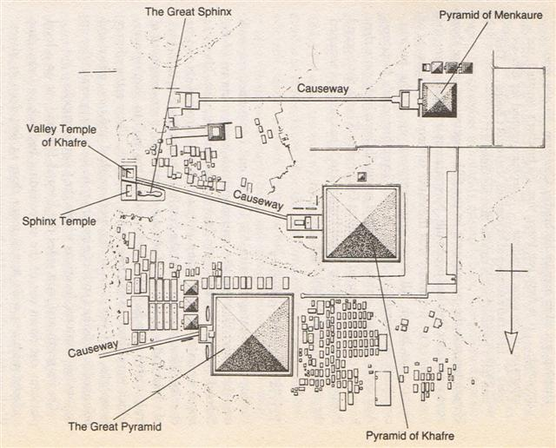

APRIL 8 | 9 (99) | 10 (465) | 11 (*21)
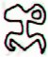 |  | 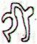
Ga1-18 → 118 = 241 - 123 | Ga1-19 → 384 - 365 | Ga1-20 | Ga1-21
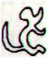 | 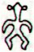 |  | 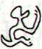
Gb6-1 (383 = 365 + 18) | Gb6-2 | Gb6-3 (385 = 465 - 80) | Gb6-4 (229 + 314 / 2)
PLACE OF THE SUN:
KHUFU  MINTAKA (Belt) = δ Orionis, υ Orionis (82.4), χ Aurigae (82.5), ε Columbae (82.6)  *41.0 = *82.4 - *41.4  → 41 Arietis (Bharani) | KHAFRE  Al Hak'ah-3 (White Spot) / Mrigashīrsha-5 (Stag's Head) / Turtle Head-20 (Monkey) / Mas-tab-ba-tur-tur (Little Twins)  ARNEB = α Leporis, CRAB NEBULA = M1 Tauri (83.0), φ¹ Orionis (83.1), HEKA (KAKKAB SAR, the Constellation of the King), λ Orionis, ORION NEBULA = M42 (83.2), φ² Orionis (83.6), ALNILAM (String of Pearls) = ε Orionis (83.7) | MENKAURE  Three Stars-21 (Gibbon) / Shur-narkabti-sha-shūtū-6 (Star in the Bull towards the south) / ANA-IVA-9 (Pillar of exit)  HEAVENLY GATE = ζ Tauri, ν Columbae (84.0), ω Orionis (84.2), 121 Tauri (84.6), ALNITAK (Girdle) = ζ Orionis, PHAKT (Phaet) = α Columbae (84.7)  Nov 6 AD 2022 (310, *230)  MARS | ο Aurigae (85.8), γ Leporis (85.9)  YANG MUN (α Lupi)
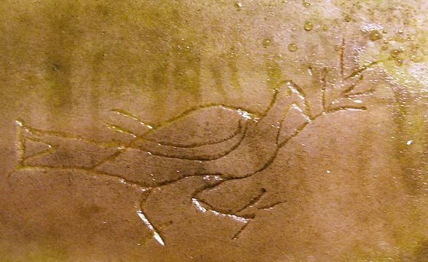
June 11 (162) | 12 (*448) | 13 (*84) | 14 (530)
°June 7 | 8 (*444) | 9 (*80) | 10 (161)
'May 15 (500 = 365 + 135) | 16 (136, *56) | 17 (*422) | 18 (*58)
"May 1 (486 = 468 + 18) | 2 (*407) | 3 (123) | 4 (*44)
THE NAKSHATRA VIEW:
OCT 7 (280) | 8 (*201) | 9 (282) | 10 (648 = 365 + 283)
LESATH (Sting) = υ (325) Scorpii, δ Arae (264.7), CHOO (Club) = α Arae (264.9) | Al Shaula-17  ALWAID (Mother Camels) = β Draconis, MAASYM (Wrist) = λ Herculis (265.1), SHAULA (Sting) = λ Scorpii (265.3), KUMA = ν Draconis (265.6), σ Arae (265.9)  HAMAL (α ARIETIS) | RAS ALHAGUE (Head of the Serpent Charmer) = α Ophiuchi (266.1), SARGAS = θ Scorpii (266.3), μ Ophiuchi, π Arae (266.5), NAN HAE (Southern Sea) = ξ Serpentis (266.6), AL DHĪLI (The Wolf) = ω Draconis, ι Herculis (266.7) | λ Arae (267.1), GIRTAB (Seizer) = κ Scorpii, ο Serpentis (267.6), DSIBAN (Wolf Pair) = ψ Draconis (267.9)
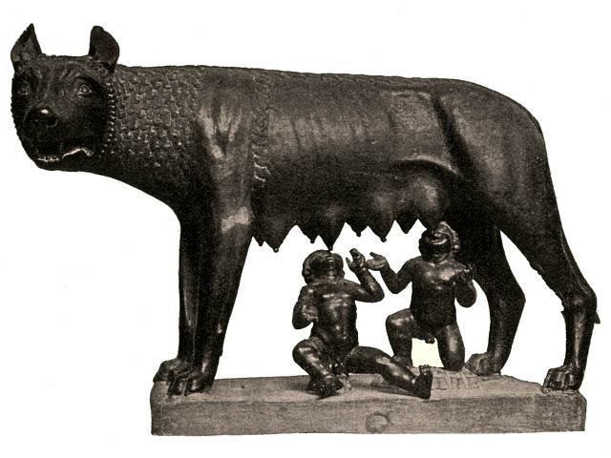
Dec 10 (*264) | 11 (345) | 12 | 13 (347)
°Dec 6 (*260) | 7 (341) | 8 | 9 (343)
'Nov 13 (*237) | 14 (318) | 15 | 16 (320)
"Oct 30 | 31 (304) | "Nov 1 | 2 (*226)
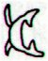 | 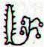 | 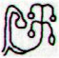 | 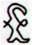
Ga7-31 (200) | Ga7-32 | Ga7-33 (202) | Ga7-34
... The 'classic' version, however, was much more detailed: the rope would seem to rise high into the skies, disappearing from view. The boy would climb the rope and be lost to view. The magician would call back his boy assistant, and, on getting no response, become furious. The magician then armed himself with a knife or sword and climbed the rope, vanishing too. An argument would be heard, and then limbs would start falling, presumably cut from the assistant by the magician. When all the parts of the body, including the torso, landed on the ground, the magician would climb down the rope. He would collect the limbs and put them in a basket, or collect the limbs in one place and cover them with a cape or blanket. Soon the boy would appear, restored ...
And the sum of 'years' up to and including Enoch was 687 which can be explaind as 460 (Mahalel) + 227 (→ π).

The antediluvian 'land' ruled by these kings should be looked for up in the night sky. And then we should come to realize that the serpentine undulations of ebb and flood
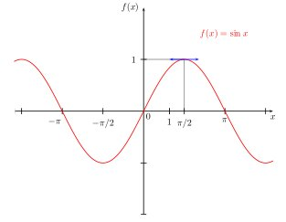
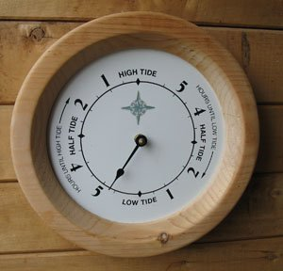

would be absent at the north pole (as well as at the south pole).
... I became curious about this star ... called Nuutuittuq [= 'never moves'] ... So, on the lee side of our uquutaq (a snow windbreak) I positioned a harpoon pointing directly at this particular star to see if it would move. In the morning I checked it and discovered that the Tukturjuit (Ursa Major) had changed their position completely but the harpoon still pointed at this star ... I had discovered the stationary star ...

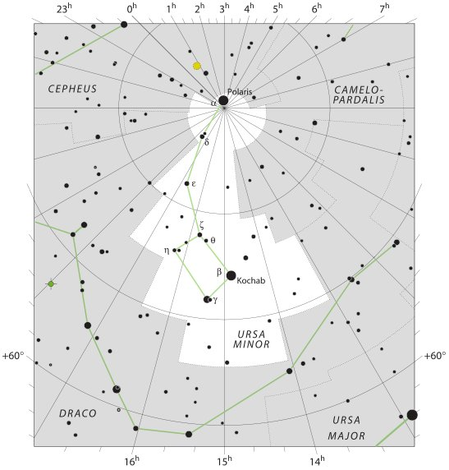
Ursa Minor was higher up than 60º and the threat from Ursa Major.



7 Ursa Minor was the Little Bear - and as such had to climb up in a tall pine tree whenever danger threatened down below on the level ground. Such as for instance from an adult bear who would not hesitate to see small bears as prey.
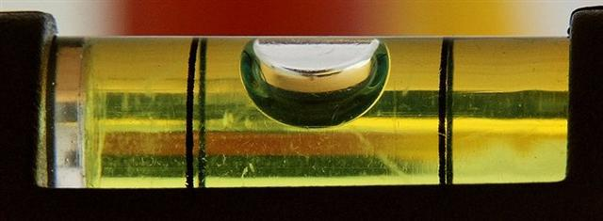
And its leading star Polaris was high up as the current star at the north pole - strangely on the other side as compared to the rest of the constellation lower down. And also compared to the Great Bear, Ursa Major (Tukturjuit):
Close up to the pole time would gradually move slower and slower because precisely at the pole there was a point of change from one direction into its opposite:

Which means that exactly at the pole the 'coin' would be turned around. On one side the 'head' was shining bald and on the other it was in the dark shadows, covered over as if by a piece of cloth (puo) - cfr Gb8-8 (Bharani) and Gb8-30 (Hyadum I).
Puo. (Also pu'a); pu'o nua, one who covers himself with a nua (blanket), that is to say, a human being. Vanaga. 1. To dress, to clothe, to dress the hair; puoa, clothed; puoa tahaga, always dressed. 2. To daub, to besmear (cf. pua 2); puo ei oone, to daub with dirt, to smear. 3. Ata puo, to hill up a plant. Churchill.
... The ancient Chinese believed that with the arrival of the dry season the earth and sky ceased to communicate. The Spirit of drought was personified by a little bald woman with eyes at the top of her head. While she was present, the sky refrained from sending rain, so as not to harm her. Hills and rivers are the first to suffer from drought. It deprives hills of their trees, i.e. their hair, and rivers of their fish, which are their people. The same word, wang, means mad, deceitful, lame, hunchbacked, bald and Spirit of drought ...
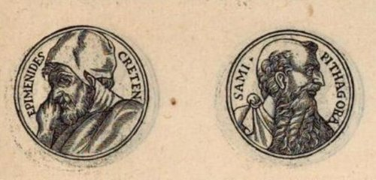

... The story is in Chapter ten in his section on the Seven Sages, who were the precursors to the first philosophers. The sage was Epimenides. Apparently Epimenides went to sleep in a cave for fifty-seven years. But unfortunately, 'he became old in as many days as he had slept years'. Although according to the different sources that Diogenes relates, Epimenides lived to be one hundred and fifty-seven years, two hundred and ninety-nine years, or one hundred and fifty-four years. A similar story is told of the Seven Sleepers of Ephesus, Christian saints who fall asleep in a cave while avoiding Roman persecution, and awake more than a century later to find that Christianity has become the religion of the Empire ...

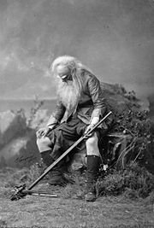

8 High up in the north, towards the top of the Earth Mountain, it was bitterly cold and its land was deserted. When old the body will no longer be as warm, soft, and well coming as before.
... Yudhishtira, the eldest of the five Pandhavas, becoming weary of the world, resolves to retire from the sovereignty and acquire merit by pilgrimage. On hearing of his intentions his four brothers - Bhima, Arjuna, and the twins Nakula and Sahadeva - resolve to follow his example and accompany him. Yudhishtira appoints successors to his various kingdoms. The citizens and the inhabitants of the provinces, hearing the king's words, became filled with anxiety and disapproved of them. 'This should never be done' - said they unto the king. The monarch, well versed with the changes brought about by time, did not listen to their counsels. Possessed of righteous soul, he persuaded the people to sanction his views ... The five brothers, with Draupadi forming the sixth [she was the joint wife of the brothers], and a dog forming the seventh, set out on their journey. The citizens and the ladies of the royal household followed them for some distance ... The denizens of the city then returned. The seven pilgrims meanwhile had set out upon their journey. They first wandered eastward, then southward, and then westward. Lastly they faced northward and crossed the Himalaya. Then they beheld before them a vast desert of sand and beyond it Mount Meru. One by one the pilgrims sank exhausted and expired, first Draupadi, then the twins, then Arjuna, then Bhima; but Yudhishtira, who never even looked back at his fallen comrades, still pressed on and, followed by the faithful dog who turns out to be Dharma (the Law), in disguise, entered Heaven in his mortal body, not having tasted death ...
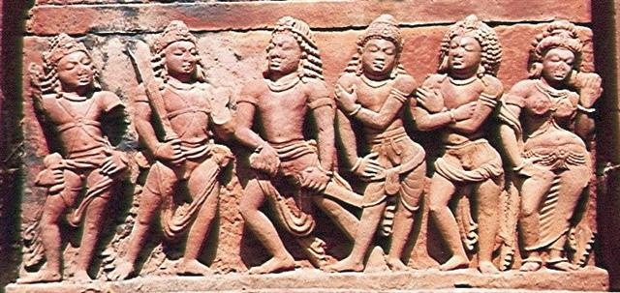
... The ancient Chinese believed that with the arrival of the dry season the earth and sky ceased to communicate. The Spirit of drought was personified by a little bald woman with eyes at the top of her head. While she was present, the sky refrained from sending rain, so as not to harm her. Hills and rivers are the first to suffer from drought. It deprives hills of their trees, i.e. their hair, and rivers of their fish, which are their people. The same word, wang, means mad, deceitful, lame, hunchbacked, bald and Spirit of drought ...

Because warmth is created by movements and old people will no longer jump arund.
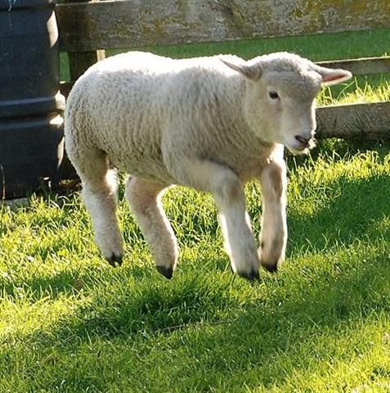
Towards the poles the distance between the right ascension lines will become more narrow, ultimately leading them all together to a full stop (the spider's home).
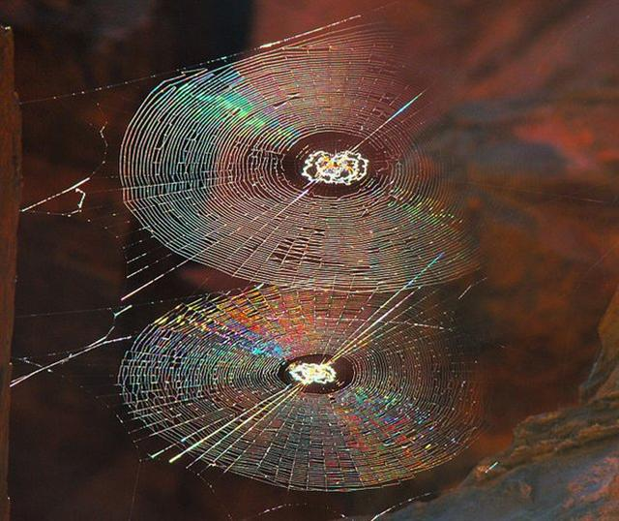

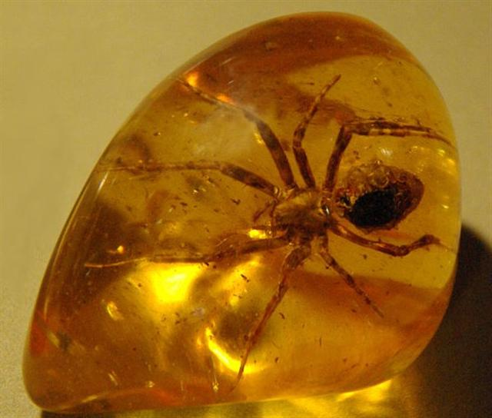
... Take the lower part of a gourd or hula drum, rounded as a wheel (globe), on which several lines are to be marked and burned in, as described hereafter. These lines are called na alanui o na hoku hookele, the highways of the navigation stars, which stars are also called na hoku ai-aina, the stars which rule the land. Stars lying outside these three lines are called na hoku a ka lewa, foreign, strange, or outside stars. The first line is drawn from Hoku-paa, the fixed or North Star, to the most southerly star of Newe, the Southern Cross. (This hour circle coincides with the meridian on an evening in June, when it would divide the visible sky into halves.) The portion (of the sky) to the right or east of this line (the observer is evidently assumed to be facing north) is called ke ala ula a Kane, the dawning or bright road of Kane, and that to the left or west is called ke alanui maawe ula a Kanaloa, the much-traveled highway of Kanaloa. (Kane and Kanaloa were important gods in the Polynesian pantheon, Kane being associated with light, Kanaloa with darkness.) Then three lines are drawn east and west, one across the northern section indicates the northern limit of the Sun (corresponding with the Tropic of Cancer) about the 15th and 16th days of the month Kaulua (i.e., the 21st or 22nd of June) and is called ke alanui polohiwa a Kane, the black-shining road of Kane. The line across the southern section indicates the southern limit of the Sun about the 15th or 16th days of the month Hilinama (December 22) and is called ke alanui polohiwa a Kanaloa, the black-shining road of Kanaloa. The line exactly around the middle of the sphere is called ke alanui a ke ku'uku'u, the road of the spider ...

According to Einstein's theory of gravitation time will appear to move slower and slower for a clock seen rushing towards a black hole. Space-time will no longer appear to be straight and instead it will look curved.
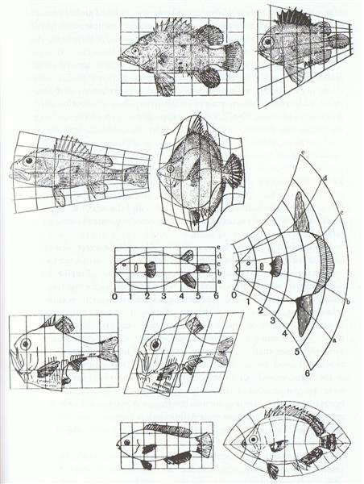
Also the ancient time-space curvatures should result in slowing down.
... The dream soul moved along a curve from Peke Tau O Hiti to the mountain Hau Epa, which she named 'Maunga Hau Epa A Hau Maka O Hiva.' The dream soul went to the other side of the mountain Hau Epa. As soon as the dream soul looked around, she saw the sand (beach), which was very white and light. She remained there and explored everything ...

This effect caused both Epimenides and the Seven Sleepers of Ephesus to remain young when the rest of the world kept on ageing.
And it caused trouble also for Rip Van Winkle:
... The story of Rip Van Winkle is set in the years before and after the American Revolutionary War. Rip Van Winkle, a villager of Dutch descent, lives in a nice village at the foot of New York's Catskill Mountains. An amiable man whose home and farm suffer from his lazy neglect, he is loved by all but his wife. One autumn day he escapes his nagging wife by wandering up the mountains. After encountering strangely dressed men, rumored to be the ghosts of Henry Hudson's crew, who are playing nine-pins, and after drinking some of their liquor, he settles down under a shady tree and falls asleep. He wakes up twenty years later and returns to his village. He finds out that his wife is dead and his close friends have died in a war or gone somewhere else. He immediately gets into trouble when he hails himself a loyal subject of King George III, not knowing that in the meantime the American Revolution has taken place. An old local recognizes him, however, and Rip's now grown daughter eventually puts him up ...

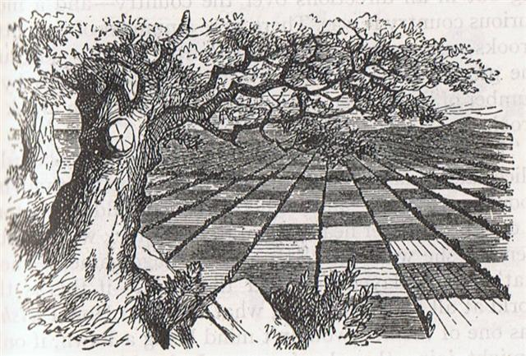

9 On the other hand, moving towards the equator (ke alanui a ke ku'uku'u) means the right ascension lines will spread out and it will become warmer, with growth speeding up. When the molecules are moving quicker we will feel warmth, when they slow down we will feel cold. The tropical belt is the hottest region. Whereas the top of the 'Earth Mountain' can be compared to the curved horns on the head of an old ram:
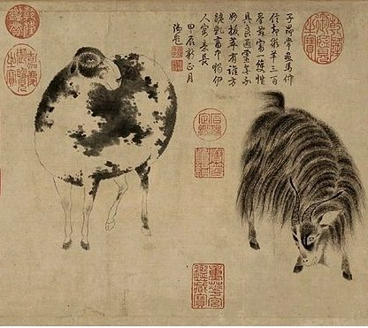
In contrast the bottom part of a young person should be characterized by bouncing around on quickly moving feet:
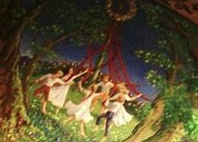

... It was 4 August 1968, and it was the feast day of Saint Dominic, patron of Santo Domingo Pueblo, southwest of Santa Fe. At one end of the hot, dusty plaza, a Dominican priest watched nervously as several hundred dancers arranged in two long rows pounded the earth with their moccasined feet as a mighty, collective prayer for rain, accompanied by the powerful baritone singing of a chorus and the beat of drums. As my family and I viewed this, the largest and in some ways the most impressive Native American public ceremony, a tiny cloud over the Jémez Mountains to the northwest got larger and larger, eventually filling up the sky; at last the storm broke, and the sky was crisscrossed by lightning and the pueblo resounded with peals of rolling thunder ...

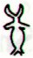 | *100 | 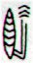
Ga3-13 (72 = 136 - 64) | *100 | Ga7-3 (172 = 236 - 64)
Aug 4 (*136) | *100 | Nov 12 (*236)
JUNE 1 (152, *72 = *136 - *64) | *100 | SEPT 9 (*172)
DEC 1 (335 = 152 + 183, *255) | *100 | MARCH 11 (*355)

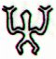 | *100 | 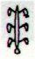
Ca5-31 (136) | *100 | Ca9-8 (236)
Aug 4 (216 = 33 + 183) | *100 | Nov 12 (316)
Febr 2 (33, *318 = *365 - *47) | *100 | May 13 (133 = 316 - 183)
NOV 30 (*254 = *318 - *64) | *100 | MARCH 10 (133 - 64 = 69)

 | 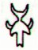 | *99 |  |  | *23
Ca5-31 (136) | Ca5-32 | *99 | Ca9-8 (236) | Ca9-9 | *23 | Ca10-5 (260) | (78 + 183)
Aug 4 (216) | 5 (*137) | *99 | Nov 12 (316) | Nov 13 (*237) | *23 | Dec 6 (340) | Dec 7
*319 - *183 | 9h (*137.0) | *99 | *53 + *183 | COR SERPENTIS | *23 | RAS ALGETHI | ALRISHA
21h (*319.6) | DRAMASA | *99 | ACRUX (*53) | *237 - *183 | *23 | *260 - *183 | THUBAN (*78)

Instead of a gear hiding the top of the head (→ Epimenides) the pair of feet should be protected by wear:
Insulating them from the intensely hot ground.

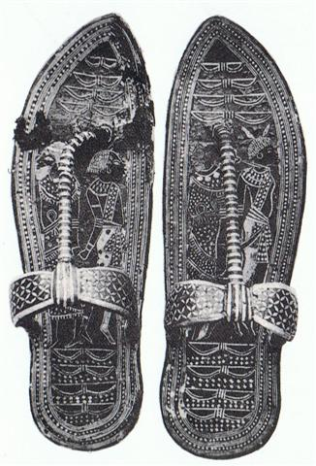
... They walked in crowds when they arrived at Tulan, and there was no fire. Only those with Tohil had it: this was the tribe whose god was first to generate fire. How it was generated is not clear. Their fire was already burning when Jaguar Quitze and Jaguar Night first saw it: 'Alas! Fire has not yet become ours. We'll die from the cold', they said. And then Tohil spoke: 'Do not grieve. You will have your own even when the fire you're talking about has been lost', Tohil told them. 'Aren't you a true god! Our sustenance and our support! Our god!' they said when they gave thanks for what Tohil had said. 'Very well, in truth, I am your god: so be it. I am your lord: so be it,' the penitents and sacrificers were told by Tohil. And this was the warming of the tribes. They were pleased by their fire. After that a great downpour began, which cut short the fire of the tribes. And hail fell thickly on all the tribes, and their fires were put out by the hail. Their fires didn't start up again. So then Jaguar Quitze and Jaguar Night asked for their fire again: 'Tohil, we'll be finished off by the cold', they told Tohil. 'Well, do not grive', said Tohil. Then he started a fire. He pivoted inside his sandal ...

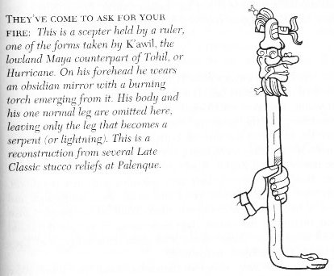

10 The source of the heat was far below. There was a great fire at the very bottom.
... He turned round and round to the right as he fell from the sky back to the water. Still in his cradle, he floated on the sea. Then he bumped against something solid. 'Your illustrious grandfather asks you in', said a voice. The Raven saw nothing. He heard the same voice again, and then again, but still he saw nothing but water. Then he peered through the hole in his marten-skin blanket. Beside him was a grebe. 'Your illustrious grandfather asks you in', said the grebe and dived. Level with the waves beside him, the Raven discovered the top of a housepole made of stone. He untied himself from his cradle and climbed down the pole to the lowermost figure.
Hala qaattsi ttakkin-gha, a voice said: 'Come inside, my grandson.' Behind the fire, at the rear of the house, was an old man white as a gull. 'I have something to lend you', said the old man. 'I have something to tell you as well. Dii hau dang iiji: I am you.' Slender bluegreen things with wings were moving between the screens at the back of the house. Waa'asing dang iiji, said the old man again: 'That also is you.'
The old man gave the Raven two small sticks, like gambling sticks, one black, one multicoloured. He gave him instructions to bite them apart in a certain way and told him to spit the pieces at one another on the surface of the sea. The Raven climbed back up the pole, where he promptly did things backwards, just to see if something interesting would occur, and the pieces bounced apart. It may well be some bits were lost. But when he gathered what he could and tried again - and this time followed the instructions he had been given - the pieces stuck and rumpled and grew to become the mainland and Haida Gwaii ...
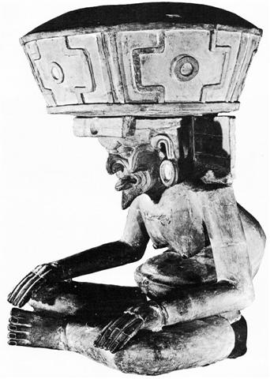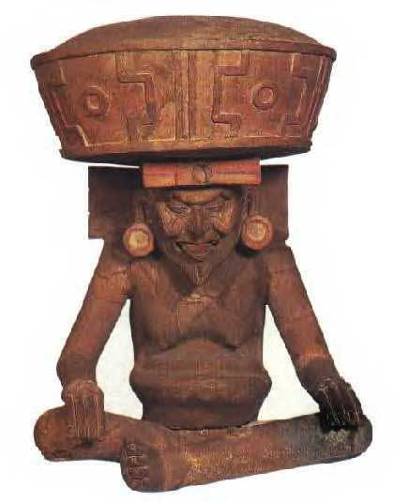

... Xiuhtecuhtli, the fire god, as Huehueteotl, 'the old god at the centre'. One of the oldest deities of ancient America, this clay figure from the Veracruz culture shows him seated with a brazier on his head. Xiuhtecuhtli was lord of the present 'Sun', or era, his ceremonies being particularly important at the end of every fifty-two-year cycle when all fires were put out and a fresh one was kindled on a prisoner's breast in order to keep time moving ...
As soon as Man had mastered the art of kitchen fires he would have noticed that above the fire it was safe to warm his hands - if it was not too close. It would be less and less heat higher up, decreasing with the Square of the distance.
... Strassmeier and Epping, in their Astronomishes aus Babylon, say that there its stars formed the third of the twenty-eight ecliptic constellations, - Arku-sha-rishu-ku, literally the Back of the Head of Ku, - which had been established along that great circle milleniums before our era; and Lenormant quotes, as an individual title from cuneiform inscriptions, Dil-kar, the Proclaimer of Dawn, that Jensen reads As-kar, and others Dil-gan, the Messenger of Light. George Smith inferred from the tablets that it might be the Star of the Flocks; while other Euphratean names have been Lu-lim, or Lu-nit, the Ram's Eye; and Si-mal or Si-mul, the Horn star, which came down even to late astrology as the Ram's Horn. It also was Anuv, and had its constellation's titles I-ku and I-ku-u, - by abbreviation Ku, - the Prince, or the Leading One, the Ram that led the heavenly flock, some of íts titles at a different date being applied to Capella of Auriga. Brown associates it with Aloros, the first of the ten mythical kings of Akkad anterior to the Deluge, the duration of whose reigns proportionately coincided with the distances apart of the ten chief ecliptic stars beginning with Hamal, and he deduces from this kingly title the Assyrian Ailuv, and hence the Hebrew Ayil; the other stars corresponding to the other mythical kings being Alcyone, Aldebaran, Pollux, Regulus, Spica, Antares, Algenib, Deneb Algedi, and Scheat ...
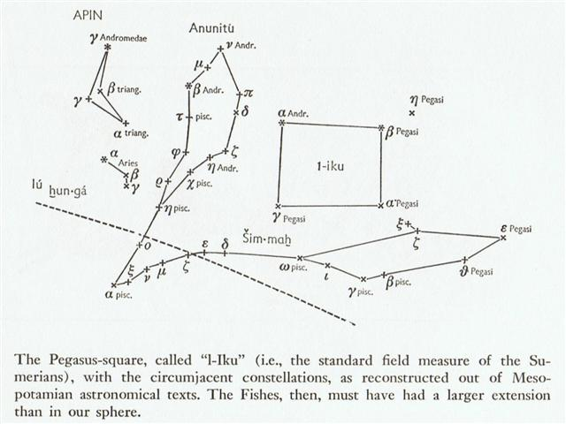

... According to an etiological Hawaiian myth, the breadfruit originated from the sacrifice of the war god Kū. After deciding to live secretly among mortals as a farmer, Ku married and had children. He and his family lived happily until a famine seized their island. When he could no longer bear to watch his children suffer, Ku told his wife that he could deliver them from starvation, but to do so he would have to leave them. Reluctantly, she agreed, and at her word, Ku descended into the ground right where he had stood until only the top of his head was visible. His family waited around the spot he had last been day and night, watering it with their tears until suddenly a small green shoot appeared where Ku had stood. Quickly, the shoot grew into a tall and leafy tree that was laden with heavy breadfruits that Ku's family and neighbors gratefully ate, joyfully saved from starvation ...
... He showed them the staff with its twelve notches, one for each month. They replied: 'We are in error since we have but ten months. Are we wrong in lifting our crop of kumara (sweet potato) in the eighth month?' Whare-patari answered: 'You are wrong. Leave them until the tenth month. Know you not that there are two odd feathers in a bird's tail? Likewise there are two odd months in the year.' The grateful tribe of Rua-roa adopted Whare's advice and found the sweet potato crop greatly improved as the result ...

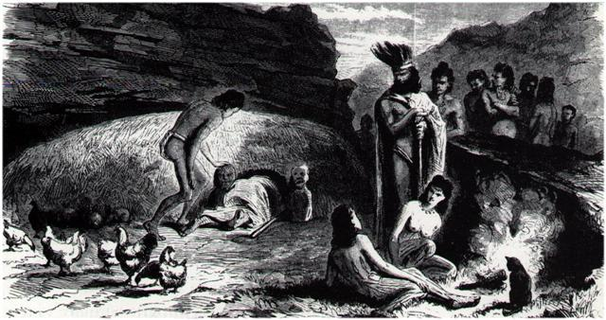
When the distance had become far enough the humidity inherent in the warmth from the flames below would condensate into water droplets ('tears'). This was also known since the beginning of time. These droplets from the back side (its past) of fire could be collected and would be perfect for drinking.
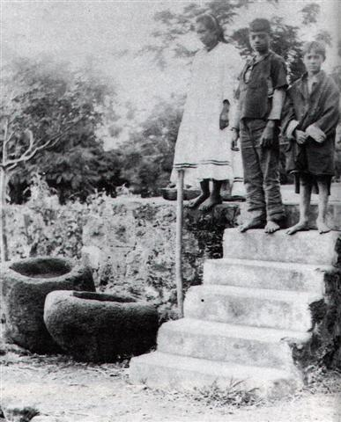

The moai statues on Easter Island were in principle facing inwards with their backs as pointers to where fresh water could be found:
... Most of the statues were located at a place where sweet water could be obtained. As they explained it: Captain Cook had been wrong when he said that the Easter Islanders went down to the sea in order to drink from the salty water. They instead went down to the places where underground sweet water streams from the interior of the island finally emerged and flowed out on top of the sea water. Sweet water is lighter than salty water and therefore it flowed on top ...
... There is a couple residing in one place named Kui and Fakataka. After the couple stay together for a while Fakataka is pregnant. So they go away because they wish to go to another place - they go. The canoe goes and goes, the wind roars, the sea churns, the canoe sinks. Kui expires while Fakataka swims. Fakataka swims and swims, reaching another land. She goes there and stays on the upraised reef in the freshwater pools on the reef, and there delivers her child, a boy child. She gives him the name Taetagaloa. When the baby is born a golden plover flies over and alights upon the reef. (Kua fanau lā te pepe kae lele mai te tuli oi tū mai i te papa). And so the woman thus names various parts of the child beginning with the name 'the plover' (tuli): neck (tuliulu), elbow (tulilima), knee (tulivae) ...
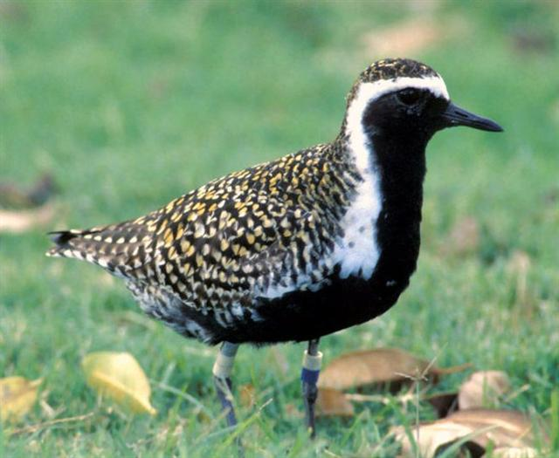

DRIPPING WATER:
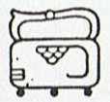 | 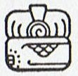 | 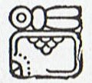 | 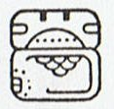
WELL | MACAW | QUETZAL | RED DEER
9 Ch'en (180) | 10 Yax (Green) | 11 Sac (White) | 12 Ceh (240)
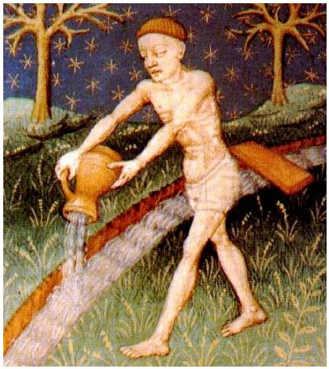
... The life-force of the earth is water. God moulded the earth with water. Blood too he made out of water. Even in a stone there is this force, for there is moisture in everything. But if Nummo is water, it also produces copper. When the sky is overcast, the sun's rays may be seen materializing on the misty horizon. These rays, excreted by the spirits, are of copper and are light. They are water too, because they uphold the earth's moisture as it rises. The Pair excrete light, because they are also light ... 'The sun's rays,' he went on, 'are fire and the Nummo's excrement. It is the rays which give the sun its strength. It is the Nummo who gives life to this star, for the sun is in some sort a star.' It was difficult to get him to explain what he meant by this obscure statement. The Nazarene made more than one fruitless effort to understand this part of the cosmogony; he could not discover any chink or crack through which to apprehend its meaning. He was moreover confronted with identifications which no European, that is, no average rational European, could admit. He felt himself humiliated, though not disagreeably so, at finding that his informant regarded fire and water as complementary, and not as opposites. The rays of light and heat draw the water up, and also cause it to descend again in the form of rain. That is all to the good. The movement created by this coming and going is a good thing. By means of the rays the Nummo draws out, and gives back the life-force. This movement indeed makes life ...

... But in the fullness of time an obscure instinct led the eldest of them towards the anthill which had been occupied by the Nummo. He wore on his head a head-dress and to protect him from the sun, the wooden bowl he used for his food. He put his two feet into the opening of the anthill, that is of the earth's womb, and sank in slowly as if for a parturition a tergo. The whole of him thus entered into the earth, and his head itself disappeared. But he left on the ground, as evidence of his passage into that world, the bowl which had caught on the edges of the opening. All that remained on the anthill was the round wooden bowl, still bearing traces of the food and the finger-prints of its vanished owner, symbol of his body and of his human nature, as, in the animal world, is the skin which a reptile has shed ...

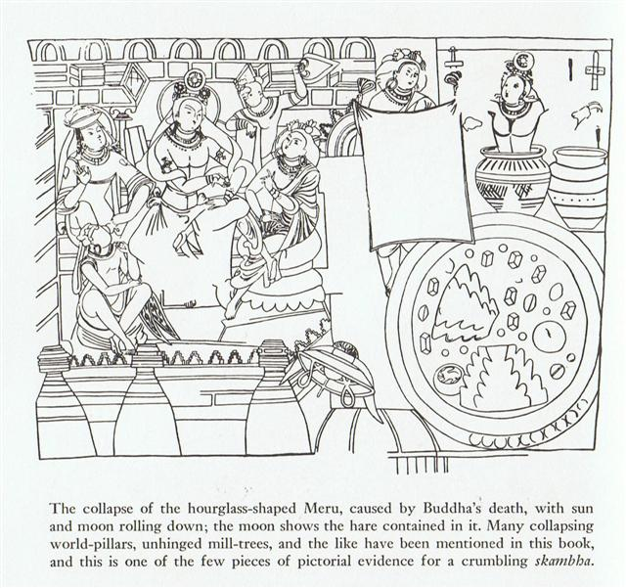

The Great Bear (Ursa Major) was just below the Dragon constellation, just below the resting place (→ Cursa) of the Serpent. High up it was so cold that the fine droplets of water in the air froze to a standstill in form of flakes - like the old worn out skin of a serpent. But later on the fresh serpent would once again thaw out and descend in small streems coalescing into great navigable rivers.:
... Snorri Sterluson explains why 'Frodi's grist' is a kenning for gold. Frodi ruled during a peaceful and productive period, contemporaneous with Augustus's Pax Romana and the birth of Christ; hence the kenning. There were neither thieves nor robbers during this period, 'so that a gold ring lay long on Jalang's heath'. Snorri continues his account with the legend of the mill beyond what is told in the song: The girls' grinding produced an army hostile to Frodi. On the very day of the girls' predictions, the sea-king, Musing (Son of the Mouse), landed on the Danish shore, killed Frodi, and took away Grotti and the women on his ship. The girls were bidden to grind out salt on the mill. At midnight they asked for further instructions. 'Keep grinding', he told them. Then they ground with such vigor that the ship sank. Water poured into the eye of the mill, creating the maelstroem of the sea. Therefore the sea was salt. Incidentally, the mill was given a kenning, Serpent's Couch ...

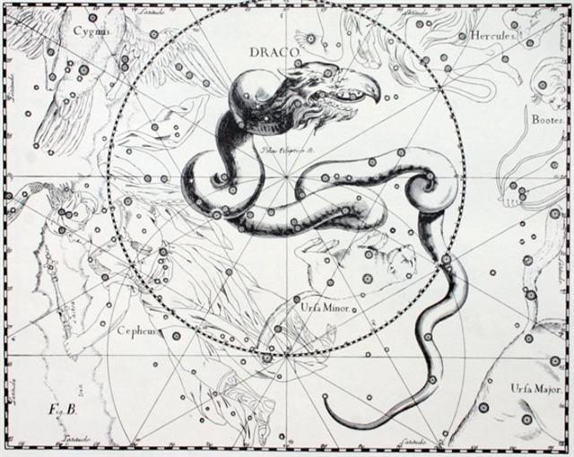

11 Popol Vuh:
... When it was evident that the years lay ready to burst into life, everyone took hold of them, so that once more would start forth - once again - another (period of) fifty-two years. Then (the two cycles) might proceed to reach one hundred and four [104] years. It was called One Age when twice they had made the round, when twice the times of binding the years had come together. Behold what was done when the years were bound - when was reached the time when they were to draw the new fire, when now its count was accomplished. First they put out fires everywhere in the country round. And the statues, hewn in either wood or stone, kept in each man's home and regarded as gods, were all cast into the water. Also (were) these (cast away) - the pestles and the (three) hearth stones (upon which the cooking pots rested); and everywhere there was much sweeping - there was sweeping very clear. Rubbish was thrown out; none lay in any of the houses ...
91 | 91 | 91 | 91

52 | 260 = 5 * 52 | 52
364 = 4 * 91 = 7 * 52

I associate 52 with the extraordinary synodic orbit of the planet Mars.

Due to his retrograde path, ideally beginning in November 6 and then reversing itself close to the Pleiades, the synodic period had to be extended. The slowest planet Saturn needed 378 (→ 310 + 68 = 300 + 78) days whereas the period of Mars was 780 days (→ *78 → Rigel).

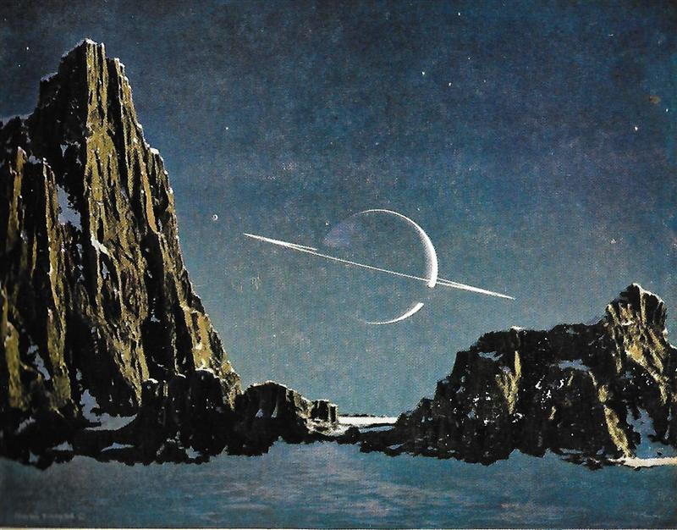
From the change into retrograde motion in November 6 (310) to the change back to normal motion in January 20 (385) there were 75 days. Reasonably these retrograde days (75) had to be compensated for by 75 days of normal motion. → 780 (Mars) - twice 75 = 630 → *63 (Hyadum I) = January 20 + 123 days = May 23 (*428) = MARCH 20 (*364).
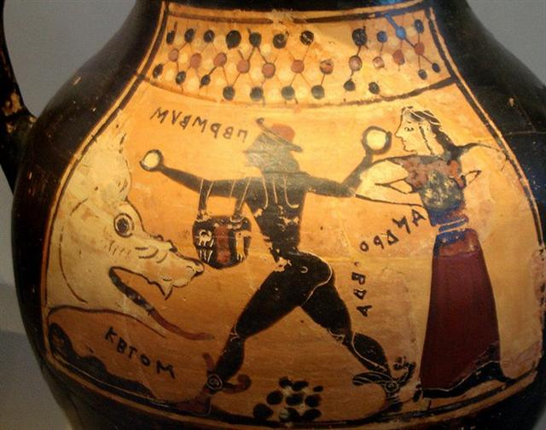

The names of Perseus and Andromeda are here above spelled backwards (retrograde, withershins), whereas the name of Ketos is spelled from left to right. Therefore it is the outstretched (Mebsuta) right arm of Perseus which is holding the light bulb above the black eye of the Cetus fish.
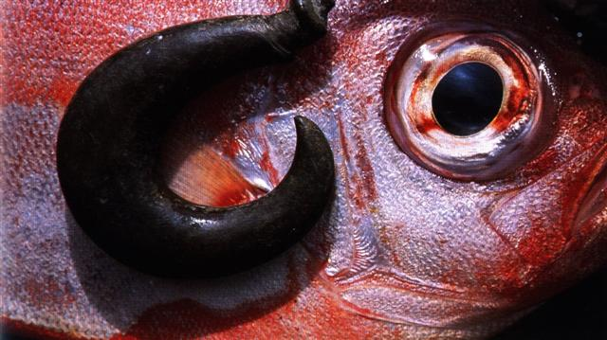
Nine black boulders (9 * 7 = 63) are depicted below in the center and the hands of Andromeda are hidden from view (chained)
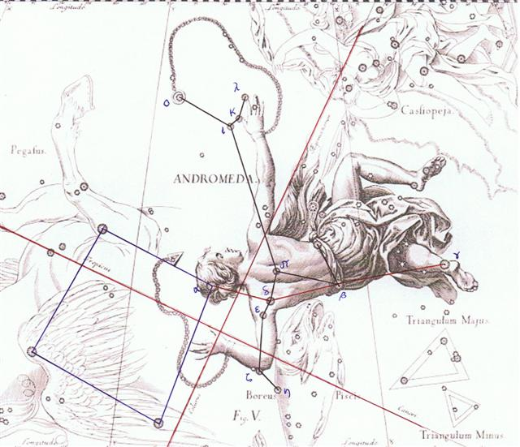

In the center up above the headgear of Perseus is evidently a pukau.
Pau. 1. To run out (food, water): ekó pau te kai, te vai, is said when there is an abundance of food or water, and there is no fear of running out. Puna pau, a small natural well near the quarry where the 'hats' (pukao) were made; it was so called because only a little water could be drawn from it every day and it ran dry very soon. 2. Va'e pau, clubfoot. Paupau: Curved. Vanaga. 1. Hakapau, to pierce (cf. takapau, to thrust into). Pau.: pau, a cut, a wound, bruised, black and blue. 2. Resin. Mq.: epau, resin. Ta.: tepau, gum, pitch, resin. (Paupau) Hakapaupau, grimace, ironry, to grin. 3. Paura (powder), gunpowder. 4. Pau.: paupau, breathless. Ta.: paupau, id. 5. Ta.: pau, consumed, expended. Sa.: pau, to come to an end. Ma.: pau, finished. 6. Ta.: pau, to wet one another. Mq.: pau, to moisten. Churchill. Paua or pāua is the Māori name given to three species of large edible sea snails, marine gastropod molluscs which belong to the family Haliotidae (genus Haliotis), known in the USA as abalone, and in the UK as ormer shells ... Wikipedia.
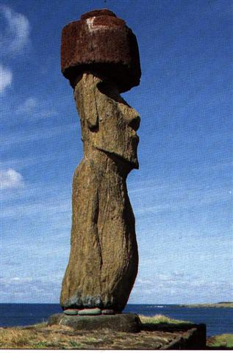

For every synodic circuit of Mars it was necessary to add 52 days in order to synchronize Mars:
Circuit of the planet Mars
Aug 23 (258, *178.0) | Nov 6 (258 + 52 = 310, *230) | Dec 28 (310 + 52 = 362, *282) |  | Febr 20 (*336, 416 = 364 + 52)
2023 (→ 460) | 2025 | 2027 |  | 2030 (→ 600)
LION | SCORPION | GOAT |  | PEGASUS
93 LEONIS | VRISCHIKA (π Scorpii) | DABIH (β Capricornii) |  | SIRRAH (α Andromedae)
*178.0 | *241 (→ 178 + 63) | *308.0 (→ 178.0 + 130.0) |  | 0h (*285 → 178 + 107)
Popol Vuh, on the other hand, appears to state that One Age was 2 years + twice 52 days = 728 + 104 = 832 (→ 8 * 8 * 13 days) = 780 + 52. 104 → 8 * 13 → 107 - 3 → the change from Julian spring equinox to that of the Pope Gregory XIII.
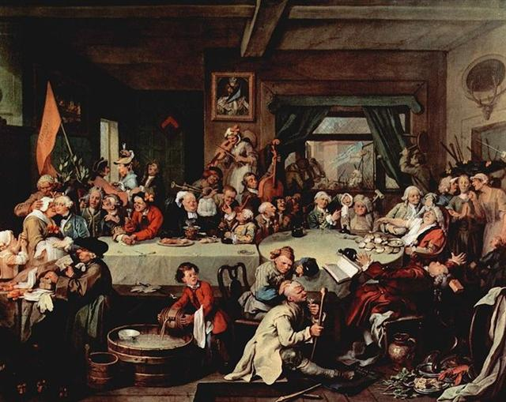
2 * 364 = 728 = 780 - 52. And twice (364 - 260) = 2 * 104 = 16 * 13 = 208 → August 23 - 50 = July 27. = 143 (May 23) + 65 (→ 365 - 300).

Here we are sailing on unchartered waters.
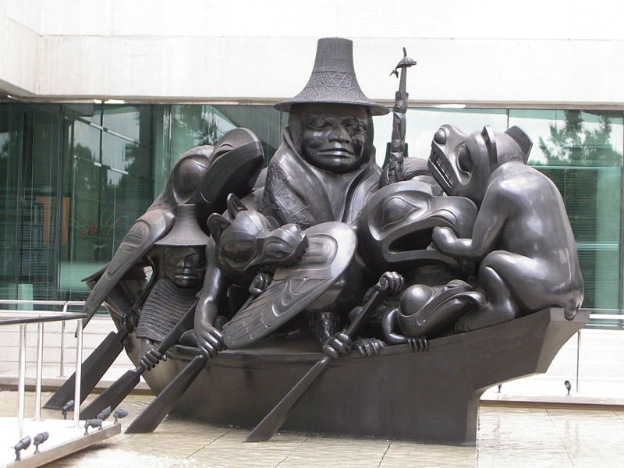
But evidently there was a 6 day long interregnum - resting days (sleeping mat, couch, foot rest) - to be added to 28 * 29½ nights. Basically it should have been the timetable of the Moon which needed these extra 6 nights:
28 * 29.5 = 7 * 118 = 826 | *6 | 832 = 2 * 364 + 2 * 52
... The author of the Book of Enoch in his treatise on astronomy and the calendar also reckoned a year to be 364 days, though he pronounced a curse on all who did not reckon a month to be 30 days long ...
364 + 52 = 416 (→ 156 + 260) → Gb4-16 (107):
... On the twenty-fifth day [raa] of the first month ('Vaitu Nui'), Ira and Makoi set sail; on the first day [te raa po rae] of the month of June ('Maro'), the bow [te ihu] of Ira's canoe touched land again ... [E:17]

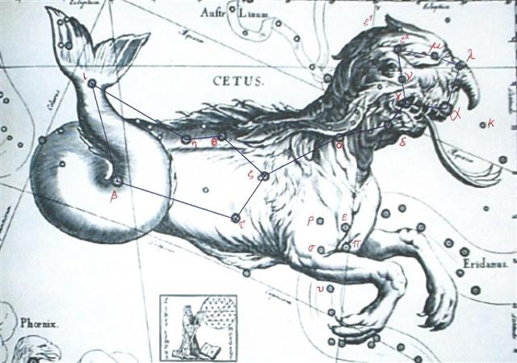

93 | FEBR 19 | 20 (*336 → 4 * 84) | 21 | 22 (53) | TERMINALIA | 25
93 | 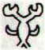 | 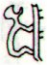 | 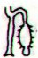 | 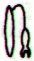 | 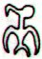 | 25
93 | Gb8-1 | Gb8-2 (2 * 107) | Gb8-3 (215) | Gb8-4 | Gb8-5 (242 - 25) | 25
93 | 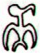 |  | 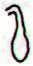 | 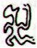 | 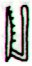 | 25
93 | Gb4-15 (335) | Gb4-16 (107) | Gb4-17 | Gb4-18 | Gb4-19 (110) | 25
93 | No star listed (34) | ξ Arietis (35.0), ρ Ceti (35.4), 12 Trianguli (35.8), ξ² Ceti (35.9)  *360.0 = *35.4 - *41.4  April 25 AD 2023 (115)  MARS (*35) | σ Ceti (36.9) | ν Ceti (37.9) | ν Arietis (38.5), δ, ε Ceti (38.8) | 25
93 | April 24 (*399) | 25 (115) | 6 (*36) | 27 | April 28 (118) | 25
93 | 'March 28 | 29 (88) | 30 | 31 (*375) | 'April 1 (91) | 25
93 | 3-14 (73) | "March 15 | 16 (*360) | 17 | "March 18 | 25
93 | NAKSHATRA DATES: |  |  |  |  | 25
93 | AUG 21 | 22 | 23 | 24 (236) | 25 (*157) | 25
93 | ASELLUS PRIMUS (1st Ass Colt) = θ Bootis (217.8) | τ Lupi, δ Oct. (218.1), Φ Virginis (218.7)  FOMALHAUT (α Piscis Austrini) | σ Lupi (219.1), ρ Bootis (219.5), HARIS (Keeper) = γ Bootis (219.7)  FUM AL SAMAKAH (β Piscium) | σ Bootis (220.2), η Centauri (220.4)  *179.0 = *220.4 - *41.4 | ρ Lupi (221.0), TOLIMAN (Shoot from the Vine) = α Centauri (221.2), π Booti | 25
93 | Oct 24 | 25 (*218) | 26 | 27 (300) | 28 | 25
93 | 'Sept 27 (270) | 28 | 29 (*192) | (3 * 91) | 'Oct 1 | 25
93 | (16 * 16) | "Sept 14 | 15 (*178) | 16 | 17 (260) | 25
93 |  | 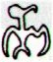 | 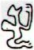 | 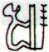 | 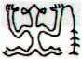 | 25
93 | Ga6-13 | Ga6-14 | Ga6-15 | Ga6-16 | Ga6-17 (157) | 25
123 (→ 3 * 41 = 164 - 41) → 241 - 118 → May 23 (143) - January 20

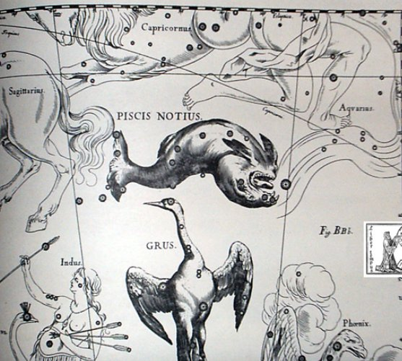

One and Seven Hunaphu told Blood Moon she should go up to the surface of the 'earth' (the plane of the ecliptic), because she was now pregnant.
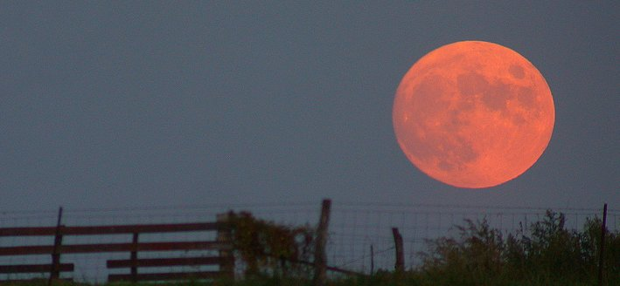

... And then the bone spoke; it was there in the fork of the tree: Why do you want a mere bone, a round thing in the branches of a tree? said the head of One Hunaphu when it spoke to the maiden. You don't want it, she was told. I do want it, said the maiden. Very well. Stretch out your right hand here, so I can see it, said the bone. Yes, said the maiden. She stretched out her right hand, up there in front of the bone. And then the bone spit out its saliva, which landed squarely in the hand of the maiden.
And then she looked in her hand, she inspected it right away, but the bone's saliva wasn't in her hand. It is just a sign I have given you, my saliva, my spittle. This, my head, has nothing on it - just bone, nothing of meat. It's just the same with the head of a great lord: it's just the flesh that makes his face look good. And when he dies, people get frightened by his bones. After that, his son is like his saliva, his spittle, in his being, whether it be the son of a lord or the son of a craftsman, an orator. The father does not disappear, but goes on being fulfilled. Neither dimmed nor destroyed is the face of a lord, a warrior, craftsman, an orator. Rather, he will leave his daughters and sons. So it is that I have done likewise through you. Now go up there on the face of the earth; you will not die. Keep the word. So be it, said the head of One and Seven Hunaphu - they were of one mind when they did it ...
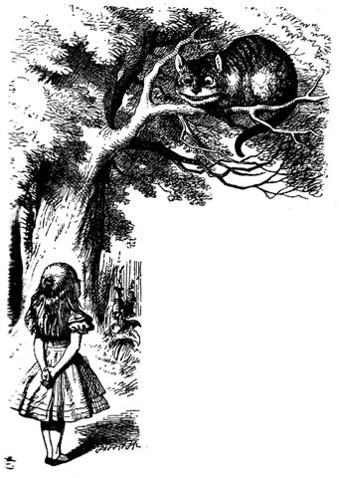

1(0)7 is One and Seven. 10 days + 7 weeks = 59 right ascension nights = 2 * 29½. One day + seven weeks = 50 right ascension nights. → Gb4-16 → 416 → 2 * 208 = 8 * 52.
Also twice 107 = 214 (Gb8-2) is at April 25 (115). And 214 → 2-14 → February 14 = All Hearts' Day. All the cycles were here converging and ready to once again burst into life.
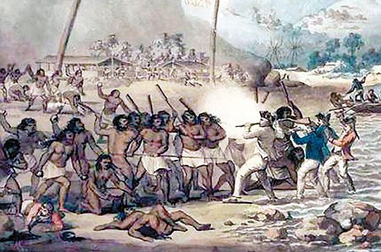
All the right ascension lines (every one) converged at the house of the Spider and therefore all would also burst out simultaneously from that place.

Keep the Word! said 107 - i.e. the Head (0) - of One and Seven, which we can perceive as an allusion to the star named Haris (the Keeper) at Ga6-15. October 26. → 8-26 → 8 * 26 = 208 (July 27).

