29

Number 29 alludes to the night of Hiro (Mercury). When the old woman (somewhere in the Mediterranean area) was asked what 29 meant she chuckled and formed a round opening between her left forefinger and thumb through which she then repeatedly pushed her right forefinger.
...when the new moon appeared women assembled and bewailed those who had died since the last one, uttering the following lament: 'Alas! O moon! Thou has returned to life, but our departed beloved ones have not. Thou has bathed in the waiora a Tane, and had thy life renewed, but there is no fount to restore life to our departed ones. Alas' ...
The basic meaning of 29 seems to be absence. It is the remarkable event after the presence of Sun light on the 28 faces of the Moon (→ E:28).
In the D text, measuring 212 glyphs (right ascension days), we can count 212 - 29 = 183 (= 366 / 2).
Liberalia
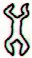 | 29 | 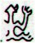
Da7-9 (113) | 29 | Db2-1 (143)
March 17 (441 = 80 + 361) | 365 | March 17 (31 + 28 + 17 = 76)
γ¹ Oct. (*361.4) | *0.0 | γ¹ Oct. (*361.4)
From this little table we can then count 112 days to the left of Da7-9 and 212 - 143 = 69 days to the right of Db2-1, which in turn will give us 112 + 69 = 181 days, presumably an allusion to June 30 and heliacal Sirius although it was also (for instance) the day distance from Aldebaran (148, *68) to Antares (329, *249).
181 = 212 - 29
181 (June 30)
Sirius
Aldebaran | 181 | Antares

In other words 181 (*101) + *31 = *132 (212) = 395 (*315) - 183, where *315 could refer to Baten Algedi (the Belly of the Goat, the star which had been denoted ω Capricorni).
In the G text its side a carries 229 glyphs and this could perhaps indicate we should recount 229 into 200 (= 171 + 29 = 9 * 19 + 29) regular calendar days.
Notably June 20 (161 + 10) + 29 = 200 (July 19) was located at heliacal ω Cancri (*120 = *195 right ascension days earlier than Baten Algiedi).
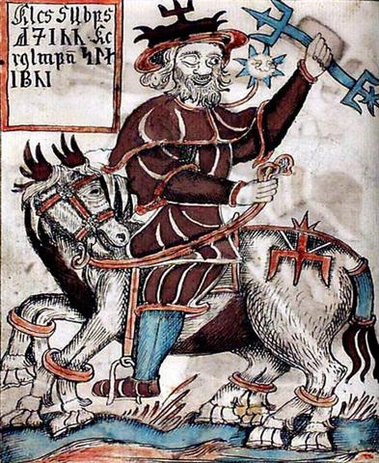
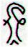 | 29 | 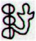
Ga7-30 (199) | 29 | Ga8-26 (229)
However, the first 6 glyphs on side b of the G tablet should reasonably be included in our overview because glyph number 235 is at Gb1-6.

The action of turning a rongorongo tablet around could have been associated with a recalibration of the relation between dates and stars, not only as shown above for the D tablet but also, as we have seen, on the C tablet where the view certainly had shifted from heliacal to nakshatra 6 days after heliacal Polaris (*26), at the time when the Full Moon ideally would be at Arcturus (*215.4 → *315 - *100).
April 16 (106, *26) + 6 = April 22 (*32) = October 22 (295) - 183.
This idea suggests April 16 (April 10 + 6) at heliacal Polaris could be perceived as *29 right ascension days after Dzaneb, the star denoted ω in the tail of the horizontally oriented southern fish in Pisces:
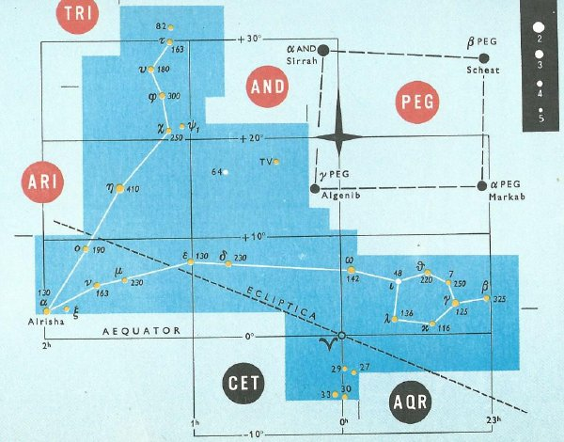
Notably the distance from Baten Algiedi (ω Capricorni) to Dzaneb (ω Piscium) was *362 - *135 (→ Tau-ono, the 6 'stones' - stars - in the Pleiades → E:29) = *227 right ascension days → 22 / 7 → π.
*120 → 240 / 2 | *95 | *315 → *630 / 2 | *47 | *120 + *242 → 2 * 181
ω Cancri | *95 | ω Capricorni | *47 | ω Piscium

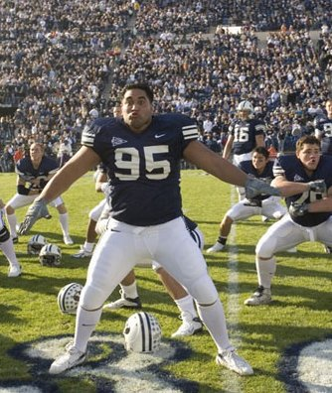

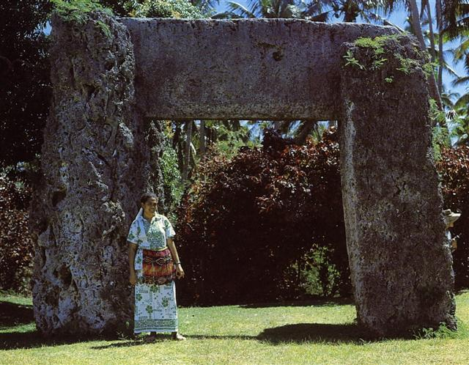

0h | 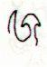 | *361 |  | *29 | 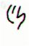 | *6 | 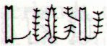
0h | Ca1-1 | *361 | Ca13-20 (→ 13 * 20) | *29 | Ca14-29 (392) | *6 | Cb1-6 (398)
0h | March 22 (81, *1) | *361 | March 18 (443, *362) | *29 | April 16 (106, *26) | *6 | April 22 (112, *32)
0h | ALGENIB PEGASI | *361 | DZANEB (*362.4)  ACUBENS | *29 | POLARIS | *6 | no star listed (*32)
0h | *1 + *183 = *184 | *361 | no star listed (*180) | *29 | no star listed (*209) | *6 | ARCTURUS (*215.4)
0h | Sept 21 (264. *184) | *361 | Sept 17 (260, *180) | *29 | Oct 16 (289, *209) | *6 | Oct 22 (295, *215)
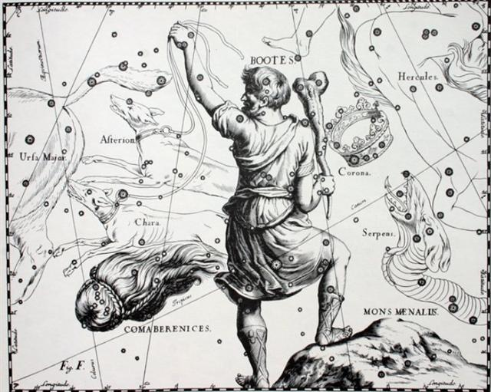

Polaris at April 16 (106, *26) + 6 = April 22 (*32) = Arcturus at October 22 (295, *215) - 183.
Ca13-20 (→ 13 * 20 = 260) at nakshatra September 17 (260, *180) + *29 + *6 = *215 (October 22) at nakshatra Cb1-6.
Dzaneb was not at 0h, which seems to have forced a necessary compensation for the 3 (= *365 - *362) days 'when only cold food could be served'. This surely followed from the culmination (at 21h) of Acubens, for there were 3 days from March 18 to March 21 (0h).
... In China, every year about the beginning of April, certain officials called Sz'hüen used of old to go about the country armed with wooden clappers. Their business was to summon the people and command them to put out every fire. This was the beginning of the season called Han-shih-tsieh, or 'eating of cold food'. For three days all household fires remained extinct as a preparation for the solemn renewal of the fire ...
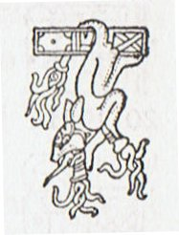

29-1
Once again. Dzaneb (ω Piscium) was not at 0h, instead it was Sirrah in the 3rd corner of the Pegasus Square which was at 0h.
0h |  | *361 |  | *29 |  | *6
0h | Ca1-1 | *361 | Ca13-20 (→ 13 * 20) | *29 | Ca14-29 (392) | *6 | Cb1-6 (398)
0h | March 22 (81, *1) | *361 | March 18 (443, *362) | *29 | April 16 (106, *26) | *6 | April 22 (112, *32)
0h | ALGENIB PEGASI | *361 | DZANEB (*362.4)  ACUBENS | *29 | POLARIS | *6 | no star listed (*32)
0h | *1 + *183 = *184 | *361 | no star listed (*180) | *29 | no star listed (*209) | *6 | ARCTURUS (*215.4)
0h | Sept 21 (264. *184) | *361 | Sept 17 (260, *180) | *29 | Oct 16 (289, *209) | *6 | Oct 22 (295, *215)

Heliacal Polaris at the end of side a on the C tablet would have been at *29 (= *26 + *3) if counted from Dzaneb.
And in a way time could have stood still so to say for 29 days from March 18 (*362, Dzaneb) to April 16 (80 + *26 at Polaris).

From Dzaneb (*362) to Sirrah (0h) there were 3 days, which we can compare with 3 days from γ¹ Octantis (*361.4) to θ Octantis (364.4):
Liberalia
 | 29
Da7-9 (113) | 29 | Db2-1 (143)
March 17 (441 = 80 + 361) | 365 | March 17 (31 + 28 + 17 = 76)
γ¹ Oct. (*361.4) | *0.0 | γ¹ Oct. (*361.4)
... Another name for Mercury was Hermes and Hermes Trismegisthos (thrice-mighty) could have referred to the fact that there were 3.141 * 115.88 = 364.0 days for the cycle of the Earth around the Sun. Although the calendar has 365 days for a year this is due to the fact that the Earth has to turn around an extra day in order to compensate for how the direction to the Sun changes during a year ...

In the G text θ Octantis has evidently been placed at Gb6-25 in the day preceding Sirrah:
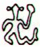 | 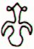
Gb6-25 (229 + 178) | Gb6-26 (408)
θ Oct. (*364.4) | SIRRAH (0h)
... Ecclesiastically, the equinox is reckoned to be on 21 March (even though the equinox occurs, astronomically speaking, on 20 March in most years) ...

However, counted from the beginning of the G text at heliacal Ain (Ga1-1)
... The letter name is derived from Proto-Semitic *‘ayn-, eye, and the Phoenician letter had an eye-shape, ultimately derived from the jr hieroglyph ... To this day, ‘ayin in Hebrew, Arabic and Maltese means 'eye' and 'spring' (‘ayno in Neo-Aramaic) ...
we will find heliacal Sirius first at Ga2-7 (1 + 36 = 37) and then once again at Gb6-20:
MARCH 22 (*1) | *36 | APRIL 27 (117) | *192 | *172 | APRIL 27 (*37)
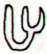 | *36 | 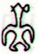 | *192 | *172 | 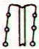
Ga1-1 | *36 | Ga2-7 (37) | *192 | *172 | Gb6-20 (37 + 364 = 401)
AIN (*65) | *36 | SIRIUS (*101) | *192 | *172 | SIRIUS (*465)
May 25 (290 / 2) | *36 | June 30 (181 = 117 + 64) | *192 | *172 | June 30 (*101 = *465 - *364)
Which suggests a reorientation could have taken place from *360 (Gb6-21) to Gb6-26 (*365):
... Nut, whom the Greeks sometimes identified with Rhea, was goddess of the sky, but it was debatable if in historical times she was the object of a genuine cult. She was Geb's twin sister and, it was said, married him secretly and against the will of Ra. Angered, Ra had the couple brutally separated by Shu and afterwards decreed that Nut could not bear a child in any given month of any year. Thoth, Plutarch tells us, happily had pity on her. Playing draughts with the Moon, he won in the course of several games a seventy-second part of the Moon's light with which he composed five new days. As these five intercalated days did not belong to the official Egyptian calendar of three hundred and sixty days, Nut was thus able to give birth successively to five children: Osiris, Haroeris (Horus), Set, Isis and Nepthys ...:
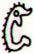 | 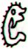 | 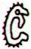 | 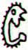
Gb6-21 | Gb6-22 | Gb6-23 | Gb6-24 | Gb6-25 | Gb6-26
*360 | γ¹ Oct. (*361.4) | *362 | *363 | θ Oct. (*364.4) | SIRRAH (0h)
March 16 | 17 (441) | 18 | 19 | 20 (444) | March 21

Or we could say there were 6 dark nights 'with sleeping mats' which ended at March 22 (*366) at the 4th and last corner of the Pegasus Square, viz. at Algenib.
From the First Spout (Al Fargh al Mukdim) at Scheat (β Pegasi) in March 5 (31 + 28 + 5 = 64) to Algenib (γ) in March 22 there were 17 days - possibly alluded to at March 17 - the date named Liberalia by the Romans.
17 = 16 + 1 → 171 = 161 + 10:
... Midsummer is the flowering season of the oak, which is the tree of endurance and triumph, and like the ash is said to 'court the lightning flash'. Its roots are believed to extend as deep underground as its branches rise in the air - Virgil mentions this - which makes it emblematic of a god whose law runs both in Heaven and in the Underworld ... The month, which takes its name from Juppiter the oak-god, begins on June 10th and ends of July 7th. Midway comes St. John's Day, June 24th, the day on which the oak-king was sacrificially burned alive. The Celtic year was divided into two halves with the second half beginning in July, apparently after a seven-day wake, or funeral feast, in the oak-king's honour ...

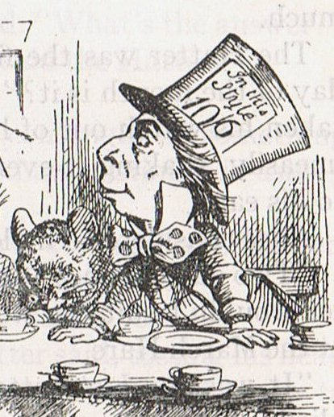
Quicksilver (the metal connected with the Mad Hatter) has been found in the foundations of great ancient pyramids.
... Mercury was used in the process of curing pelts for hats, making it impossible for hatters to avoid inhaling the mercury fumes given off during the hat making process; hatters and mill workers thus often suffered mercury poisoning, causing neurological damage, including confused speech and distorted vision ...
Confused speech and distorted vision characterized both hatters and those who worked at the mill (like a merry-go-round).
... Snorri Sterluson explains why 'Frodi's grist' is a kenning for gold. Frodi ruled during a peaceful and productive period, contemporaneous with Augustus's Pax Romana and the birth of Christ; hence the kenning. There were neither thieves nor robbers during this period, 'so that a gold ring lay long on Jalang's heath'. Snorri continues his account with the legend of the mill beyond what is told in the song: The girls' grinding produced an army hostile to Frodi. On the very day of the girls' predictions, the sea-king, Musing (Son of the Mouse), landed on the Danish shore, killed Frodi, and took away Grotti and the women on his ship. The girls were bidden to grind out salt on the mill. At midnight they asked for further instructions. 'Keep grinding', he told them. Then they ground with such vigor that the ship sank. Water poured into the eye of the mill, creating the maelstroem of the sea. Therefore the sea was salt. Incidentally, the mill was given a kenning, Serpent's Couch ...

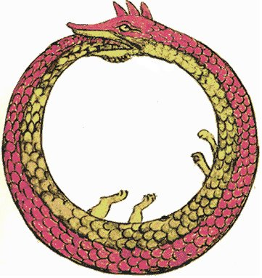
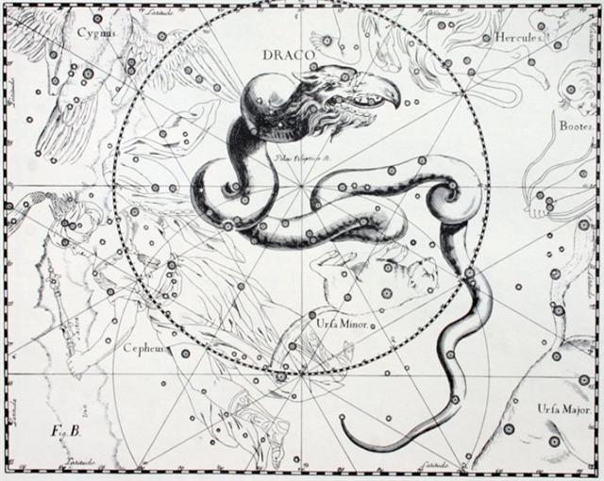

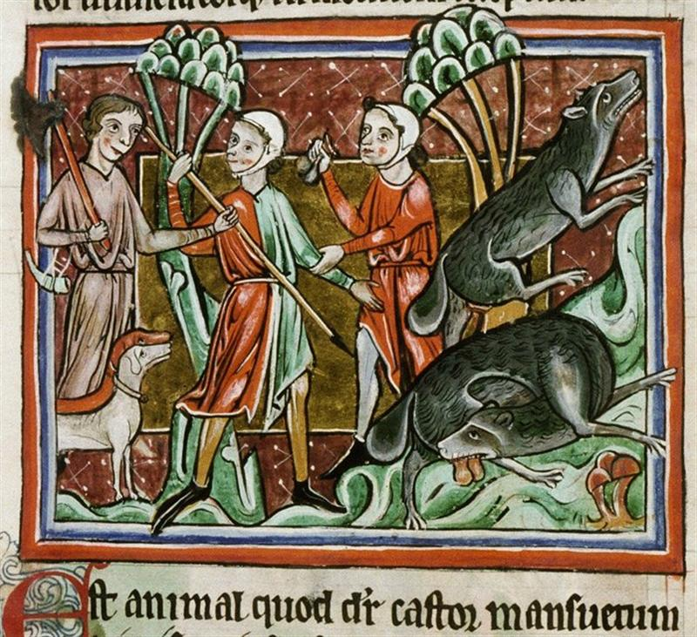

The last page in the Dresden Codex is number 74, which we now can guess could be referring to Sirius (*465) in the day before March 16 (75 = 31 + 28 + 16).
Here the confused emperor of China was bound to draw his bow towards the Celestial Jackal:

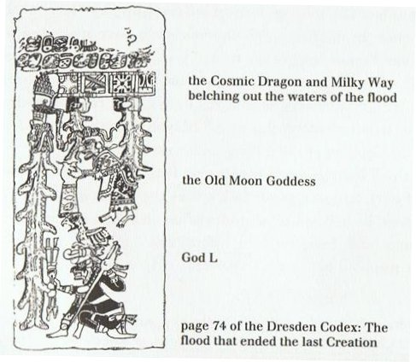
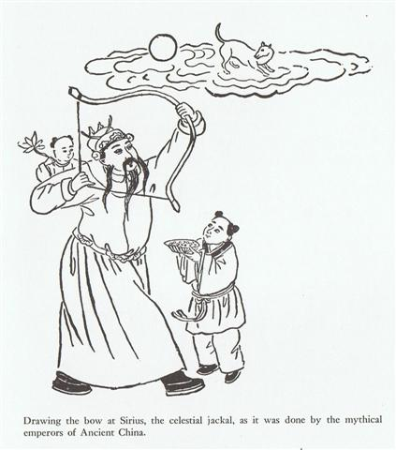

29-2
The eye-catching (thought provoking) quartet from *360 is beginning with a figure which seems to call out (ragi) like a cock at dawn:
Nose up: |  | Nose down:
2 | 3 | 2 | 3
Gb6-21 | Gb6-22 | Gb6-23 | Gb6-24
*360 | γ¹ Oct. (*361.4) | *362 | *363
March 16 | 17 (441) | 18 | 19 (78)
... The three of them had their copal, and this is what they burned as they incensed the direction of the rising sun. They were crying sweetly as they shook their burning copal, the precious copal. After that they cried because they had yet to see and yet to witness the birth of the sun. And then, when the sun came up, the animals, small and great, were happy. They all came up from the rivers and canyons; they waited on all the mountain peaks. Together they looked toward the place where the sun came out. So then the puma and jaguar cried out, but the first to cry out was a bird, the parrot by name ...
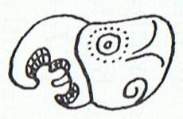

The back side of all 4 creatures are adorned with feathers, suggesting they are birds (gods).
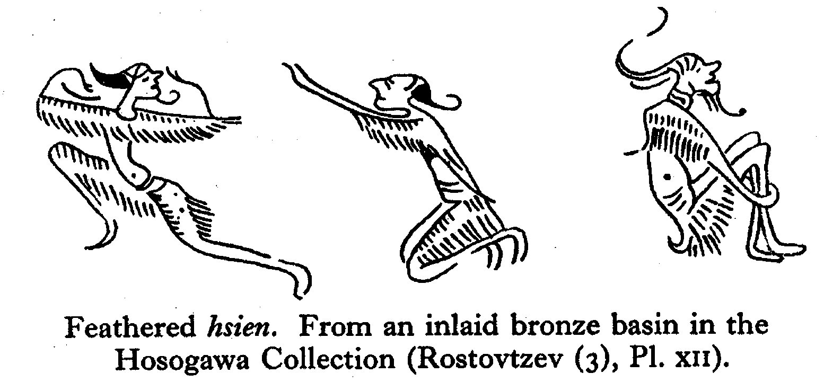
... In many Polynesian cultures the bodies of gods were conceived of as covered with feathers and they were frequently associated with birds: in Tahiti and the Society Islands, bird calls on the marae signaled the presence of the gods. Hawaiian feathered god figures generally depict only the head and neck of the god ...
... Ta'aroa sat in his heaven above the earth and conjured forth gods with his words. When he shook off his red and yellow feathers they drifted down and became trees ...
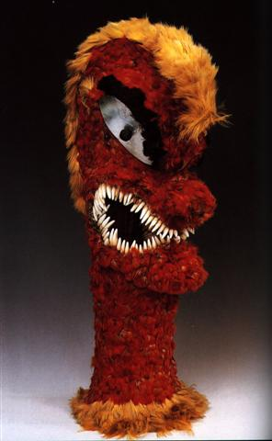

I have earlier tried to count the number of feathers, and the result became 57.(→ 3 * 19)
Thus the sum total of the feathers could have been intended to allude to 3 * 19 → 320 (Dramasa, the South Pole star) - 1.

*320 (Dramasa) / 10 = *32 = *215 (Arcturus) - *366 / 2:
0h |  | *361 |  | *29 |  | *6
0h | Ca1-1 | *361 | Ca13-20 (→ 13 * 20) | *29 | Ca14-29 (392) | *6 | Cb1-6 (398)
0h | March 22 (81, *1) | *361 | March 18 (443, *362) | *29 | April 16 (106, *26) | *6 | April 22 (112, *32)
0h | ALGENIB PEGASI | *361 | DZANEB (*362.4)  ACUBENS | *29 | POLARIS | *6 | no star listed (*32)
0h | *1 + *183 = *184 | *361 | no star listed (*180) | *29 | no star listed (*209) | *6 | ARCTURUS (*215.4)
0h | Sept 21 (264. *184) | *361 | Sept 17 (260, *180) | *29 | Oct 16 (289, *209) | *6 | Oct 22 (295, *215)

The Celestial Mill was anciently far up in the north, but at a certain time it fell down - by cause of the Son of the Mouse (Mysingr):
... In other words, the ancient Druidic religion based on the oak-cult will be swept away by Christianity and the door - the god Llyr - will languish forgotten in the Castle of Arianrhod, the Corona Borealis. This helps us to understand the relationship at Rome of Janus and the White Goddess Cardea who is ... the Goddess of Hinges who came to Rome from Alba Longa. She was the hinge on which the year swung - the ancient Latin, not the Etruscan year - and her importance as such is recorded in the Latin adjective cardinalis - as we say in English 'of cardinal importance - which was also applied to the four main winds; for winds were considered as under the sole direction of the Great Goddess until Classical times.
As Cardea she ruled over the Celestial Hinge at the back of the North Wind around which, as Varro explains in his De Re Rustica, the mill-stone of the Universe revolves. This conception appears most plainly in the Norse Edda, where the giantesses Fenja and Menja, who turn the monstrous mill-stone Grotte in the cold polar night, stand for the White Goddess in her complementary moods of creation and destruction. Elsewhere in Norse mythology the Goddess is nine-fold: the nine giantesses who were joint-mothers of the hero Rig, alias Heimdall, the inventor of the Norse social system, similarly turned the cosmic mill ...
... Snorri Sterluson explains why 'Frodi's grist' is a kenning for gold. Frodi ruled during a peaceful and productive period, contemporaneous with Augustus's Pax Romana and the birth of Christ; hence the kenning. There were neither thieves nor robbers during this period, 'so that a gold ring lay long on Jalang's heath'. Snorri continues his account with the legend of the mill beyond what is told in the song: The girls' grinding produced an army hostile to Frodi. On the very day of the girls' predictions, the sea-king, Musing (Son of the Mouse), landed o the Danish shore, killed Frodi, and took away Grotti and the women on his ship. The girls were bidden to grind out salt on the mill. At midnight they asked for further instructions. 'Keep grinding', he told them. Then they ground with such vigor that the ship sank. Water poured into the eye of the mill, creating the maelstroem of the sea. Therefore the sea was salt. Incidentally, the mill was given a kenning, Serpent's Couch ...
... In China, with Capricornus, Pisces, and a part of Sagittarius, it [Aquarius] constituted the early Serpent, or Turtle, Tien Yuen; and later was known as Hiuen Ying, the Dark Warrior and Hero, or Darkly Flourishing One, the Hiuen Wu, or Hiuen Heaou, of the Han dynasty, which Dupuis gave as Hiven Mao. It was a symbol of the emperor Tchoun Hin, in whose reign was a great deluge; but after the Jesuits came in it became Paou Ping, the Precious Vase. It contained three of the sieu, and headed the list of zodiac signs as the Rat, which in the far East was the ideograph for 'water', and still so remains in the almanacs of Central Asia, Cochin China, and Japan ...

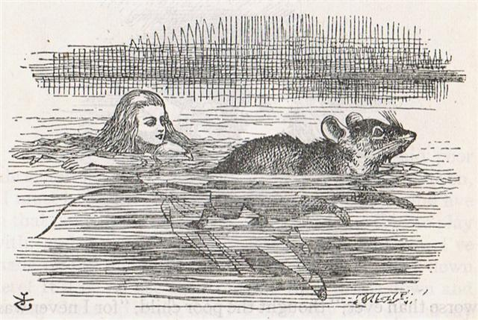

29-3
We can imagine the complicated glyph Cb1-6 as an illustration of how the connection to the previous place for the Mill high up in the north (to the left in the glyph - past tense) was cut off and instead (right) the grinding was continuing down far in the south around Dramasa (*320):
0h |  | *361 |  | *29 |  | *6
0h | Ca1-1 | *361 | Ca13-20 (→ 13 * 20) | *29 | Ca14-29 (392) | *6 | Cb1-6 (398)
0h | March 22 (81, *1) | *361 | March 18 (443, *362) | *29 | April 16 (106, *26) | *6 | April 22 (112, *32)
0h | ALGENIB PEGASI | *361 | DZANEB (*362.4)  ACUBENS | *29 | POLARIS | *6 | no star listed (*32)
0h | *1 + *183 = *184 | *361 | no star listed (*180) | *29 | no star listed (*209) | *6 | ARCTURUS (*215.4)
0h | Sept 21 (264. *184) | *361 | Sept 17 (260, *180) | *29 | Oct 16 (289, *209) | *6 | Oct 22 (295, *215)

While in its preceding place the now salty waters would rush into the 'eye' of the Mill:
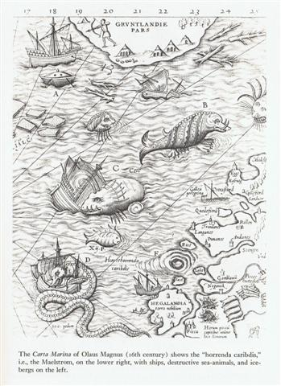

:
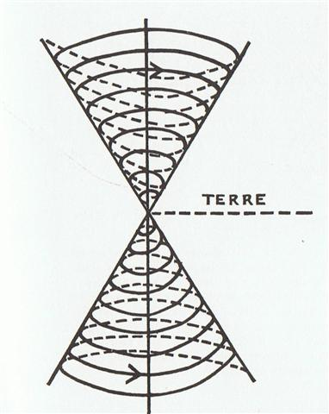

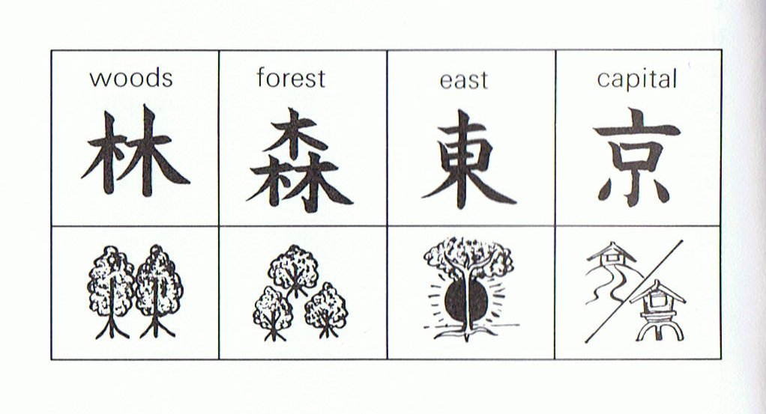
... It is a faulty explanation. Anciently it was instead a picture of a wooden pole (the vertical in the middle) for carrying things on, more specifically a pole thrust through a tied sac ...

This 'pole thrust through a tied sac' can reasonably be a reference to the midsummer 'tree' and the equatorial fertile 'plane of the earth' (where the gods of the planets moved their pieces around):
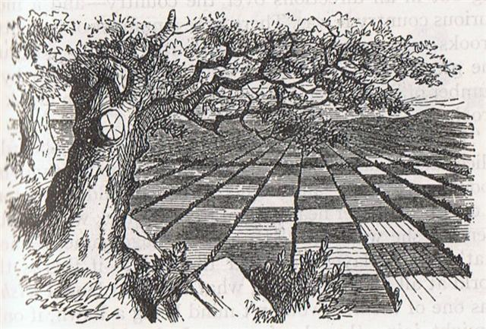
Together with the 'spider' resting high up among the 'branches' in the top of the 'tree'.
... Take the lower part of a gourd or hula drum, rounded as a wheel (globe), on which several lines are to be marked and burned in, as described hereafter. These lines are called na alanui o na hoku hookele, the highways of the navigation stars, which stars are also called na hoku ai-aina, the stars which rule the land. Stars lying outside these three lines are called na hoku a ka lewa, foreign, strange, or outside stars. The first line is drawn from Hoku-paa, the fixed or North Star, to the most southerly star of Newe, the Southern Cross. (This hour circle coincides with the meridian on an evening in June, when it would divide the visible sky into halves.) The portion (of the sky) to the right or east of this line (the observer is evidently assumed to be facing north) is called ke ala ula a Kane, the dawning or bright road of Kane, and that to the left or west is called ke alanui maawe ula a Kanaloa, the much-traveled highway of Kanaloa. (Kane and Kanaloa were important gods in the Polynesian pantheon, Kane being associated with light, Kanaloa with darkness.) Then three lines are drawn east and west, one across the northern section indicates the northern limit of the Sun (corresponding with the Tropic of Cancer) about the 15th and 16th days of the month Kaulua (i.e., the 21st or 22nd of June) and is called ke alanui polohiwa a Kane, the black-shining road of Kane. The line across the southern section indicates the southern limit of the Sun about the 15th or 16th days of the month Hilinama (December 22) and is called ke alanui polohiwa a Kanaloa, the black-shining road of Kanaloa. The line exactly around the middle of the sphere is called ke alanui a ke ku'uku'u, the road of the spider ...

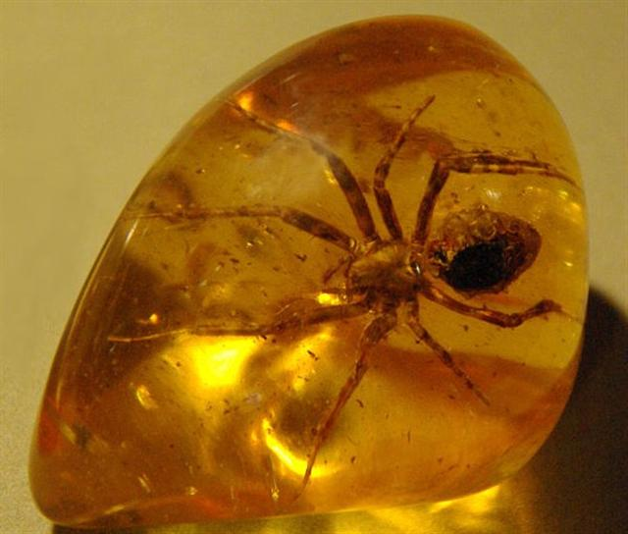
... Far away, the Mangaians of old (Austral Islands, Polynesia), who kept the precessional clock running instead of switching over to 'signs', claim that only at the evening of the solstitial days can spirits enter heaven, the inhabitants of the northern parts of the island at one solstice, the dwellers in the south at the other ... Considering the fact that the crossroads of ecliptic and Galaxy are crisis-resistant, that is, not concerned with the Precession, the reader may want to know why the Mangaians thought they could go to heaven only on the two solstitial days. Because, in order to 'change trains' comfortably, the constellations that serve as 'gates' to the Milky Way must 'stand' upon the 'earth', meaning that they must rise heliacally either at the equinoxes or at the solstices. The Galaxy is a very broad highway, but even so there must have been some bitter millenia when neither gate was directly available any longer, the one hanging in midair, the other having turned into a submarine entrance ...
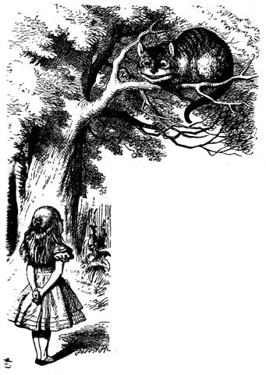

We can see 16 'feathers' (2 * 5 at the rising string to the left + 6 at the central tree itself and up to its apex), which number might suggest the ancient method of waiting for the return of the relevant stars to reappear after their close encounters with the blinding rays from the early morning Sun:
... Like the sun, chiefs of the highest tabus - those who are called 'gods', 'fire', 'heat', and 'raging blazes' - cannot be gazed directly upon without injury. The lowly commoner prostrates before them face to the ground, the position assumed by victims on the platforms of human sacrifice. Such a one is called makawela, 'burnt eyes' ...
... The heads of many of the statues on the terraces once bore a big cylinder (hau hitirau moai), made of red vesicular tuff ... The lower surface has a slight depression which fitted over the top of the image's head. This concavity is not in the center, but near one side so that the cylinder projected over the eyes ... Such a disposition was obeerved by Gonzalez' men ...:
The diameter of the crown is much greater than that of the head on which it rests, and its lower edge projects greatly beyond the forehead of the figure: a position which excites wonder that it does not fall. I was able to clear up this difficulty on making an examination of another smaller statue from whose head there projected a kind of tenon, constructed to fit into a sort of slot or mortice corresponding to it in the crown; so that by this device the latter is sustained notwithstanding its overlapping the forehead.
Roggeveen ... mistook the hats for baskets ... The present natives call the cylinders hau hitirau moai. Hitirau is the name of the tuff from which these cylinders are made ... Jaussen ... gives the word pukao which in Roussel's dictionary means crown. The original meaning of pukao is topknot ...

The connection to the past (left) had evidently been broken. Yet twice 5 double 'feathers' (→ 10 months) seems to have remained in living memory. Possibly 10 'feathers' could also have been the result of a reflection upon those 364 - 354 = 10 extra days coming beyond 12 * 29½.
Beyond the apex of the tree there are 5 further 'feathers' on its descending side. The bottom string should not be counted as such a feather. Instead it could represent the beginning of a kaikai string. Whereas in contrast the bottom string at left is not attatched to the 'trunk' but to the tip of one of its 'branches' ('feathers').
... Ta'aroa sat in his heaven above the earth and conjured forth gods with his words. When he shook off his red and yellow feathers they drifted down and became trees ...
We need to have eyes as sharp as those of an Eagle (or as the edge of a Knife).

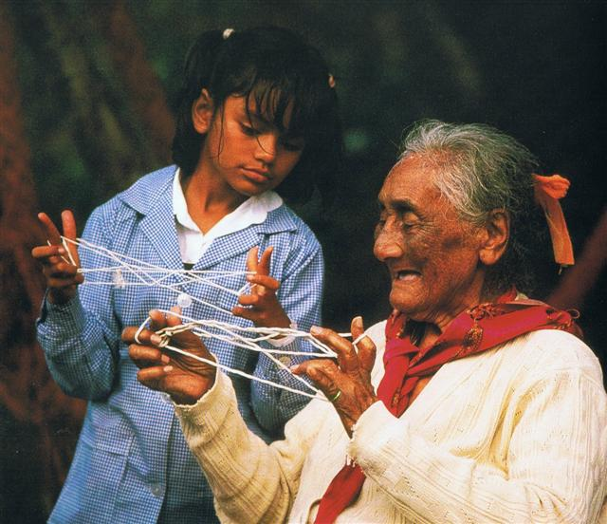
... string games were used up to the point when Aagjuuk appeared, but not after that ...

At right (where the Mill supposedly landed) there are 2 great double feathers on one side and 4 on the other. 4 + 8 = 12 'great months'.
... From the natives of South Island [of New Zealand] White [John] heard a quaint myth which concerns the calendar and its bearing on the sweet potato crop. Whare-patari, who is credited with introducing the year of twelve months into New Zealand, had a staff with twelve notches on it. He went on a visit to some people called Rua-roa (Long pit) who were famous round about for their extensive knowledge. They inquired of Whare how many months the year had according to his reckoning. He showed them the staff with its twelve notches, one for each month. They replied: 'We are in error since we have but ten months. Are we wrong in lifting our crop of kumara (sweet potato) in the eighth month?' Whare-patari answered: 'You are wrong. Leave them until the tenth month. Know you not that there are two odd feathers in a bird's tail? Likewise there are two odd months in the year.' The grateful tribe of Rua-roa adopted Whare's advice and found the sweet potato crop greatly improved as the result ...
Although there in truth are 4 'double feathers' on both sides those at left had been divided in half - as if a mirror had been placed in the middle - causing the bottom pair to look upside down. I think inverted 'feather branches' should refer to times when the Sun light was absent → 364 - 29(0) = 74 and 182 - 148 / 2 = 108, etc, etc.

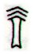 | 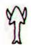
mea ke | ragi
And because the 'double feathers' down in the southern region were essentially greater (as observed from Easter Island) than those in the north we should presumably count them twice - and like the double months of the Moon they were broken in half → 29½ + 29½ = 59.
Twice 16 = 32(0) suggests *320 at Dramasa. And *320 = *80 + *240 (→ 3 * 80).
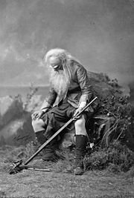

29-4

There is always ambiguity in numbers. Therefore we must relate a number to a position in a part of the total net of associations.
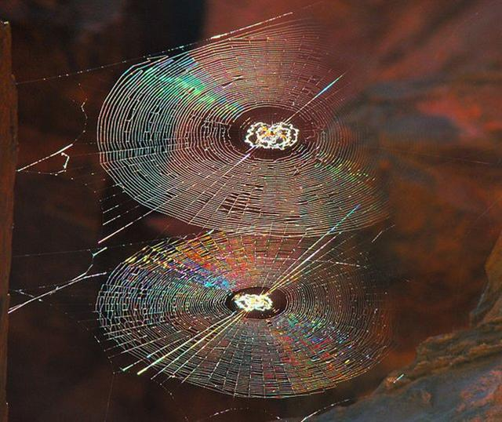
... I have earlier tried to count the number of feathers, and the result became 57.(→ 3 * 19) ...
57 has been stated as the number of years Rip Van Winkle - alias for instance Epimenides - slept.
... The story of Rip Van Winkle is set in the years before and after the American Revolutionary War. Rip Van Winkle, a villager of Dutch descent, lives in a nice village at the foot of New York's Catskill Mountains. An amiable man whose home and farm suffer from his lazy neglect, he is loved by all but his wife. One autumn day he escapes his nagging wife by wandering up the mountains. After encountering strangely dressed men, rumored to be the ghosts of Henry Hudson's crew, who are playing nine-pins, and after drinking some of their liquor, he settles down under a shady tree and falls asleep.
He wakes up twenty years later and returns to his village. He finds out that his wife is dead and his close friends have died in a war or gone somewhere else. He immediately gets into trouble when he hails himself a loyal subject of King George III, not knowing that in the meantime the American Revolution has taken place. An old local recognizes him, however, and Rip's now grown daughter eventually puts him up ...

... The original story was by Diogenes Laertius, an Epicurean philosopher circa early half third century, in his book On the Lives, Opinions, and Sayings of Famous Philosophers. The story is in Chapter ten in his section on the Seven Sages, who were the precursors to the first philosophers. The sage was Epimenides. Apparently Epimenides went to sleep in a cave for fifty-seven years. But unfortunately, 'he became old in as many days as he had slept years'. Although according to the different sources that Diogenes relates, Epimenides lived to be one hundred and fifty-seven years, two hundred and ninety-nine years, or one hundred and fifty-four years. A similar story is told of the Seven Sleepers of Ephesus, Christian saints who fall asleep in a cave while avoiding Roman persecution, and awake more than a century later to find that Christianity has become the religion of the Empire ...
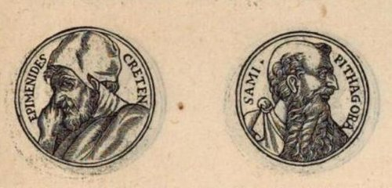
With this in mind we can once again count 'feathers', however now not by adding but by multiplying (→ Mercury):
... Ganz ähnlich is der Name 'Gott von Duazag' des Gottes Nabū ... zu erklären. Er bezeichnet ihn als den Gott des Wachtstums, welches als aus dem Osten stammend betrachtet wird, weil die Sonne, die das Wachstum bringt, im Osten aufgeht. Dass aber Nabū als Ost-Gott aufgefasst wurde, hängt damit zusammen, dass sein Stern, der Mercur, nur im Osten oder Westen sichtbar ist ...
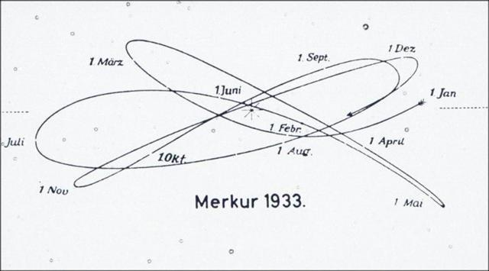

Nose up: |  | Nose down:
2 | 3 | 2 | 3
21 + 22 + 23 + 24 = 43 + 47 = 45 + 45 = 90
Gb6-21 | Gb6-22 | Gb6-23 | Gb6-24
*360 | γ¹ Oct. (*361.4) | *362 | *363
March 16 | 17 (441) | 18 | 19 (78)
12 | 14 | 15 | 16
12 * 14 = 168 |  | 15 * 16 = 240

Number 168 (= 12 * 14) above suggests heliacal Betelgeuze (the 'Moist One' on the Brink of the Milky Way River):
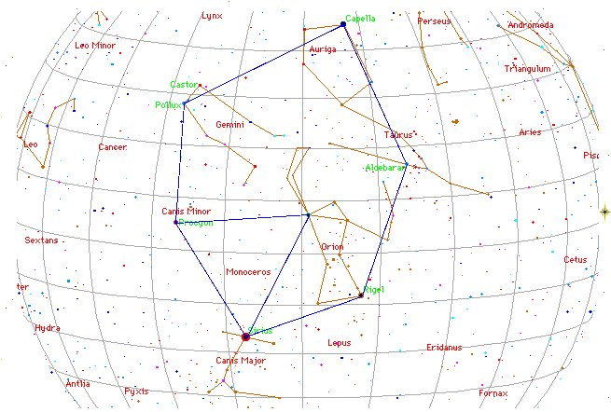

As well as these three 'runs' of a Mayan cycle:

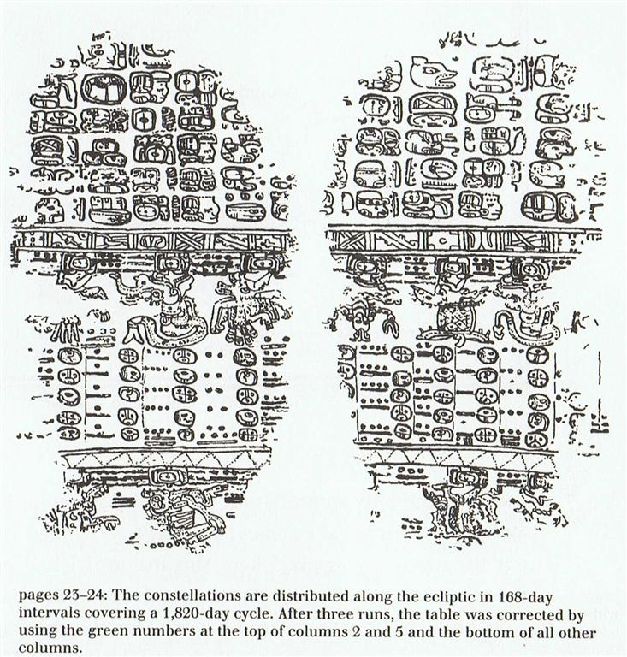

*88 (the right ascension day for heliacal Betelgeuze) * 3 = *264 → 364 - 100.
And 3 * 115 (synodic cycle of Mercury) = 345 (→ the basic Pythagorean triangle: 9 + 16 = 15) = 80 + 265.
According to the Mayas the Creation of our Present World occurred in August 13 (225 → 200 + 25), and 225 - 168 = 57.
Furthermore, 15 days (→ 360 / 24 = 1h) after August 13 was day 240. I.e., 168 + 57 + 15 = 240.
Although the mortally wounded poor Kuukuu (→ ... the line exactly around the middle of the sphere is called ke alanui a ke ku'uku'u, the road of the spider ...) was abandoned :by his comrades already after 27 days (→ the 'thrice nine hallowed days' of Pythagoras), when they left him down in his cave at Oromanga.
... As soon as he had asked, 'Where are you?' the voices [te reo] of the stone heaps [te Pipi horeko] replied, 'Here we are!' All (the youths) said [he ki anake], 'Hey you! That was well done!' He (i.e., Ira) said, 'Let's go! We shall go to Papa O Pea'. They all got up [he ea] and moved on. On the twentieth day of the month of August ('Hora Iti') they went to Papa O Pea ... [E:27-30]
... As has already been mentioned, the Delphians worshipped Dionysus once a year as the new-born child, Liknites, 'the Child in the Harvest Basket', which was a shovel-shaped basket of rush and osier used as a harvest basket, a cradle, a manger, and a winnowing-fan for tossing the grain up into the air against the wind, to separate it from the chaff. The worship of the Divine Child was established in Minoan Crete, its most famous early home in Europe. In 1903, on the site of the temple of Dictaean Zeues - the Zeus who was yearly born in Rhea's cave at Dicte near Cnossos, where Pythagoras spent 'thrice nine hallowed days' of his initiation - was found a Greek hymn which seems to preserve the original Minoan formula in which the gypsum-powdered, sword-dancing Curetes, or tutors, saluted the Child at his birthday feast. In it he is hailed as 'the Cronian one' who comes yearly to Dicte mounted on a sow and escorted by a spirit-throng, and begged for peace and plenty as a reward for their joyful leaps ...
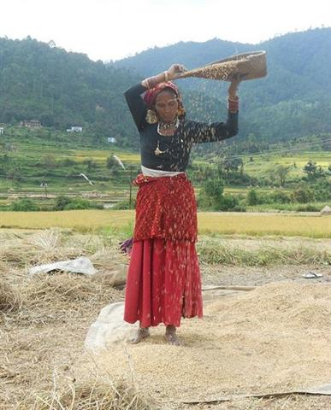

The 'twentieth day of the month of August' was one week after August 13, and 225 + 7 = 232 → 29 * 8 → 'two hundred and ninety-nine' minus one.
→ twice 149 = 298 = twice twice 21 weeks = twice 42 weeks = 84 weeks → Julian equinox in March 25 (84 = 12 weeks).
Thus we ought to count 232 - 84 = 148 (→ 168 - 20):
... He wakes up twenty years later and returns to his village ...
And evidently it took place in the Golden Age of the Bull. Because 28 May (84 + 64) + 12 weeks = 232 (→ 168 + 64):
Itzam-Yeh defeated | 28 May (148), 3149 BC
First 3-stone place | 21 May (141), 3114 BC
Creation of our present world | 13 Aug (225), 3114 BC
Hun-Nal-Ye became the sky | 5 Febr (36), 3112 BC
(3149 - 3112) / 71 = 0.52 < (26.6 - 26)
21 May, 3114 BC - 13 August, 3114 BC = 225 - 141 = 84 (= 12 * 7)
21 May, 3114 BC - 5 February, 3112 BC = 542, which 'happens to be' the sum of 365 days and 6 * 29½ nights.
148 (May 28) - *70 = 78 (19 March)

29-5

There is always a seemingly infinite (endless) amount of information to be gathered (harvested)
from a single image (myth), especially as it has to be connected as if by spider thin threads of association to all the other words inherited by men and birds. Otherwise it could not be understood.
↕

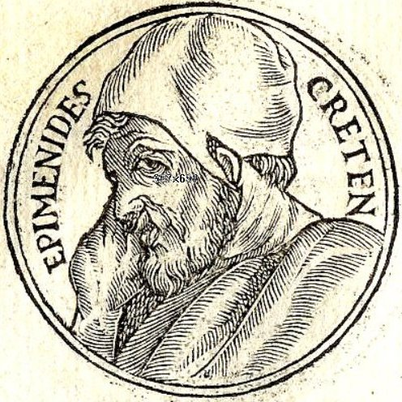
↕
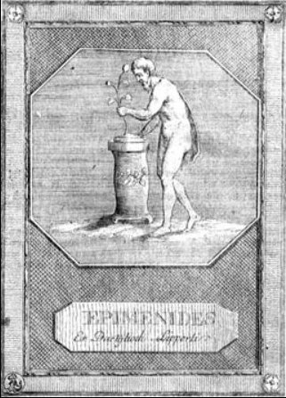

Therefore we should consider the site in the cosmic worldwide web for the central tree (Rakau) - the King (Pharaoh, Emperor, Ariki):
rakau
Rakau. Raau, medicine, remedy, drug. Ra'a'u, scratch on the skin. Rakau, a plant. Râkau, goods, property. Vanaga. 1. Wood; rakau ta, cudgel, stick.
Kauati. Pau.: to make fire. Mgv.: kounati, the plowed stick in fire-making. Ta.: auati, auai, stick used in fire-making. Mq.: koukati, koukani, the plowed stick. Viti: kaunita, to rub fire. Ma.: kauati, a fire-making stick. Churchill.
... You will notice that the wood is of a soft and spongy nature. It grows abundantly on these islands, and is a variety known as the Hibiscus tiliaceus, and called by the natives 'Purau' and 'Fau', pronounced 'Purow' and 'Fow', 'ow' being sounded as in the word 'how'. You can, if you wish, obtain large quantities of it, by going on board the vessels carrying oranges from these islands to San Francisco; the orange crates are mostly made of it ...

P Pau.: rakau, tree, to dress a wound. Mgv.: rakau, wood, timber, a tree; medicine, a remedy; an object. Mq.: ákau, wood, tree.
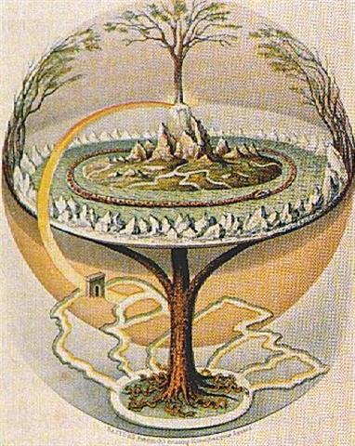
Ta.: raáu, id. 2. Medicine, remedy, potion, ointment, furniture, any precious object, resources, baggage, riches, heritage, dowry, merchandise, treasure, wealth; rakau hakaneinei, purgative; rakau nui, rich, opulent; rakau kore, poor, beggar, indigent, miserable, an inferior; hakakamikami ki te rakau, to impoverish; rakau o te miro, ballast. Mq.: akau, anything in general. The medicine sense is particularized in Tonga, Nukuoro, Hawaii, Tahiti, Mangareva, Paumotu. In no other speech does wood stand so fully for wealth of possessions, but it will be recalled that Rapanui is destitute of timber and depends wholly upon driftwood. Churchill.
... There is a mill which grinds by itself, swings of itself, and scatters the dust a hundred versts away. And there is a golden pole with a golden cage on top which is also the Nail of the North. And there is a very wise tomcat which climbs up and down this pole. When he climbs down, he sings songs; and when he climbs up, he tells tales ...

And myth is telling us clearly - this precious tree should stand tall at the climax of midsummer.
... Most of the people in our van took advantage of the interlude to shop at the nearby stalls set up by highland Maya who had come down to Tikal to take advantage of the steady supply of tourists. However, one of our group, Harriet Gillett, a retired physician and an inveterate bird-watcher, had other interests. She noticed a nearby tree hevy with white blossoms and surrounded by a raucous sphere of birds and bees. She climbed out of the van with her binoculars around her neck, and walked over to take advantage of the unexpected opportunity the morning had provided. Our local guide, Francisco Florián, who knew the forest and its creatures in an unusually intimate way, joined her, explaining that the birds came to the tree only early in the morning. The sounds and the odd sight finally drew my attention and I too disembarked from the van and edged closer to the buzzing center of the action. I stared at the screaming birds as they fought for positions among the flowers and the hovering drone of thousands of bees. How beautiful, I thought, and then my gaze happened to settle on the trunk of the tree. It had thorns and it bulged just above the ground. It was a young ceiba tree.
I already knew that the ceiba tree was the model for the sacred World Tree of the Maya, but I had never seen one in flower when I knew what I was looking at. I was really excited because normally you can't see the blossoms even if you're there when the tree is in blossom. The fully mature trees are hundreds of feet high. and the blossoms are very small. 'It's a ceiba', I chirped and began looking for a branch low enough to see one of the blossoms up close. Joyce Livingstone, a retired teacher, did the logical thing. She bent over, picked up a fallen branch, and held it out for me to see. I was too excited and full of myself to listen. She tapped my arm more insistently and still I didn't hear her. Finally, in frustration, she grabbed my wrist and raised her voice. 'Will you look at these?' she said, waving the branch, and finally I did. What I saw stunned me, for in her hand lay a perfect replica of the earflares worn by the Classic Maya kings. Suddenly I understood the full symbolism of so many of the things I had been studying for years. The kings dressed themselves as the Wakah-Chan tree, although at the time I didn't know it was also the Milky Way.
The tzuk [partition] head on the trunk of the tree covered their loins. The branches with their white flowers bent down along their thighs, the double-headed ecliptic snake rested in their arms, and the great bird Itzam-Yeh stood on their head. I already knew as I stood under the young tree in Tikal that the kings were the human embodiment of the ceiba as the central axis of the world. As I stood there gazing at the flowers in Joyce's hand, I also learned that the kings embodied the ceiba at the moment it flowers to yield the sak-nik-nal, the 'white flowers', that are the souls of human beings. As the trees flowers to reproduce itself, so the kings flowered to reproduce the world ...

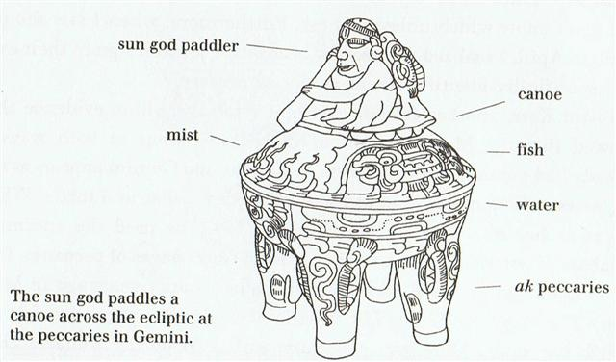

So in some way we should perceive a reflection of midsummer at Cb1-6:
0h |  | *361 |  | *29 |  | *6
0h | Ca1-1 | *361 | Ca13-20 (→ 13 * 20) | *29 | Ca14-29 (392) | *6 | Cb1-6 (398)
0h | March 22 (81, *1) | *361 | March 18 (443, *362) | *29 | April 16 (106, *26) | *6 | April 22 (112, *32)
0h | ALGENIB PEGASI | *361 | DZANEB (*362.4)  ACUBENS | *29 | POLARIS | *6 | no star listed (*32)
0h | *1 + *183 = *184 | *361 | no star listed (*180) | *29 | no star listed (*209) | *6 | ARCTURUS (*215.4)
0h | Sept 21 (264. *184) | *361 | Sept 17 (260, *180) | *29 | Oct 16 (289, *209) | *6 | Oct 22 (295, *215)

By going back in precessional time-space to the Age of the Golden Bull we can translate the current place of Arcturus from October 22 (295 → 10 synodic lunar months) to 295 - 8 * 8 = 231 and then take away 60 (→ the basic Babylonian measure for the area of an irrigated field): 231 - 60 = 171.
This construction of mine can then be connected by a thin thread of association to the overpowering image of Sleipner, the quick horse with 8 legs (↔ 2 heads):

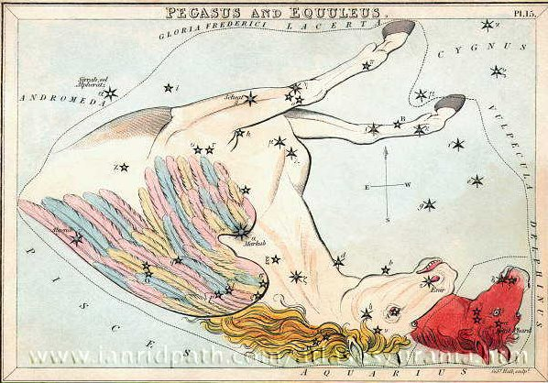

Sleipner is carrying the god Odin - as in Wednesday (the day of Wooden → Mercury). Cfr the Swedish language Onsdag (= Wednesday) ↔ the day (dag) of Odin, Odin's dag, Onsdag.
... The first of all foreign visitors on Easter Island was the Dutch admiral Jacob Roggeveen., who approached the island in the evening twilight of Easter Sunday, 1722. As the sun rose above the sea next morning the Dutchmen brought their ships close inshore and observed a mixed crowd of fair-skinned and dark-skinned people who had lit fires before some enormous statues standing in a row. The people ashore were squatting in front of the statues, with their heads bent while they alternatively raised and lowered their arms. When the sun rose they prostrated themselves on the ground facing the sunrise, their fires still flickering before the stone colossi. The statues were even then so old and eroded that Roggeveen could with his bare fingers break pieces away from the decomposed surface, wherefore he concluded that the giant figures were simply molded from clay and soil mixed with pebbles. The Dutchmen left the island after a single day's visit ...
And from 1 (in Russian odin means 1) we can add a week in order to reach 8 as in the number of legs in the horse of Mercury. Thus we can compare Sleipner with a great spider.
... In the beginning there was nothing but the sea, and above soared the Old-Spider ...

The word Sleipner gives associations of one who is slipping away, like an Octo-pus (→ 8 feet) hiding in his ink.
Hotu. Ta.: hotu, to produce fruit, Sa.: fotu, id. Mgv.: akahotu, the September season. Churchill. H.: Hoku, Night of the full moon. When this moon set before daylight it was called Hoku Palemo, Hoku that slips away. When it set after daylight it was called Hoku Ili, grounded Hoku ...

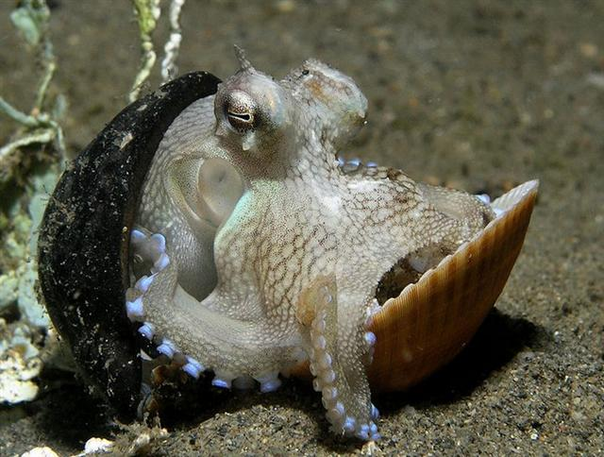
Heke. Hakaheke, to pull down, to overthrow. Mgv.: akaeke, to overthrow, to vanquish; heke, to fall down, to fall to pieces: akaheke; akahekeheke, to demolish. Mq.: heke, to crumble, to fall down; hakaheke, to demolish, to pull down. Churchill. Kai heke, hakaheke, to deflower. Kahukahu o heke, an octopus hiding in his ink. Mq.: ve'eve'e 'tentacules du heke'. Barthel 2. Pau.: Heke, to purge. Mgv.: heke-toto, hemorrhage. Ta.: hee, to purge. Mq.: heke, to drip. Ma.: heke, id. Pau.: Hekeheke, elephantiasis. Ta.: feefee, id. Mq.: fefe, id. Sa.: fe'efe'e, id. Mgv.: Heke, eke, octopus. Ta.: fee, id. Mq.: heke, feke, fee, id. Sa.: fe'e, id. Ma.: wheke, id. Ta.: Hee, to slide, to swim. Sa.: se'e, to slide, to shoot the breakers. Ha.: hee, id. Mq.: Hee oto, to cut. Sa.: sele, id. Ha.: helehele, id. Churchill. Ma.: 1. Migrate. Islands of History. 2. Rafter. Starzecka.

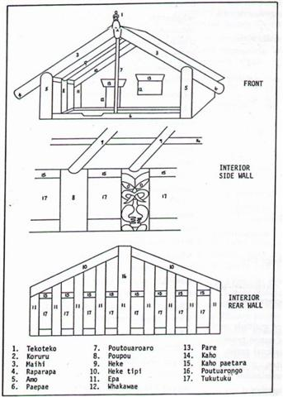

Spiders (and birds) live up in the air whereas heke (and fishes) can be found down in the sea.
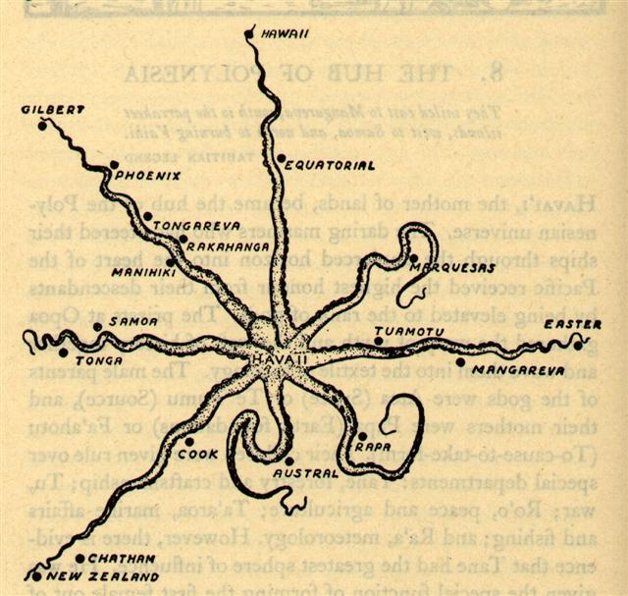
... Now birds and fishes are born under the sign of the Yin, but they belong to the Yang. This is why birds and fishes both lay eggs. Fishes swim in the waters, birds fly among the clouds. But in winter, the swallows and starlings go down into the sea and change into mussels ...

A square table of information (orientation) up at top left in the illustration for Odin riding on his 'Spider' (→ ke ku'uku'u) carries 5 (→ Sky) quite interesting numerical letters (among those 29 which I here can perceive):
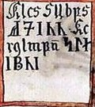
171 should refer to June 20 (*91 = *88 + *3 = *83 + *8), where we can read in the G text that midsummer was bound to begin.
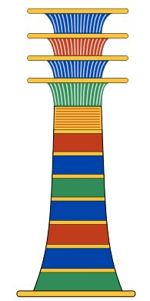

 | 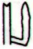 | 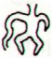
Ga1-27 | Ga1-28 | Ga1-29
June 20 (171) | Solstice | 22 (*93)
6h | Ξ Orionis | TEJAT PRIOR = η Gemini (*93.4)
... The twelve merry-men rush in a wild figure-of-eight dance around the fires, singing ecstatically and tearing at the flesh with their teeth ...
The first figure 1 in 171 (in the square above) seems to have been designed to visualize a reversed stream of water at left (in the past), similar in form to the Greek letter λ and similar in meaning to the undulating water serpent on the north side of the pyramid of Kukulkan (→ ke ku'uku'u):
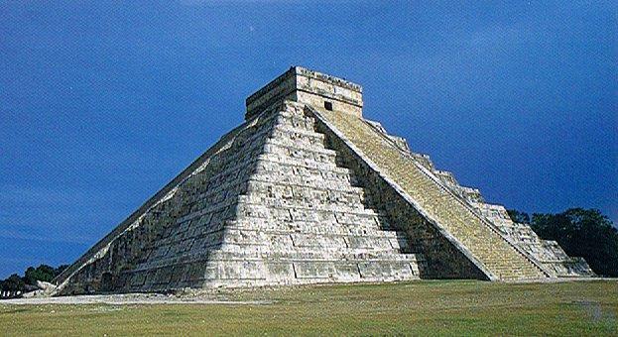
And surely also to the illustration in glyph number 29 on the G tablet, where the head has come off
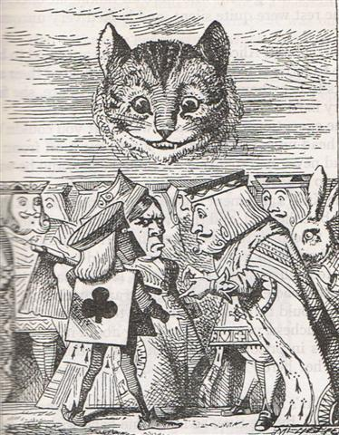

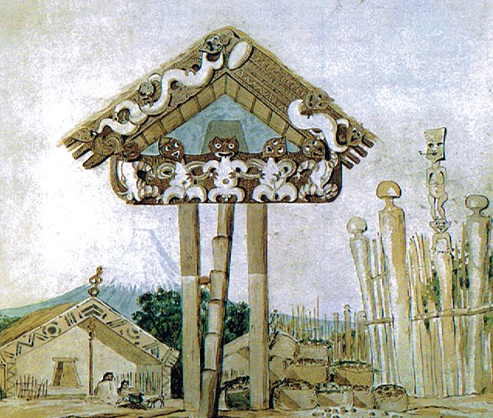
and where the right arm at the back side has been converted into a gush of water.
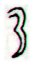
rima aueue

Aue. Ah, alas. Aueue, oh. P Pau., Ta.: aue, alas. Mgv.: aue, auhe, alas. Mq.: aue, oh, alas; auhe, a sigh. Exclamation in general representing the most primordial type of speech, it seems that this may be reduced to recognizable elements. The e is throughout these languages a vocative or hailing sign, commonly postpositive in relation to the person hailed. In the examination of au we have shown that the primal first person singular designation is u. With the comparatively scanty material afforded by this vocabulary we may not attempt ot define the use of a but we have no hesitation in noting that proof based on wider studies will show it to have, inter alia, a characteristic function as a word-maker. In a very high degree, then, a-u-e is represented by a common English interjection 'oh my!' in which oh = a, my = u, and e = !. Churchill. What is this cry which our primitive islanders share with the animals? Look at its elements, all full-throated. First we have a, the sound of mouth open, fauces open, lungs full of air. As air expires the sound recedes in the mouth towards the palate and we find the u. Last comes the conscious finish of the utterance, the muscles begin to retract, the sound-making point is forced forward and the sound is e. If the man had but a few more cubic centimeters of lung capacity he could attain cow volumne for his cry, or interjection, since it amounts to the same thing. Churchill 2.
When the new moon appeared women assembled and bewailed those who had died since the last one, uttering the following lament: 'Alas! O moon! Thou has returned to life, but our departed beloved ones have not. Thou has bathed in the waiora a Tane, and had thy life renewed, but there is no fount to restore life to our departed ones. Alas ... (Makemson)

Fforthermore, immediately after 7 (Λ)
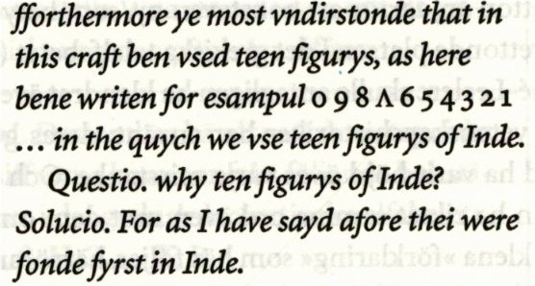
is another (ké) figure 1 (i.e. after 17), where follows a pair of reversed reversals, possibly alluding to Gemini on the other side of the Milky Way river.
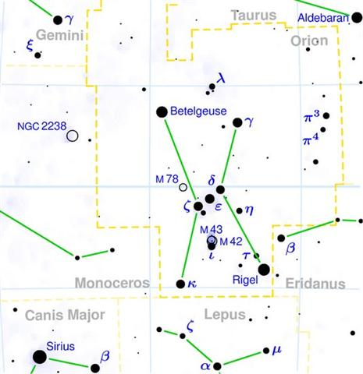

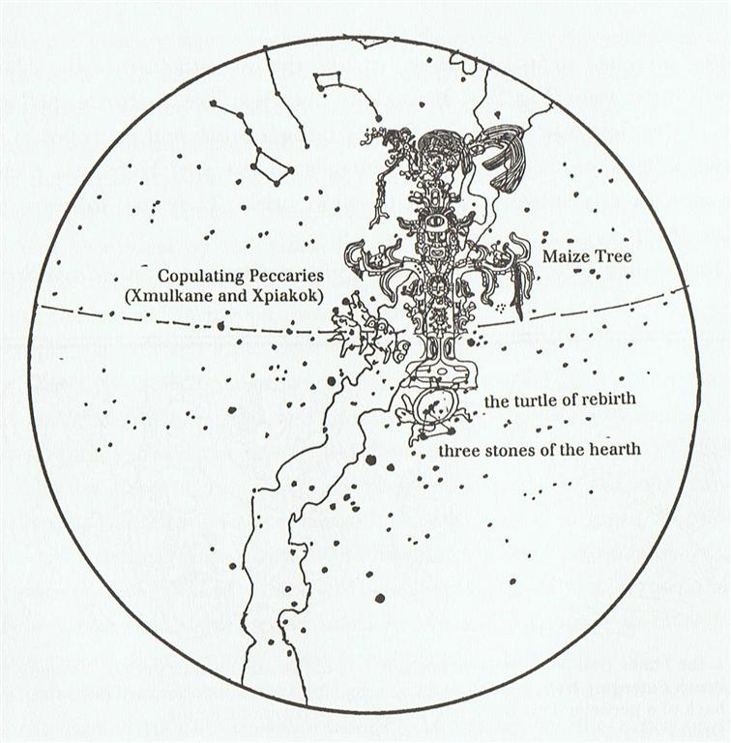

29-6

The cross connexions in a web of images will secure meaning, turning it into an implex.
... Fanciful, assuredly, but neither the Milky Way nor the terrestrial Ganges offered any basis for the imagery of a river flowing to the four quarters of the earth 'for the purification of the three worlds'. One cannot get away from the 'implex' and it is now necessary to consider the tale of a new skeleton map, alias skambha: the equinoctial colure had shifted to a position where it ran through stars of Auriga and through Rigel. Skambha, as we have said, was the World Tree consisting mostly of celestial coordinates, a kind of wildly imaginative armillary sphere. It all had to shift when one coordinate shifted ...

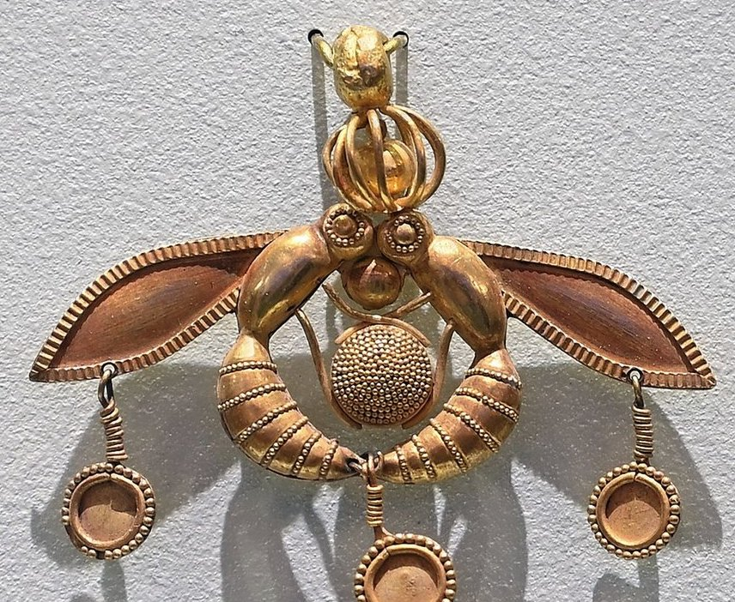

Yet, after much destruction it had to be recycled, had to be reborn.
... It is a faulty explanation. Anciently it was instead a picture of a wooden pole (the vertical in the middle) for carrying things on, more specifically a pole thrust through a tied sac ...

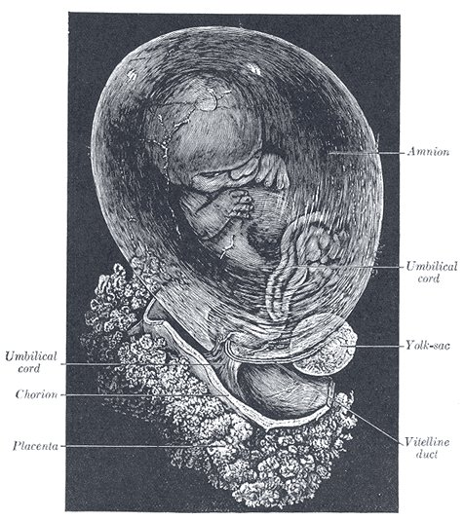
This is the crucial remedy (rakau) delivered by the midsummer tree, by the top guy (→ Gouyo!).
... And then she looked in her hand, she inspected it right away, but the bone's saliva wasn't in her hand. It is just a sign I have given you, my saliva, my spittle. This, my head, has nothing on it - just bone, nothing of meat. It's just the same with the head of a great lord: it's just the flesh that makes his face look good. And when he dies, people get frightened by his bones. After that,

his son is like his saliva, his spittle, in his being, whether it be the son of a lord or the son of a craftsman, an orator. The father does not disappear, but goes on being fulfilled. Neither dimmed nor destroyed is the face of a lord, a warrior, craftsman, an orator. Rather, he will leave his daughters and sons. So it is that I have done likewise through you. Now go up there on the face of the earth; you will not die. Keep the word. So be it, said the head of One and Seven Hunaphu - they were of one mind when they did it ...

Now we ought to have accumulated enough in order to be reasonably equipped to move on:
Especially as we have the C text as a whole to rely upon, together with the precious parallel words of Metoro:
... I'a is the general name for fishes,' Pratt notes in his Samoan dictionary, 'except the bonito and shellfish (mollusca and crustacea).' ...
0h |  | *260 |  | 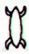 | *100
0h | Ca1-1 | *260 | Ca10-6 (9 * 29) | Ca10-7 (262) | *100 | Ca13-20 (→ 13 * 20)
0h | March 22 (81, *1) | *260 | Dec 7 (341, *261) | Dec 8 | *100 | March 18 (443, *362)
0h | ALGENIB PEGASI | *260 | Sarin (*261.0), ο Ophiuchi (*261.4)  ALRISHA | θ Ophiuchi, ν Serpentis, ζ, ι Apodis (*262.4) | *100 | DZANEB (*362.4)  ACUBENS
0h | *1 + *183 = *184 | *260 | CAPELLA (*78.4)  THUBAN | *262 + *183 = *445  ARCTURUS | *100 | no star listed (*180)
0h | Sept 21 (264. *184) | *260 | June 7 (158, *78) | June 8 | *100 | Sept 17 (260, *180)
0h | koia | *260 | Tupu te toromiro | kua noho te vai | *100 | -
Here we can see that many filaments are converging, for instance by way of a dot in front at Ca10-6.
Here Metoro saw a new beginning because his Word logic was documented as Tupu instead of tupu. Here the Full Moon should ideally be where Thuban culminated (at 21h).
... The star [Thuban] could be seen, both by day and night, from the bottom of the central passage of the Great Pyramid of Cheops (Knum Khufu) at Ghizeh, in 30° of north latitude, as also from the similar points in five other like structures; and the same fact is asserted by Sir John Herschel as to the two pyramids at Abousseir ...
...
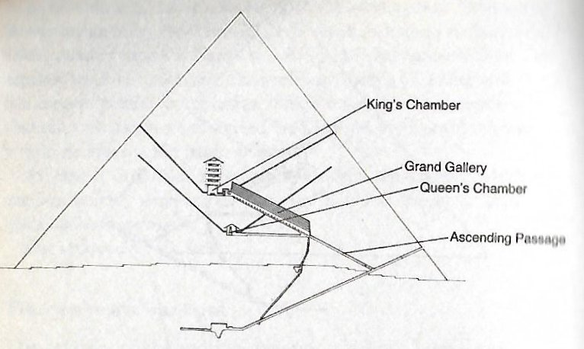
The tree named Toromiro was located in the sweet waters (noho te vai), Metoro said.
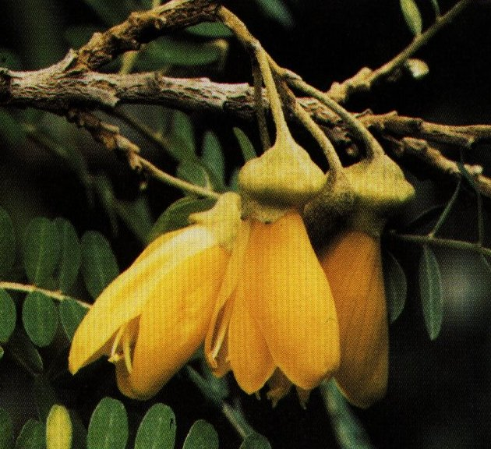

Obviously, we can see, it is the same tree as that in the center of Cb1-6:
0h |  | *361 |  | *29 |  | *6
0h | Ca1-1 | *361 | Ca13-20 (→ 13 * 20) | *29 | Ca14-29 (392) | *6 | Cb1-6 (398)
0h | March 22 (81, *1) | *361 | March 18 (443, *362) | *29 | April 16 (106, *26) | *6 | April 22 (112, *32)
0h | ALGENIB PEGASI | *361 | DZANEB (*362.4)  ACUBENS | *29 | POLARIS | *6 | no star listed (*32)
0h | *1 + *183 = *184 | *361 | no star listed (*180) | *29 | no star listed (*209) | *6 | ARCTURUS (*215.4)
0h | Sept 21 (264. *184) | *361 | Sept 17 (260, *180) | *29 | Oct 16 (289, *209) | *6 | Oct 22 (295, *215)
295 (October 22, Cb1-6) - June 7 (158, Ca10-6) = 137 (→ 183 - 46).
... Allen has documented all his star culminations at 21h, which could be due to an effort of keeping the culminations at their proper places according to the ancients, 24h (spring equinox) - 21h = 3h = 24h / 8 = 45º. 3h corresponds to 366 / 8 = 45.75 of my right ascension days and *366 - *46 = *320 (Dramasa, σ Octantis) ...
And there are no more rakau images which are exactly alike in the C text:
 |  |  | 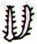
Ca4-13 | Ca4-20 | Ca4-25 | Ca5-5 |  | Ca10-6 | Cb1-6 (392 + 6)

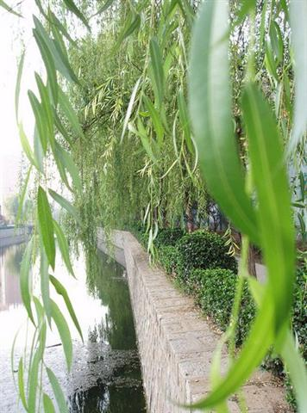

29-7

Once again. I think the reason for the immense efforts behind the rongorongo texts was the obvious need to preserve the ancient common sense - before the tornado of major changes would blow it all away.
... Most ingenious Thoth, said the god and king Thamus, one man has the ability to beget arts, but the ability to judge of their usefulness or harmfulness to their users belongs to another; and now you, who are the father of letters, have been led by your affection to ascribe to them a power the opposite of that which they really possess. For this invention will produce forgetfulness in the minds of those who learn to use it, because they will not practise their memory. Their trust in writing, produced by external characters which are no part of themselves, will discourage the use of their own memory within them. You have invented an elixir not of memory, but of reminding; and you offer your pupils the appearance of wisdom, not true wisdom, for they will read many things without instruction and will therefore seem to know many things, when they are for the most part ignorant and hard to get along with, since they are not wise, but only appear wise ...
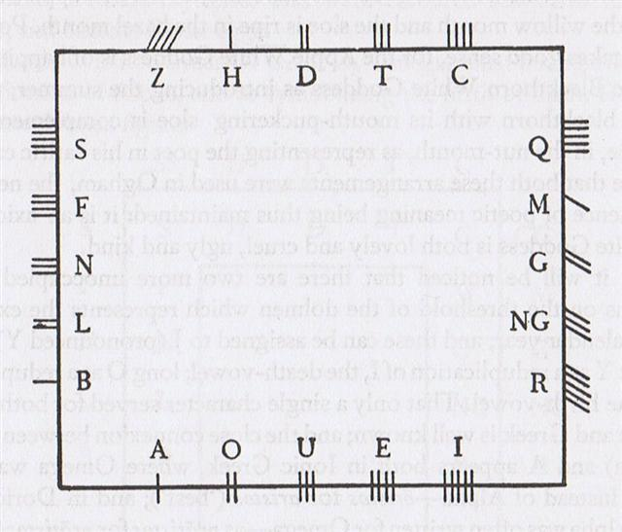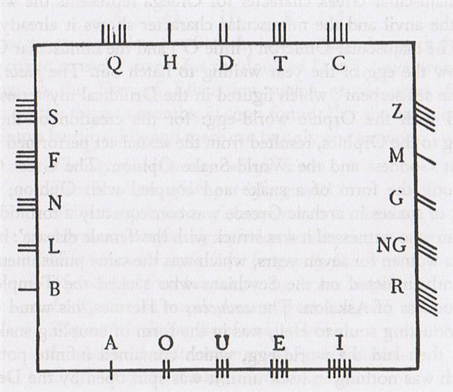
... At Opoa, at one of the last great gatherings of the Hau-pahu-nui, for idolatrous worship, before the arrival of European ships, a strange thing happened during our [the two priests of Porapora, Auna-iti and Vai-au] solemn festivity. Just at the close of the pa'i-atua ceremony, there came a whirlwind which plucked off the head of a tall spreading tamanu tree, named Paruru-mata'i-i-'a'ana (Screen-from-wind-of-aggravating-crime), leaving the bare trunk standing.
This was very remarkable, as tamanu wood is very hard and close-grained. Awe struck the hearts of all present. The representatives of each people looked at those of the other in silence for some time, until at last a priest of Opoa named Vaità (Smitten-water) exclaimed, - E homa, eaha ta 'outou e feruri nei? (Friends, upon what are you meditating?) - Te feruri nei i te tapa'o o teie ra'au i motu nei; a'ita te ra'au nei i motu mai te po au'iu'i mai. (We are

wondering what the breaking of this tree may be ominous of; such a thing has not happened to our trees from the remotest age), the people replied. Then Vaità feeling inspired proceeded to tell the meaning of this strange event… I see before me the meaning of this strange event! There are coming the glorious children of the Trunk (God), who will see these trees here, in Taputapuatea. In person, they differ from us, yet they are the same as we, from the Trunk, and they will possess this land. There will be an end to our present customs, and the sacred birds of sea and land will come to mourn over what this tree that is severed teaches.
This unexpected speech amazed the people and sages, and we enquired where such people were to be found. Te haere mai nei na ni'a i te ho'e pahi ama 'ore. (They are coming on a ship without an outrigger), was Vaitàs reply. Then in order to illustrate the subject, Vaità, seeing a large umete (wooden trough) at hand, asked the king to send some men with it and place it balanced with stones in the sea, which was quickly done, and there the umete sat upon the waves with no signs of upsetting amid the applauding shouts of the people ...

0h |  | *260 |  |  | *100
0h | Ca1-1 | *260 | Ca10-6 (9 * 29) | Ca10-7 (262) | *100 | Ca13-20 (→ 13 * 20)
0h | March 22 (81, *1) | *260 | Dec 7 (341, *261) | Dec 8 | *100 | March 18 (443, *362)
0h | ALGENIB PEGASI | *260 | Sarin (*261.0), ο Ophiuchi (*261.4)  ALRISHA | θ Ophiuchi, ν Serpentis, ζ, ι Apodis (*262.4) | *100 | DZANEB (*362.4)  ACUBENS
0h | *1 + *183 = *184 | *260 | CAPELLA (*78.4)  THUBAN | *262 + *183 = *445  ARCTURUS | *100 | no star listed (*180)
0h | Sept 21 (264. *184) | *260 | June 7 (158, *78) | June 8 | *100 | Sept 17 (260, *180)
0h | koia | *260 | Tupu te toromiro | kua noho te vai | *100 | -

*29 |  | *6
*29 | Ca14-29 (392) | *6 | Cb1-6 (398)
*29 | April 16 (106, *26) | *6 | April 22 (112, *32)
*29 | POLARIS | *6 | no star listed (*32)
*29 | no star listed (*209) | *6 | ARCTURUS (*215.4)
*29 | Oct 16 (289, *209) | *6 | Oct 22 (295, *215)
*29 | te rima | *6 | te pahu

Pahu. Drum. Pahu-rutu-roa = Long-beating-drum. Barthel.M. Pahū. Tree gong. Starzecka. Pahu uma, coffin; in modern usage, any sort of jar. Pahupahu = To dig a hole. Vanaga. A trough, barrel, cask, cradle, drum, chest, box; pahu nui, a kettle; pahu oka, a drawer; pahu papaku, coffin; pahu rikiriki, sheath; pahu viriviri, hogshead. Pahupahu, box. Churchill. A trough, barrel, cask, cradle, drum, chest, box; pahu nui, a kettle; pahu oka, a drawer; pahu papaku, coffin; pahu rikiriki, sheath; pahu viriviri, hogshead; pahupahu, box. P Mgv., Ta.: pahu, a drum. Mq.: pahu, a drum, a large cylindrical container. (To.: bahu, a hollow tree set in water as a filter.) Sa.: pusa, a box. To.: buha, id. Fu.: pusa, id. Niue: puha, id. Pau.: puha, id. Pahuahi, lantern, beacon. Paukumi, closet, cupboard. Pahupopo, a mould; pahupopokai, cupboard for food. Pahure: 1. To sweep everything away. 2. To wound, to lacerate, scar, bruise, lesion, sore; pahurehure, to wound, to scratch; hakapahure, to wound. T Pau.: pahure, to be skinned; pahore, to peel off, to scale. Mgv.: pahore, to cut off, to chop, to slice. Ta.: pahore, to flay, to skin. Churchill 2.

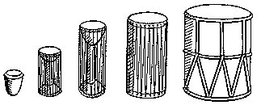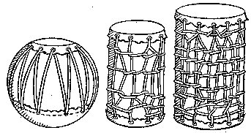

... The most important of all drums, he said, was the armpit drum. The Nummo made it. It consists of two hemispherical wooden cups connected through their centres by a slender cylinder. It is like an hour-glass with a very long narrow neck. With this instrument tucked between his left arm and armpit, the drummer, by pressing on the hollow structure of thin wood, can tighten or relax the tension on the skins and so modify the tone. 'The Nummo made it. He made a picture of it with his fingers, as children do today in games with string.' Holding his hands apart, he passed a thread ten times round each of the four fingers, but not the thumb. He thus had forty loops on each hand, making eighty threads in all, which, he pointed out, was also the number of teeth of his jaws. The palms of his hands represented the skins of the drum, and thus to play on the drum was, symbolically, to play on the hands of the Nummo. But what do they represent? Cupping his two hands behind his ears, Ogotemmêli explained that the spirit had no external ears but only auditory holes. 'His hands serve for ears,' he said; 'to enable him to hear he always holds them on each side of his head. To tap the drum is to tap the Nummo's palms, to tap, that is, his ears.' Holding before him the web of threads which represented a weft, the Spirit with his tongue interlaced them with a kind of endless chain made of a thin strip of copper. He coiled this in a spiral of eighty turns, and throughout the process he spoke as he had done when teaching the art of weaving. But what he said was new. It was the third Word, which he was revealing to men ...
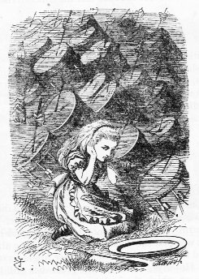

In June 7 the Sun was rising not only together with Mother Goat (Capella in Auriga)
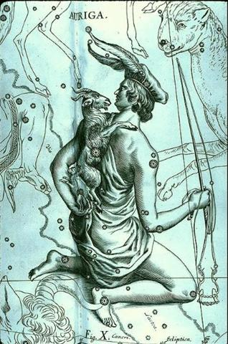
but also with Rigel - the 'Foot' of Orion.

... In view of the almost universal prevalence of the Pleiades year throughout the Polynesian area it is surprising to find that in the South Island and certain parts of the North Island of New Zealand and in the neighboring Chatham Islands, the year began with the new Moon after the early morning rising, not of the Pleiades, but of the star Rigel in Orion ...
... Antevorta and Postvorta had two altars in Rome and were invoked by pregnant women as protectors against the dangers of childbirth. Antevorta was said to be present at the birth when the baby was born head-first; Postverta, when the feet of the baby came first ...
... The four males and the four females were couples in consequence of their lower, i.e. of their sexual parts. The four males were man and woman, and the four females were woman and man. In the case of the males it was the man, and in the case of the females it was the woman, who played the dominant role. They coupled and became pregnant each in him or herself, and so produced their offspring. But in the fullness of time an obscure instinct led the eldest of them towards the anthill which had been occupied by the Nummo. He wore on his head a head-dress and to protect him from the sun, the wooden bowl he used for his food. He put his two feet into the opening of the anthill, that is of the earth's womb, and sank in slowly as if for a parturition a tergo. The whole of him thus entered into the earth, and his head itself disappeared. But he left on the ground, as evidence of his passage into that world, the bowl which had caught on the edges of the opening. All that remained on the anthill was the round wooden bowl, still bearing traces of the food and the finger-prints of its vanished owner, symbol of his body and of his human nature, as, in the animal world, is the skin which a reptile has shed ...
... The Euripus, which has already come up in the Phaedo, was really a channel between Euboea and the mainland, in which the conflict of the tides reverses the current as much as seven times a day, with ensuing dangerous eddies - actually a case of standing waves rather than a true whirl. We meet the name again at a rather unexpected place, in the Roman circus or hippodrome, as we know from J. Laurentius Lydus (De Mensibus I.12), who states that the center of the circus was called Euripos; that in the middle of the stadium was a pyramid, belonging to the Sun; that by the Sun's pyramid were three altars, of Saturn, Jupiter, Mars, and below the pyramid, altars of Venus, Mercury, and the Moon, and that there were not more than seven circuits (kykloi) around the pyramid, because the planets were only seven. (See also F. M. Cornford's chapter on the origin of the Olympic games in J. Harrison's Themis (1962), p. 228; G. Higgins' Anacalypsis (1927), vol. 2., pp. 372ff.) This brings to mind (although not called Euripus, obviously, but 'the god's place of skulls') the Central American Ball Court which had a round hole in its center, termed by Tezozomoc 'the enigmatic significance of the ball court', and from this hole a lake spread out before Uitzilopochtli was born ...
... That there is a whirlpool in the sky is well known, it is most probably the essential one, and it is precisely located. It is a group of stars so named (zalos) at the foot of Orion, close to Rigel (beta Orionis, Rigel being the Arabic word for 'foot'), the degree of which was called 'death', according to Hermes Trismegistos, whereas the Maori claim outright that Rigel marked the way to Hades (Castor indicating the primordial homeland) ...

... There is a mill which grinds by itself, swings of itself, and scatters the dust a hundred versts away. And there is a golden pole with a golden cage on top which is also the Nail of the North. And there is a very wise tomcat which climbs up and down this pole. When he climbs down, he sings songs; and when he climbs up, he tells tales ...

